JETI Application Instructions and Tab Information
ALL form fields must contain requested information or N/A. No field can be left blank.
Send all completed applications, schedules and other supporting documents to:
jeti.apps@cpa.texas.gov

Sect # | Instructions
1 | The applicant must be an active taxpayer in good standing.
2 | Provide contact information for ISD representative. Also, provide consultant information, if known.
3 | Provide payment information, which must include date, amount, sender, recipient and reason for payment in Tab 1.
4 | No. 1 – Provide detailed project description information in Tab 2.  No. 5 population resource:  https://www.census.gov/library/stories/state-by-state/texas-population-change-between-census-decade.html  No. 8 – Provide a list of grants and loans received or expected to receive in Tab 3.  No. 9 & 10 – If the project is not located entirely within the ISD listed in Section 2, provide maps of the entire project and provide evidence that the project is in an Enterprise, Reinvestment or Opportunity Zone in Tab 4.  Opportunity Zone resource: https://txcpa.maps.arcgis.com/apps/instant/basic/index.html?appid=593123c636e345a596ace1d255804661
5 | No. 1 – Provide eligible property information in Tab 5.
6 | No. 1 & 2 – Provide information regarding ineligible property in Tab 6.
7 | Provide requested timeline information.
8 | Wage resource: https://texaslmi.com/LMIbyCategory/QCEW  No. 2.b. – Enter specific county, WDA or Texas.  Must use most recent/consecutive four quarters. Required search order:  - County – 6-digit NAICS, 5-digit NAICS, 4-digit NAICS  - WDA – 6-digit NAICS, 5-digit NAICS, 4-digit NAICS  - Statewide (Texas) – 6-digit NAICS, 5-digit NAICS, 4-digit NAICS  See additional details on the following pages.
9 | Provide supporting information to all questions in Tab 7.
10 | The statement must include a brief summary of the projected economic benefits of the proposed project and the information described in Government Code, §403.608(b), including the sources relied on in Tab 8. Schedules necessary for this application are provided on the JETI website under Forms. Provide completed schedules in  Tab 8. Also include the completed schedules in Excel format with your application.  The Comptroller’s office may reject an economic benefit statement determined to be unreasonable or relies on unrealistic assumptions of economic conditions.  If rejected, the Comptroller’s office may recommend not to approve the application.
11 | Sec. 403.606. A person is not eligible to submit an application to the comptroller or enter into an agreement under this subchapter if the person is a company that is listed as ineligible to receive a state contract or investment under Chapter 808, 809, 2270, 2271, or 2274, as added by Chapters 529 (S.B. 13), 530 (S.B. 19), and 975 (S.B. 2116), Acts of the 87th Legislature, Regular Session, 2021.  Provide your signed and notarized affidavit in Tab 9.  For your convenience, an affidavit template has been provided on the JETI Forms website.
12 | Application must be signed and dated by Authorized Company Representative.

Wages – additional instructions and screenshots

Step 1: Under Select Area Type, select the County tab and enter county name.
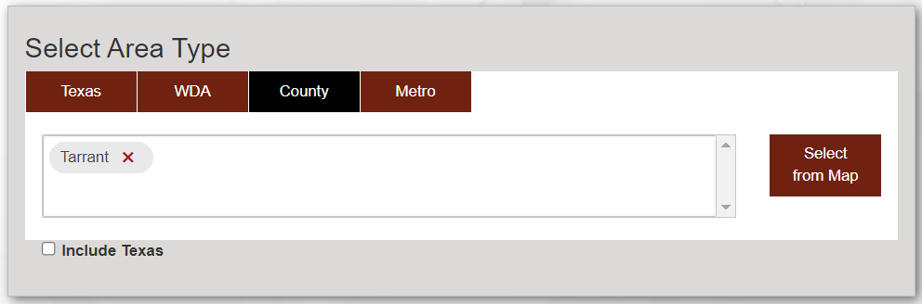

Step 2: Under Select Time Period, select year(s) and quarters from the dropdown menus.
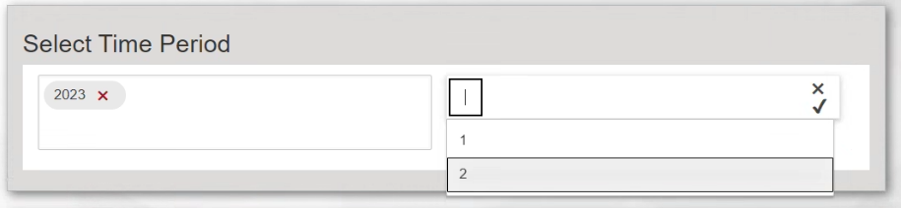

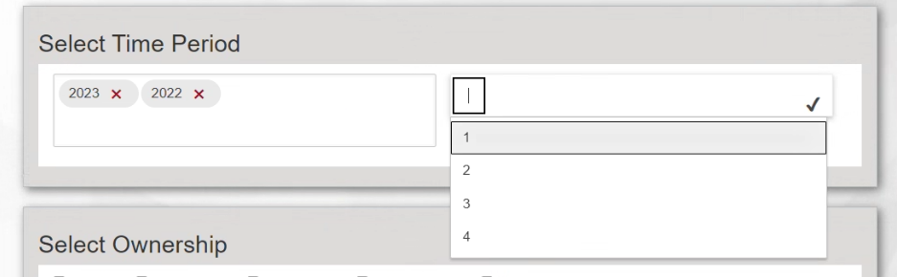

If there are not four consecutive quarters in County, go back to Step 1 and select WDA as Area Type. If there are not four consecutive quarters in WDA, then Texas must be selected as Area Type.
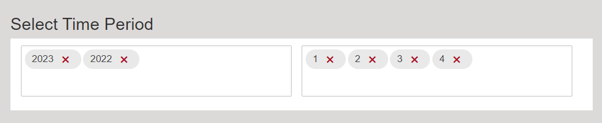

Step 3: Under Select Ownership, select Total.
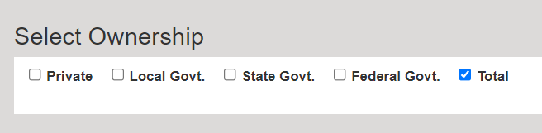

Step 4: Select Get Industries.

Step 5: Under Select Industries, enter the 6-digit project NAICS code. If the 6-digit code does not exist,
enter the 5-digit code. If the 5-digit code does not exist, enter the 4-digit code. Mark your selection
and select Get Report.
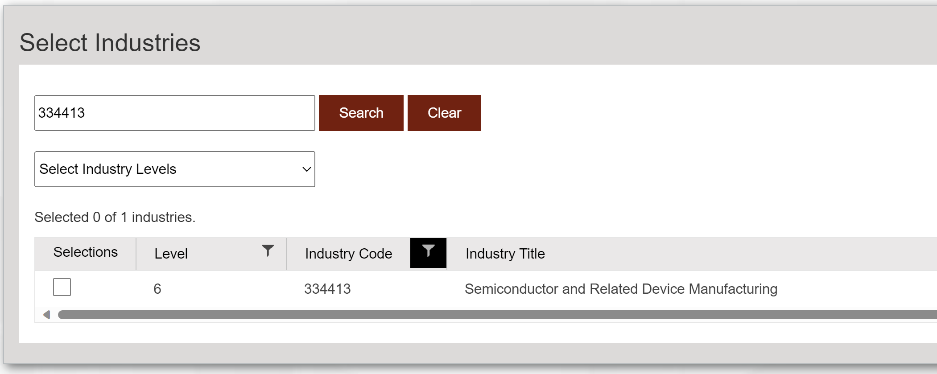

Step 6: Use Average Weekly Wage for the four most recent consecutive quarters.
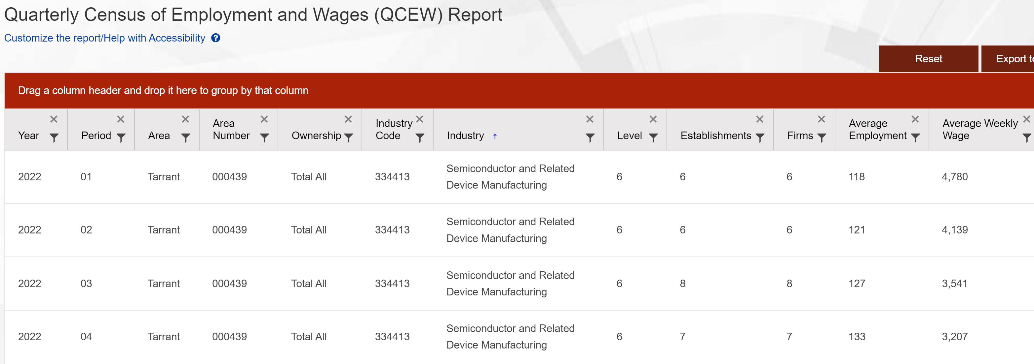

Step 7: Calculate the average annual wage from the 4 quarters of weekly wages. Calculate 110%
of the average annual wage.

