Proposal Title: Statewide status, phenology, and habitat use of bats with particular focus on Perimyotis subflavus and Myotis velifer

Responding University Name:
Texas State University

Responding University Address:
Texas State University
601 University Dr.
San Marcos, TX 78666

PI:
Sarah Fritts, Ph.D.
Associate Professor
Department of Biology
Texas State University
512-245-3814
fritts.sarah@txstate.edu

Co-PI
Donal Solick
Vesper Bats Detection Service, LLC

Report Prepared By:
Sarah Fritts
Madison Nadler
Cerise Mensah
Carly Naundorff

Contents
Background 4
Purpose 5
Objectives: 5
Task 1A: Bat Acoustic Monitoring: Methods 6
Task 1B: Vetting of bat acoustic calls: Methods 8
Task 1B–D: Analyses: Methods 13
Influence of temperature and landcover on bat activity methods 13
Mixed effects linear regression: habitat and temperature associations 13
Phenology, migration and hibernation ecology methods 13
Dynamic occupancy: Phenology, migration, and hibernation ecology 14
Linear regression: Phenology, migration, and hibernation ecology 15
Faceted maps: Phenology, migration, and hibernation ecology 15
Community Analysis Methods 15
Broad Results 16
Fall 17
Winter 23
Task 1B: Perimyotis subflavus 28
PESU Introduction 28
PESU Fall Results 29
General 29
PESU Grid Level Activity: habitat and weather associations 31
PESU Winter Results 35
PESU Grid–level Daily Activity: habitat and weather associations 36
PESU Hibernation Ecology/Phenology 42
PESU Summary of Results/Discussion 48
Task 1B: Myotis velifer 51
MYVE Introduction 51
MYVE Fall Results 52
General 52
MYVE Grid Level Activity: habitat and weather associations 53
MYVE Winter Results 58
General 58
MYVE Grid–level Daily Activity: habitat and weather associations 59
MYVE Hibernation Ecology/Phenology 64
MYVE Summary of Results/Discussion 70
Task 1C: Lasiurus spp. (Lasiurus cinereus and Red bats) 71
Lasiurus Introduction 71
LACI Fall Results 73
LACI Winter Results 77
LACI Migration and Hibernation Ecology 82
Red Bats Fall Results 91
Red Bats Winter Results 96
Red Bats Migration and Hibernation Ecology 103
Lasiurus Summary of Results/Discussion 110
Task 1D: Community Ecology of Texas Bats 111
Community Analysis Introduction 111
Community Analysis Results 113
Fall 113
Winter 117
Task 2: Data uploads 120
Deliverables 121
Publications and Theses 121
Presentations as of May 2025 121
Literature Cited 122

Background
Due to the unprecedented risks that Texas bats face, including white-nose syndrome (WNS), wind energy development, and climate change, coupled with the vast knowledge gaps regarding bat species, there is an urgent need to assess and predict distributions, population fluctuations, phenology, habitat associations, community dynamics, hibernation ecology, and seasonal movement/migration. Bats in Texas are critical to natural and agricultural ecosystem functions and tourism, yet are rapidly diminishing in the state and country due to WNS and wind energy. Texas is at the epicenter of bats and their threats, hosting more species than any other state, the largest populations in the world, and a species recommended by the US Fish and Wildlife Service to be listed as Endangered in September 2022 (i.e., Perimyotis subflavus), while also being at the center of invasion of WNS, the site of a new species to contract WNS (i.e., Myotis velifer), and supplying the most wind energy in the U.S.
Decreasing bat populations could lead to severe socio-economic consequences for agriculture and renewable energy. It has been estimated Tadarida brasiliensis saves cotton (Gossypium spp.) farmers in an eight-county region of Texas $121,000 -1,750,000 annually, solely through their predation on corn earworms (Helicoverpa zea), which also decreases pesticide use thereby reducing overall ecological effects and human health impacts (Cleveland et al. 2006). A quarter of the nation’s wind energy is produced in Texas, which is causing high rates of bat fatalities, including P. subflavus (Whitby et al. 2022, Wiens et al. 2022). High fatalities, in turn, lead to reductions of wind energy generation through curtailment to protect listed bat species. However, blanket curtailment jeopardizes the local economies that wind energy supports and climate change mitigation strategies. For example, the listing of M. septentrionalis as threatened already has curtailed wind farms in Missouri, decreasing wind energy production. With the recommendation for P. subflavus to be listed as Endangered, these impacts will expand to the most productive wind farms in Texas.
Throughout Texas, WNS is currently known to affect seven species and wind energy causes fatalities of at least 16 species in the state, although data currently is sparse. Mitigation of threats from WNS and wind energy needs targeted approaches to minimize disruption to the Texas economy. In the U.S., WNS has killed millions of bats during winter hibernation whereas wind turbines have caused hundreds of thousands of fatalities during fall migration. Thus, we proposed to leverage an existing project focused on monitoring bats across Texas to examine the status of P. subflavus, M. velifer, and other species of greatest conservation need. We will fill knowledge gaps regarding distribution, phenology, habitat associations, community dynamics, hibernation ecology, and seasonal movement/migration of bats.
The proposed project will use bat acoustic data that already is, and in process of being, collected year-round across the entire state of Texas for 2.5 years. This project is low risk as we already have >100 TB of data that is in need of processing so that we can identify bat calls to species to be used in analyses. Although bat acoustic software programs automatically identify calls to species, there are many discrepancies among programs, leading to misidentifications. To make effective and efficient management strategies, particularly for listed species, calls require manual identification by an expert. We will use manually vetted species identification calls in a suite of occupancy models that focus on SGCN during the fall and winter, as this is when most bat fatalities are occurring due to WNS and wind energy. Results can then be used to guide science-based management actions including, but not limited to, WNS treatments and targeted wind-energy minimization strategies. These targeted approaches will save time and money for state agencies and landowners across Texas.
Pseudogymnascus destructans (Pd), a cutaneous fungal pathogen that causes WNS, is considered one of the most devastating infectious disease outbreaks to emerge over the last decade in wild mammals and has caused the decimation of numerous bat populations in North America (Hoyt et al. 2021). WNS was first observed in the U.S. during the winter of 2006–2007 and has since caused die-offs of several species of hibernating bats. Although the overall loss is difficult to enumerate, the U.S. Fish and Wildlife Service (USFWS) estimated over six million bats had died from WNS in the first 10 years after being detected in the winter of 2006–2007. Since the publication of that report, the numbers are no doubt greater. Significant declines in the abundance of many bat species have been demonstrated through summer bat surveys and hibernacula counts (Francl et al. 2012, Thogmartin et al. 2012, Cheng et al. 2021). NatureServe ranking criteria considers the potential impact as “extreme,” which will play a role in many states’ ranking and conservation prioritization methodologies (Cheng et al. 2021).
The first documentation of Pd in Texas was in 2017. The arrival of WNS to Texas is a new threat and its unknown implications for common Texas bat species spurred Texas Parks and Wildlife Department (TPWD) to implement a WNS Action Plan in February 2017. To understand the implications of P. destructans, the first goal of TPWD’s action plan is to determine the pre-WNS exposure population parameters of Texas bats using acoustic monitoring implementing the North American Bat Monitoring (NABat) protocol. Researchers have vast knowledge gaps regarding bat distributions, and there has been a recognized need to monitor North American bats for many years (O’Shea et. al 2003), but no coordinated program existed to monitor most bat species until the NABat program was established. Based on Loeb et al. (2015), the purpose of NABat is to create a continent-wide program to monitor bats at local to range-wide scales that will provide reliable data to promote effective conservation decision making and the long-term viability of bat populations across the continent.

Purpose
Herein, we provide the Texas Comptroller with in-depth information on bat species distribution and activity across Texas during Fall and Winter seasons for three years.

Objectives:
Task 1: Agency will monitor bats across Texas to examine the status of the tricolored bat, cave myotis, and other species of greatest conservation need.
A. Agency will manually identify bat echolocation calls recorded during high-risk time periods for white nose syndrome and wind energy fatalities.
B. Agency will identify winter locations, activity, movement patterns, hibernation ecology, and habitat associations of white nose syndrome susceptible species including the tricolored bat and cave myotis.
C. Agency will assess movement patterns, community dynamics, and habitat associations of tree-roosting species that interact with wind turbines.
D. Agency will perform statistical analyses to assess and predict distribution, phenology, habitat associations, community dynamics, hibernation ecology, and seasonal movement/migration of Texas bats.

Task 2: Agency will upload all data and results from this Contract to a database maintained by the North American Bat Monitoring Project (NABat).

Task 1A: Bat Acoustic Monitoring: Methods
We deployed 97 acoustic monitors across the state (Fig. 1) all within the top 200 priority grid cells as designated by the North American Bat Monitoring Program (NABat, Loeb et al. 2015). We collected year-round data for 3 years to determine baseline distribution and activity for acoustically detectible bat species following the NABat protocol (Loeb et al. 2015). We used a suite of occupancy, regression, and circular statistics to assess and predict the distribution and activity of WNS priority bat species tricolored bats (PESU, Perimyotis subflavus) and cave myotis (MYVE, Myotis velifer) and wind energy affected species red bats (red bats, Lasiurus spp.), and hoary bats (LACI, Laiurus cinereus). We assessed both local and landscape habitat characteristics of survey sites across Texas as well as meta-community structure of detected species. We determined diel and seasonal activity patterns and niche partitioning of target species and examine temporal niche overlap and potential predictors of activity including landcover and weather. We compared community composition and activity within season and across districts (i.e., Texas Parks and Wildlife Districts or “Ecoregions”; 1) Trans–Pecos, (2) High Plains/Panhandle, (3) Cross Timbers, (4) Hill Country, (5) Post Oak Savannah, (6) Pineywoods, (7) Oak Prairie, and (8) South Texas Plains).

Fig. 1. Locations of acoustic bat detectors across Texas. Note dots do not indicate exact locations/properties of data collection, and instead are fuzzed for landowner privacy.
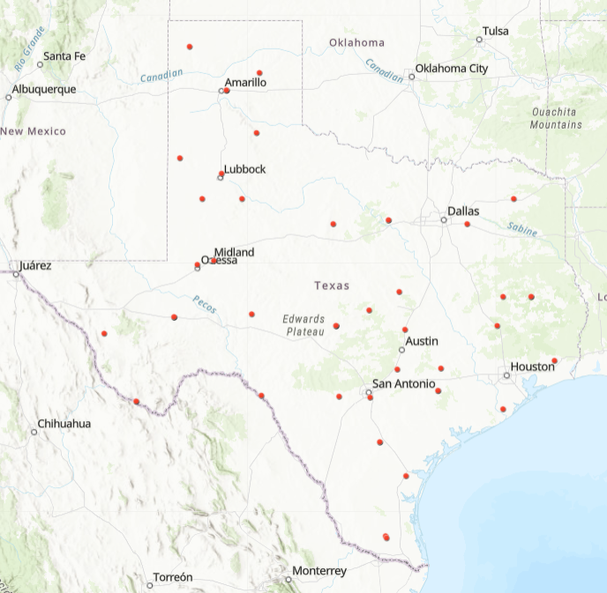

Bat acoustic monitoring
From Fall 2020 to Summer 2023, we recorded bat echolocation calls at 49 grid cell sites across Texas. We selected a 4-day period in each season of the three years (i.e., four seasons per year) to conduct these analyses. In the project’s first year, we deployed two Wildlife Acoustics Song Meter 4 BAT-FS passive acoustic monitors within each survey grid cell in the fall and spring. One monitor was placed in two of four 5 km x 5 km quadrants that constitute a grid cell (Loeb et al. 2015). Microphones were placed approximately 3.5 meters above the ground in areas considered appropriate for high bat activity. Private property was somewhat restrictive, so certain monitor locations may have been less suitable. We followed the recommendations from Loeb et al. (2015) for the location of stationary monitoring sites and microphone deployment, considering clutter, microphone height and microphone orientation. The SM4 BAT-FS was set to record in a two-second trigger window with a maximum file length of 15 seconds.
We used typical hibernating insectivorous bat phenology to define seasons. Summer was juvenile pre-volancy (March 16 - June 15) with Fall (June 16 - September 15), Winter (September 16 - December 15), and Spring (December 16 - March 15) categorized accordingly. Challenges that attributed to data loss or gaps included detectors losing power, detectors knocked over by livestock or wildlife, and unresponsive landowners. Due to this, we selected the 4-day period as a time period with maximum detector coverage. If data was missing from the predetermined 4-day period, we analyzed available data before or after that period within the same season.

Task 1B: Vetting of bat acoustic calls: Methods

Manual and automatic identification of bat echolocation calls
We attributed and scrubbed.wav files in Sonobat and then sent files to Vesper Bat Echolocation Specialists, LLC for manual vetting. It is recommended that a bat echolocation specialist trained in manual identification vet bat calls due to margins of error in the program (Solick et al. 2024). Vesper Bats manually vetted echolocation calls using a voucher approach, whereby data from each detector was examined for each bat species that occurs in Texas for each of the four days. Once the species was detected at that site on that day, the vetters moved to the next species. This resulted in a matrix of each bat species either detected or not detected at each detector per day. We then pooled data over the two detectors for each grid cell for analyses.
We automatically vetted all data over each 4-day period using Sonobat to estimate activity of each species. The manually-vetted data was cross-referenced with the autoclassified calls and we removed identifications of species that were not manually vetted at each site. Thus, if a call was autoclassified as a MYVE in Sonobat, but was not manually-vetted at that site in any of the seasons, we removed that call from all analyses. All species were assigned a species code (Table 1).

Table 1. Species codes for species identified acoustically in Texas.
Code | Scientific Name | Common Name
40K Myotis | 40 kHz myotis species
ANPA | Antrozous pallidus | Pallid bat
CORA | Corynorhinus rafinesquii | Rafinesque's big eared bat
COTO | Corynorhinus townsendii | Townsend's big eared bat
EPFU | Eptesicus fuscus | Big brown bat
EUPE | Eumops perotis | Western mastiff bat
HiF | Hi frequency bat of unknown species
LABL | Lasiurus blossevillii | Western red bat
LABO | Lasiurus borealis | Eastern red bat
LACI | Lasiurus cinereus | Hoary bat
LAEG | Lasiurus ega | Southern yellow bat
LAIN | Lasiurus intermedius | Northern yellow bat
LANO | Lasionycteris noctivagans | Silver-haired bat
LAXA | Lasiurus xanthinus | Western yellow bat
LESP | Leptonycteris
LoF | low frequency bat of unknown species
MOME | Mormoops megalophylla | Ghost-faced bat
MYAU | Myotis austroriparius | Southeastern myotis
MYCA | Myotis californicus | California myotis
MYCI | Myotis ciliolabrum | Western small-footed myotis
MYEV | Myotis evotis | Western small-footed bat
MYLU | Myotis lucifugus | Little brown bat
MYTH | Myotis thysanodes | Fringed myotis
MYVE | Myotis velifer | Cave myotis
MYVO | Myotis volans | Long-legged myotis
MYYU | Myotis yumanensis | Yuma myotis
NYHU | Nycticeius humeralis | Evening bat
NYMA | Nyctinomops macrotis | Big free-tailed bat
NYSP | Nyctinomops
PAHE | Parastrellus hesperus | Canyon bat
PESU | Perimyotis subflavus | Tricolored bat
REDS | One of three species of red bats
TABR | Tadarida brasiliensis | Brazilian free-tailed bat
Yellows | One of the yellow bat species

Landcover data acquisition
We used the National Land Cover Database (NLCD) and ArcGIS Pro to create three buffers around each detector, one at each of 10-km, 25-km, and 50-km). We divided landcover data into eighth landcover classes (Forest (FOR), Grassland (GRA), Shrub (SHR), Urban (URB), Barren (BAR), Crop (CRO), Water (WAT), and Wetland (WET)) and averaged across each of the two detectors per grid cell. All data are represented in ha within the corresponding buffer size, which will be used as covariates in subsequent analyses. For example, FOR10 is forest landcover at the 10-km scale and GRA50 is grassland landcover at the 50-km scale.

Weather data acquisition
We compiled weather data at two scales. First, we were interested in daily weather averages to assess activity and occupancy probability of bats across Texas and acquired daily weather data from the National Oceanic and Atmospheric Administration to use in models. The activity analyses. From the database, we retrieved maximum daily temperature (Tmax) and minimum daily temperature (Tmin) and we then subtracted to use the difference in Tmax and Tmin as Tdiff.

Periods
We divided data into several 4-day periods per season to use in analyses that assessed trends in activity (Tables 2 and 3).

Table 2. Period designations during fall seasons. Note that exact days depended on year.
Period | Date | Period | Date
P1 | 09/02 | P4 | 10/20
 | 09/03 |  | 10/21
 | 09/04 |  | 10/22
 | 09/05 |  | 10/23
 | 09/06 |  | 10/24
P2 | 09/20 |  | 10/25
 | 09/21 |  | 10/26
 | 09/22 |  | 10/27
 | 09/23 |  | 10/28
 | 09/24 | P5 | 11/01
 | 09/25 |  | 11/02
 | 09/28 |  | 11/03
 | 09/29 |  | 11/04
 | 09/30 |  | 11/05
 | 10/01 |  | 11/06
P3 | 10/11 |  | 11/07
 | 10/12 |  | 11/10
 | 10/13 |  | 11/11
 | 10/14 |  | 11/12
 | 10/15 |  | 11/13
 | 10/16 | P6 | 11/14
 | 10/17 |  | 11/15
 | 10/18 |  | 11/16
 | 10/19 |  | 11/17
 |  |  | 11/18
 |  |  | 11/19
 |  |  | 11/20
 |  |  | 11/23
 |  |  | 11/24
 |  |  | 11/25
 |  |  | 11/26

Table 3. Period designations during winter. Note that exact days depended on year.
Period | Date | Period | Date
P1 | 12/04 | P5 | 02/01
 | 12/05 |  | 02/02
 | 12/06 |  | 02/03
 | 12/07 |  | 02/04
 | 12/08 |  | 02/05
 | 12/09 |  | 02/06
 | 12/10 |  | 02/07
 | 12/11 |  | 02/08
 | 12/12 | P6 | 02/15
 | 12/13 |  | 02/16
 | 12/14 |  | 02/17
P2 | 12/23 |  | 02/18
 | 12/24 |  | 02/19
 | 12/25 |  | 02/20
 | 12/26 |  | 02/21
 | 12/27 |  | 02/22
 | 12/28 | P7 | 03/10
 | 12/29 |  | 03/11
 | 12/30 |  | 03/12
 | 12/31 |  | 03/13
P3 | 01/04 |  | 03/14
 | 01/05 |  | 03/15
 | 01/06 |  | 03/16
 | 01/07 |  | 03/17
 | 01/08 | P8 | 03/22
 | 01/09 |  | 03/23
 | 01/10 |  | 03/24
 | 01/12 |  | 03/25
P4 | 01/14 |  | 03/26
 | 01/15 |  | 03/27
 | 01/16 |  | 03/28
 | 01/17
 | 01/18
 | 01/19
 | 01/20
 | 01/21
 | 01/22
 | 01/23

Task 1B–D: Analyses: Methods

Influence of temperature and landcover on bat activity methods

Mixed effects linear regression: habitat and temperature associations
The goal of this analysis goal was to assess landcover data influence at multiple scales (10 km, 25 km, and 50 km) and temperature on daily activity of each species of concern (PESU, MYVE, Reds, and LACI) and compare to Julian date, distribution data (latitude, longitude, and elevation), period (the 4-day period during the season), and the null model. We used manually-vetted and automatically classified calls to conduct this analysis. We pooled activity and averaged the weather variables by day. We then used linear mixed effects models with the count of bat calls as the response variable and a suite of categorical factors and continuous fixed variables and grid cell as a random effect (Table 4). We used day-specific weather data, so data was not pooled over season. We used package ‘glmmTMB’ in R. We used the model with the lowest AIC resulting from the stepwise regression as the best model.
Table 4. Candidate models used in species-specific regression models.
Model | Covariates
Temperature | Tmax | Tmin | Tdiff
LAND10 | FOR10 | CRO10 | BAR10 | URB10
LAND25 | FOR25 | SHR25 | WET25 | CRO25 | BAR25 | URB25
FOR50 | FOR50 | BAR50 | WET50 | GRA50 | URB50
Period | Period
DOY | Day of Year (Julian Datae
Distribution | Latitude | Longitude | Elevation
Effort | # of detectors (1 or 2)
Null

Phenology, migration and hibernation ecology methods
We attempted to use dynamic occupancy models to assess hibernation and migration ecology; however, the data distributions were not sufficient so we used linear regression models instead. Additionally, we used the maps created for each species to assess potential movement/migration.

Dynamic occupancy: Phenology, migration, and hibernation ecology
We explored dynamic occupancy models using the unmarked R package to evaluate and assess winter and fall site occupancy, colonization, and extinction dynamics for PESU, MYVE, LACI, LANO, and Reds across each season year. Each season included six to eight 4-day primary periods, with two periods per month (e.g., September through March). We created vectors for the response variable (acoustic pass counts for each species), site-level covariates (e.g., landcover at three scales), and observation-level covariates (e.g., temperature). We incorporated these in an unmarkedMultFrame() object specifying the multiple primary periods and then scaled all covariates.
A null model was fit for each species and season that included ~1 for all parameters: initial occupancy probability (psi), colonization probability (gamma), extinction probability (epsilon), and detection probability (p). Following the null model, we then created a detection-only model to determine which observation-level covariate best predicts the probability of detecting a species given it is present at that site. We did this by creating three models where all parameters besides p were ~1, while each separate model had either Tmin, Tmax, or Tdiff for detection probability (Table 5). We then compared AIC values and determined Tmax was the best observation-level covariate for detection probability.

Table 5. Covariate table for species-specific dynamic occupancy modelling.
Obs. level | Weather | Tmin | Tmax | Tdiff
 | Land10 | FOR10 | SHR10 | GRA10 | WET10 | CRO10 | BAR10 | URB10
Site level | Land25 | FOR25 | SHR25 | GRA25 | WET25 | CRO25 | BAR25 | URB25
 | Land50 | FOR50 | SHR50 | GRA50 | WET50 | CRO50 | BAR50 | URB50

For each subsequent model, covariates significant on detection were included as the detection probability parameter, whereas site-level covariates were tested independently within the initial occupancy, colonization, or extinction parameters. The unfilled parameters (initial occupancy and/or colonization and/or extinction) were ~1 to isolate the effects of each site-level covariate.

Although we attempted these analyses for each species, statistical outputs continuously showed very small beta estimates, indicating little to no significance of site-level predictors. Additionally, inflated standard errors indicated that the models may not have enough data, or there may be too few detections or sites with few detections, to confidently estimate the parameters precisely.

Given this, we decided that dynamic occupancy models were not the most suitable for our dataset, except for MYVE during fall seasons. Instead, we proceeded with generalized linear models (GLMs) using negative binomial distributions.

Linear regression: Phenology, migration, and hibernation ecology
We used GLMs with negative binomial distributions to assess the relationships between time in the season (using the 4-day period) and location in the state. We divided each grid cell into either north, south, east, west, or central, depending on location in Texas. We then conducted the linear regression with an interactive effect between period and location. We also plotted results of the interactive effects. We completed these analyses in the winter for hibernating species (when sample sizes allowed) and for both winter and fall for migratory species, as migratory is a two-way movement.

Faceted maps: Phenology, migration, and hibernation ecology
We created faceted and animated maps of activity by period for each season and year to further assess migration and hibernation ecology visually.

Community Analysis Methods
We grouped several species into categories due to the inability to consistently determine species by echolocation signature. Specifically, we combined Lasiurus borealis (LABO), Lasiurus seminolus (LASE), and Lasiurus blossevillii (LABL) into one category of “red bats;” Lasiurus ega (LAEG), Lasiurus xanthinus (LAXA), and Lasiurus intermedius (LAIN) as “yellow bats;” and all Myotis spp. (except Myotis velifer (MYVE)) as “Myotis.” Although researchers previously thought that location separated eastern and western red bats, recent genetic evidence identified LABL in central Texas where researchers had previously identified only LABO (Guest et al. in review). Several Myotis were identified to species with automatic classification, however, many files were autoclassified only as 40k Myotis or were misclassified. In this section, Winter 2021 refers to Winter 2020/2021, Winter 2022 refers to Winter 2021/2022, and Winter 2023 refers to Winter 2022/2023. Periods represent each of the 4-day periods per season where calls were analyzed (n_{falls}=6, n_{winters}=8).
Community Comparisons
We assessed differences in species community composition among years, Ecoregion, and Periods separately for falls and winters in RStudio (R Development Core Team 2014) using a permutational multivariate analysis of variance (PERMANOVA) from the ‘vegan’ package (Oksanen et al. 2022) and visualized on non-metric multidimensional scaling (nMDS) plots using ‘ggplot2’ and 999 permutations (Wickham 2016). We used a fourth-root transformation of the Bray-Curtis similarity matrix to more equally weight less common species. We also conducted a permutational multivariate analysis of dispersion (PERMDISP) to determine if differences in the PERMANOVA analysis were due to differences in dispersion. We then conducted pairwise post-hoc analyses for significant PERMANOVA factors using the pairwise.adonis2 function created by Martinez (2020) with a bonferroni correction. In the nMDS plot, overlapping ellipses have the same bat communities; non-overlapping ellipses have different bat communities; overlapping ellipses among Ecoregions with different dispersions may or may not have the same bat communities because differences in dispersion could be masking differences or similarities between bat communities. Lastly, we conducted similarity percentage (SIMPER) analyses to determine which species were driving the observed differences in bat communities among factor levels that were statistically significant in the PERMANOVA. Lastly, we compared Shannon diversity indices among years, Ecoregions, and Periods separately for falls and winters using the ‘vegan’ package.

Broad Results
From Fall 2020–Summer 2023, we detected 244,891 echolocation calls that could be classified to species or taxonomic group. Bats were detected in every grid cell, depending on species (Table 6). Result tables of species by grid cell as well as species by Ecoregion/TPWD District and county are in the Supplemental Excel file. Note that not all results are listed in the species by grid cell due to landowner permissions. We divided data into the six to eight primary periods (two during each month) to visualize results by species. We pooled the winter data by period due to lower activity than fall seasons.
Table 6. Number and percentage of grid cells that each species was detected in over the 3-year project.
Species | Count of Grid Cells | Percentage of Grid Cells
ANPA | 14 | 29.17%
CORA | 5 | 10.42%
COTO | 9 | 18.75%
EPFU | 22 | 45.83%
EUPE | 3 | 6.25%
LACI | 48 | 100%
LANO | 33 | 68.75%
MACA | 1 | 2.08%
MOME | 8 | 16.67%
MYAR | 2 | 4.17%
MYAU | 10 | 20.83%
MYCA | 6 | 12.50%
MYCI | 6 | 12.50%
MYTH | 3 | 6.25%
MYVE | 28 | 58.33%
MYVO | 2 | 4.17%
MYYU | 6 | 12.50%
NYHU | 35 | 72.92%
NYMA | 10 | 20.83%
NYSP | 2 | 4.17%
PAHE | 11 | 22.92%
PESU | 40 | 83.33%
REDS | 43 | 89.58%
TABR | 48 | 100%
Yellows | 26 | 54.17%

Fall
In Fall 2020, we detected 218,056 bat calls, mostly comprised of TABR. In Fall 2021, we detected 184,105 bat calls used for analyses, also with the majority (121,490) being TABR. District 4 had the greatest number of calls, which is not surprising given the dense populations of TABR in central Texas. In Fall 2022, we detected less bat calls (45,073), but still with the majority as TABR.

Regression results are listed by species below.

Dynamic occupancy outputs for all species except MYVE had issues with convergence indicating incorrect data structure and low sample sizes and/or showed very small beta estimates, indicating little to no significance of site-level predictors. Additionally, inflated standard errors indicated that the models may not have enough data, or there may be too few detections or sites with few detections, to confidently estimate the parameters precisely. Given this, we decided that dynamic occupancy models were not the most suitable for the fall dataset for species other than MYVE.

Most activity detected was by TABR in all seasons, years, and period (Figs. 2-7).

Fig. 2. Fall 2020 activity by species. Most activity was comprised of TABR.
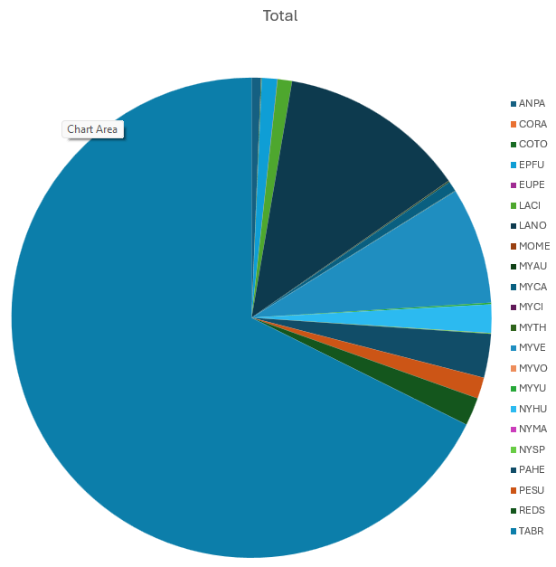

Fig. 3. Fall 2020 activity by species and period (P).
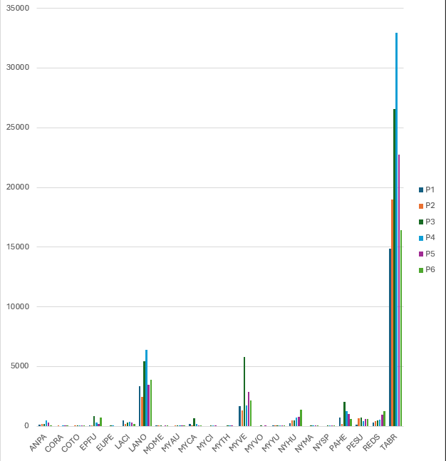

Fig. 4. Fall 2021 activity by species. Most activity was comprised of TABR.
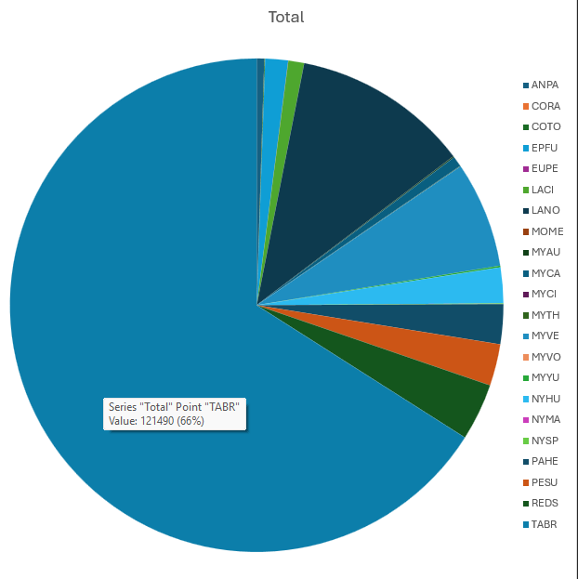

Fig. 5. Fall 2021 activity by species and period (P).
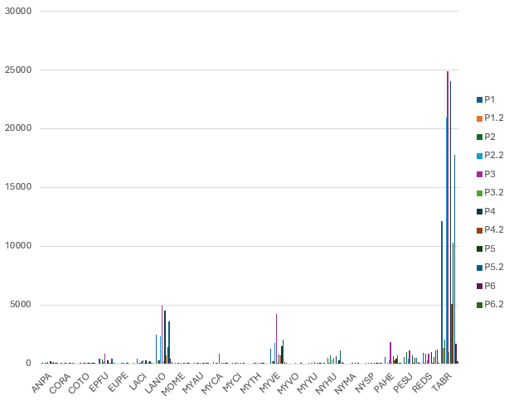

Fig. 6. Fall 2022 activity by species and period (P).
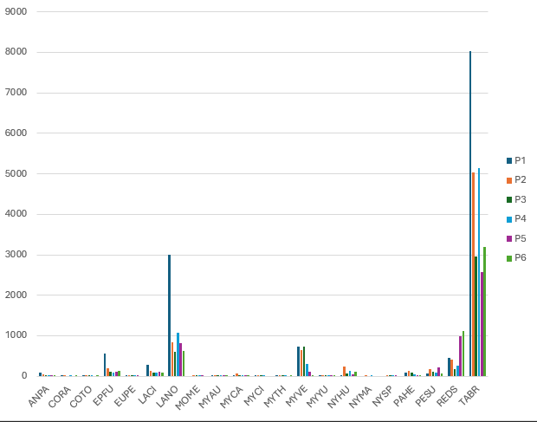

Fig. 7. Fall 2022 activity by species. Most activity was comprised of TABR.
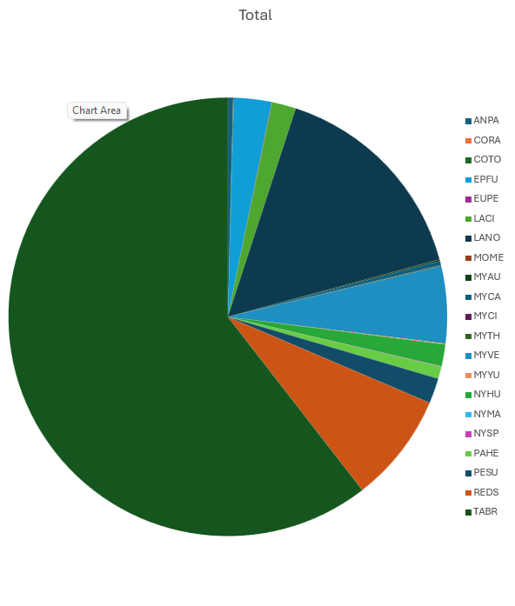

Winter
During winter, a total of 356,878 bat calls were recorded for analysis. There were 131,914 bat calls during winter 2020/2021; 77,662 bat calls during winter 2021/2022; and 147,301 bat calls during winter 2022/2023. TABR contributed the majority of calls, mostly in District 8.

Regression results are listed by species below.

Dynamic occupancy outputs showed very small beta estimates, indicating little to no significance of site-level predictors. Additionally, inflated standard errors indicated that the models may not have enough data, or there may be too few detections or sites with few detections, to confidently estimate the parameters precisely.

Given this, we decided that dynamic occupancy models were not the most suitable for our winter dataset. Instead, we used generalized linear mixed models (GLMMs) using glmmTMB for negative binomial to model predicted bat activity in relation to landcover covariates with our over dispersed and zero-inflated data.

Similar to fall, during winter, most activity was comprised of TABR for the three years and multiple periods (Figs. 8-11).

Fig. 8. Winter activity by species.
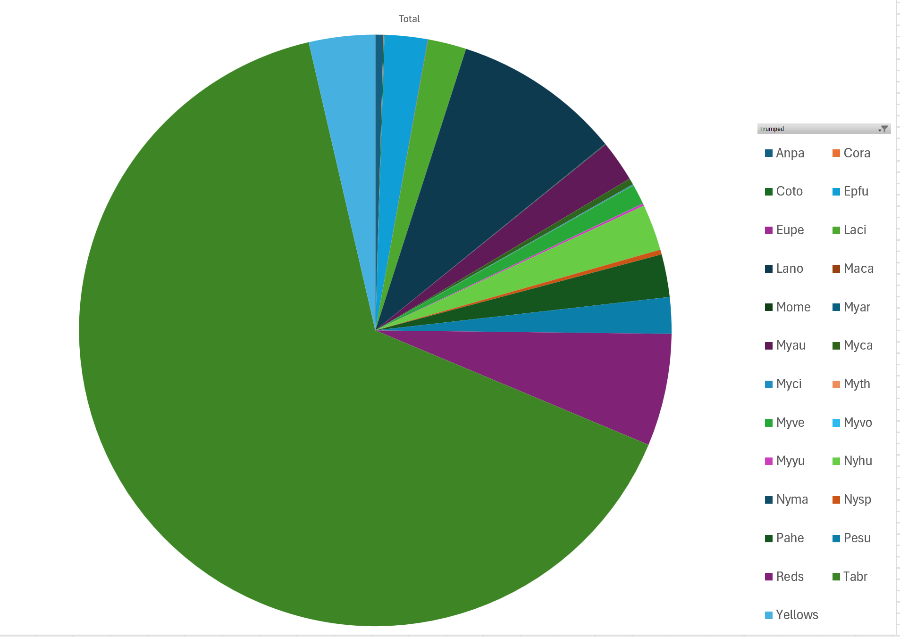

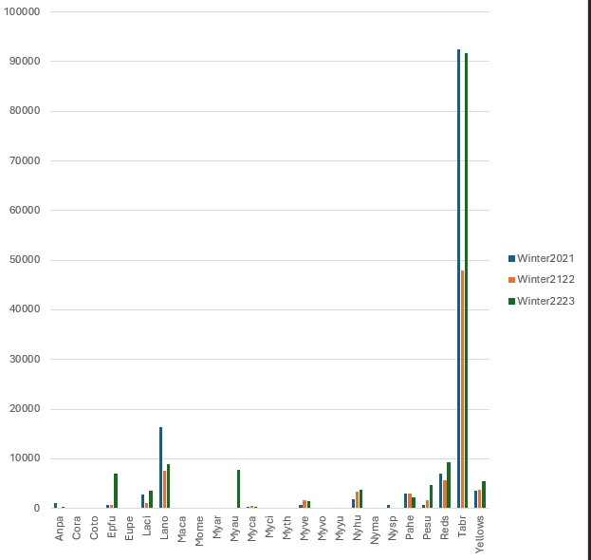
Fig. 9. Winter bat activity by species and season (Winter 2020/2021; 2021/2022; 2022/2023)

Fig. 10. Winter bat activity (2020-2023) by species and period
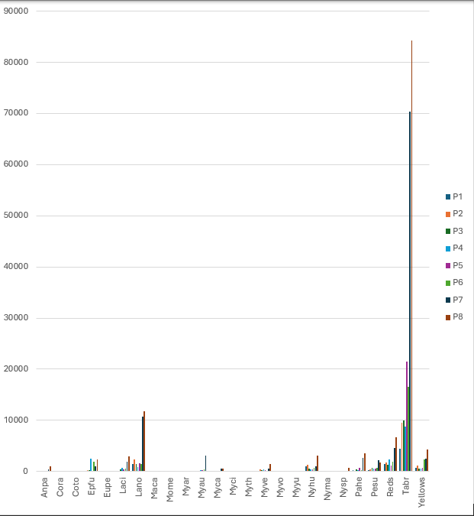

Fig. 11. Winter bat activity by species and district
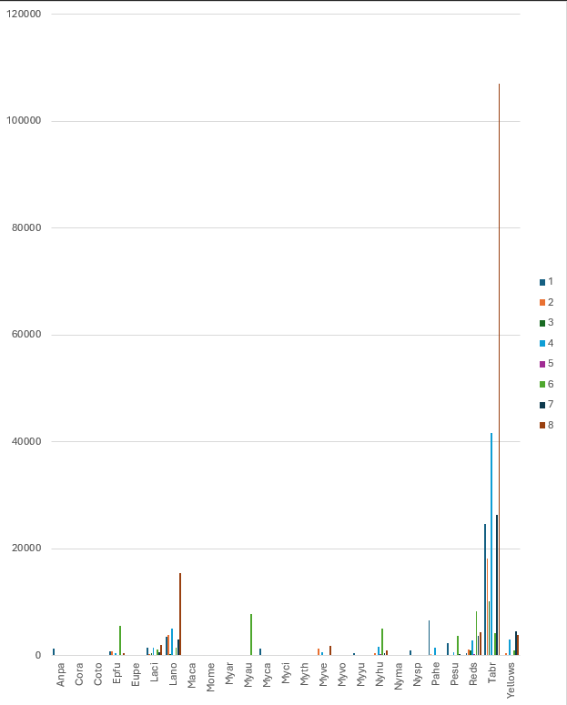

Task 1B: Perimyotis subflavus

PESU Introduction
Until recently, Perimyotis subflavus was one of the most common and widely distributed bat species in the United States (U.S.), with a range that extends from southern Canada into Central America and includes most of the eastern and midwestern U.S. However, dramatic population declines of this previously common species have been documented across the species’ range since white-nose syndrome (WNS) was discovered in the U.S. in 2007. In fact, 90-100% declines in winter colony abundance have been observed at sites impacted by the disease (Cheng et al. 2021) (Vanderwolf and McAlpine 2021). Potential contributing factors in PESU’ susceptibility include low body mass and longer hibernation time relative to some other bat species, contributing to starvation (Haase et al. 2021), and skin microbiome properties increasing vulnerability (Vanderwolf et al. 2021). In response to population declines across much of the species’ range, the USFWS has recommended endangered status for PESU (Federal Registrar 2022), and the listing is expected in 2024. Therefore, PESU is a species of interest for conservation and management.
Texas is home to the largest bat populations in the world, has the greatest bat species richness of any state in the U.S., and is at the epicenter of WNS spread (Ammerman et al. 2012). Within Texas, PESU was first confirmed with WNS in winter 2024 (TPWD 2024) although Pseudogymnascus destructans (Pd), the fungus that causes WNS, was detected in Texas in hibernating PESU in 2017. The arrival of Pd to Texas spurred Texas Parks and Wildlife Department (TPWD) to implement a WNS Action Plan in February 2017 (TPWD 2017). In March 2020, Myotis velifer, the only species until 2024 that had contracted WNS in Texas, had a die-off in central Texas due to WNS. Since then, taking action has become even more essential as many ecologically critical caves in Texas have become infected with Pd. Goals of the TPWD WNS Action Plan include determining the pre-WNS exposure population parameters of Texas bats using acoustic monitoring by implementing the North American Bat Monitoring (NABat) protocol (Loeb et al. 2015). This protocol is a multinational, multi-agency effort to conduct long-term standardized monitoring of bats (Loeb et al. 2015). The program aims to provide comprehensive guidelines to survey and monitor all 47 bat species that occur in the United States, Canada, and Mexico and is a direct response to the threat of WNS, created to determine the susceptibility differences between bat species to P. destructans and to determine which species are at most risk of extinction. In Texas, the NABat program was recommended so that the post-WNS detection goals of coordinating immediate responses to the disease, monitoring the spread and impact of WNS, preventing the spread of Pd into new areas, and administering WNS treatments can be completed (TPWD 2017). NABat monitoring is accomplished with four approaches: maternity colony counts, winter hibernaculum surveys, mobile acoustic surveys on transects, and stationary acoustic surveys (Loeb et al. 2015).
While spring and summer seasons are important for bat populations due to reproductive timing and availability of winter roots, baseline data on seasonal distributions and associated habitat use and activity patterns are crucial for management and conservation. For example, recent research suggests PESU may be more active during winter months in Texas than previously documented (Stevens 2024). Estimates of winter activity are important for conservation of WNS, as timing can be important for planning management activities such as inoculating individual bats or treating winter roosts. Seasonal distribution and activity data also are important for documenting population-level trends, such as range contractions, and can identify potential limiting factors for the population. This is increasingly important on privately-owned, working lands, where access to roosting locations and otherwise important habitat may be limited.

PESU Fall Results

General
We identified 7,886 calls as PESU over three Fall seasons at 35 grid cells (Table 2.1). Fall 2021 had the greatest number of calls and active grid cells, with Fall 2020 following and Fall 2022 with the least. Eastern Texas had the most PESU calls (Fig. 2.1).

Table 2.1. The number of PESU calls, grid cells, vetted calls, and calls/detector night for each year.
Estimate | Fall 2020 | Fall 2021 | Fall 2022
Number Active Cells | 42 | 43 | 38
Cells w/Manually Vetted Calls | 35 | 28 | 15
Call count | 3,090 | 4,055 | 741
Calls/detector Night | 128.7 | 168.9 | 30.9

Fig. 2.1. PESU locations during Fall seasons. Note dots do not indicate exact locations/properties of data collection, and instead are fuzzed for landowner privacy.
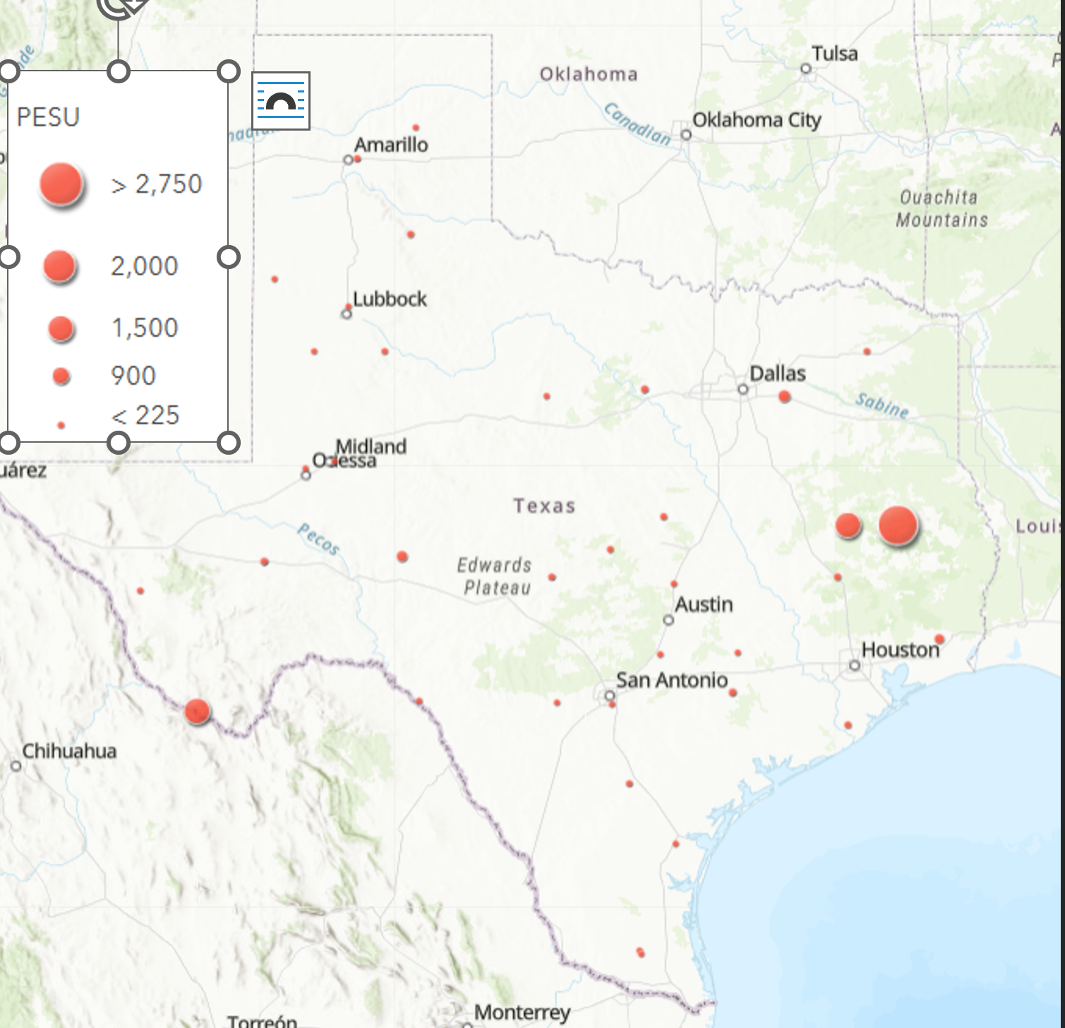

PESU Grid Level Activity: habitat and weather associations

Fall 2020
The maximum temperature °C model was the BIC top model and had ΔBIC = 0 and had 99% cumulative weight; however, maximum temperature was not a significant predictor of activity (Table 2.2). The 50-km Water model was the BIC top model for all landcover variables ΔBIC = 89. PESU activity increased with increasing temperature and increasing water (Table 2.2, Fig. 2.2).

Table 2.2. Model output for PESU grid-level activity in Fall 2020.
Modnames | K | BIC | Delta_BIC | ModelLik | BICWt | LL | Cum.Wt
Maximum Temperature°C | 5 | 1601.92 | 0 | 1.00E+00 | 9.99E-01 | -783.554 | 0.998
Temp_2020 | 7 | 1615.143 | 13.223 | 1.34E-03 | 1.34E-03 | -783.203 | 1
50km_Water | 4 | 1690.572 | 88.652 | 5.62E-20 | 5.61E-20 | -831.361 | 1
50km_Forest | 4 | 1694.197 | 92.277 | 9.17E-21 | 9.16E-21 | -833.174 | 1
25km_Forest | 4 | 1695.958 | 94.038 | 3.80E-21 | 3.80E-21 | -834.054 | 1

Term | Estimate | Std. Error | z value | P-value
(Intercept) | -1.429 | 0.781 | -1.828 | 0.068
Scale(TMAX) | -0.012 | 0.022 | -0.557 | 0.577

Term | Estimate | Std. Error | z value | P-value
(Intercept) | -0.321 | 0.252 | -1.271 | 0.204
Water50 | 1.054 | 0.182 | 5.791 | 0

Figure 2.2. PESU activity was significantly influenced by water at the 50-km level in Fall 2020.
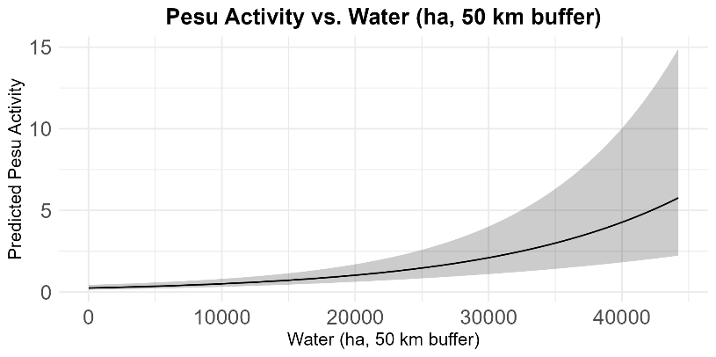

Fall 2021
The maximum temperature °C model was the BIC top model and had ΔBIC = 0 and had 99% cumulative weight; however, similar to Fall 2020, maximum temperature was not a significant predictor of activity (Table 2.3). The 50 km Water model was the BIC top model for all landcover variables ΔBIC = 276 (Table 2.3, Figure 2.3).

Table 2.3. Model output for PESU grid-level activity in Fall 2021.
Modnames | K | BIC | Delta_BIC | ModelLik | BICWt | LL | Cum.Wt
Maximum Temperature°C | 5 | 1781.31 | 0 | 1.00 | 9.99E-01 | -872.93 | 0.999
Temp_2021 | 7 | 1794.90 | 13.586 | 1.12E-03 | 1.12E-03 | -872.63 | 1
Minimum Temperature°C | 4 | 2024.89 | 243.580 | 1.28E-53 | 1.28E-53 | -998.26 | 1
50km_Water | 4 | 2057.46 | 276.147 | 1.08E-60 | 1.08E-60 | -1014.3 | 1
50km_Forest | 4 | 2060.23 | 278.920 | 2.71E-61 | 2.71E-61 | -1015.71 | 1

Term | Estimate | Std. Error | z value | P-value
(Intercept) | -1.414 | 0.931 | -1.518 | 0.129
Scale(TMAX) | -0.004 | 0.024 | -0.153 | 0.878
Term | Estimate | Std. Error | z value | P-value
(Intercept) | 0.216 | 0.287 | 0.75 | 0.453
Water50 | 0.782 | 0.203 | 3.849 | <0.01

Fig. 2.3. PESU activity was significantly influenced by water at the 50-km level in Fall 2021.
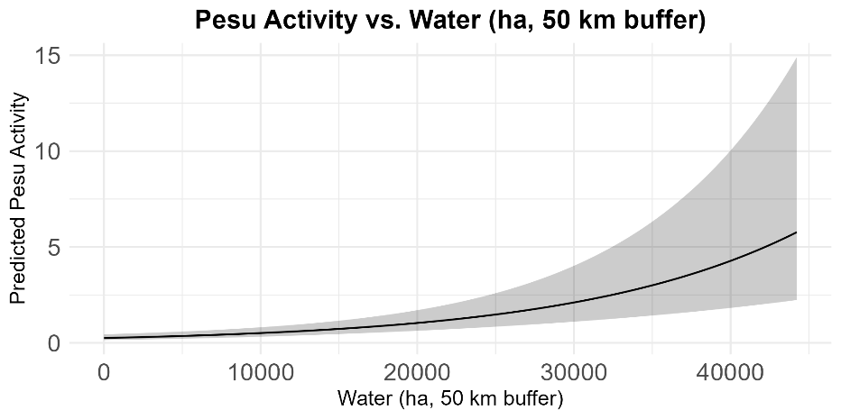

Fall 2022
The maximum temperature °C model was the BIC top model and had ΔBIC = 0 and had 99% cumulative weight; however, maximum temperature was no a significant predictor of activity (Table 2.4). The 10-km Forest model was the BIC top model for all landcover variables ΔBIC = 60, and PESU activity increased with increasing forest cover (Table 2.4, Fig. 2.4).
Table 2.4. Model output for PESU grid-level activity in Fall 2022.
Modnames | K | BIC | Delta_BIC | ModelLik | BICWt | LL | Cum.Wt
Maximum Temperature°C | 5 | 678.10 | 0 | 1.00E+00 | 9.92E-01 | -322.01 | 0.992
Temp_2022 | 7 | 687.86 | 9.756 | 7.61E-03 | 7.55E-03 | -320.081 | 1
10km_Forest | 4 | 738.08 | 59.971 | 9.49E-14 | 9.42E-14 | -355.408 | 1
25km_Forest | 4 | 738.70 | 60.600 | 6.93E-14 | 6.88E-14 | -355.723 | 1
50km_Forest | 4 | 741.01 | 62.911 | 2.18E-14 | 2.17E-14 | -356.878 | 1

Term | Estimate | Std. Error | z value | P-value
(Intercept) | -3.137 | 1.168 | -2.685 | 0.007
TMAX | -0.028 | 0.032 | -0.882 | 0.378
Term | Estimate | Std. Error | z value | P-value
(Intercept) | -1.858 | 0.525 | -3.538 | <0.01
Forest10 | 1.196 | 0.325 | 3.675 | <0.01

Fig. 2.4. PESU activity increased with increasing forest cover at the 10-km scale in Fall 2022.
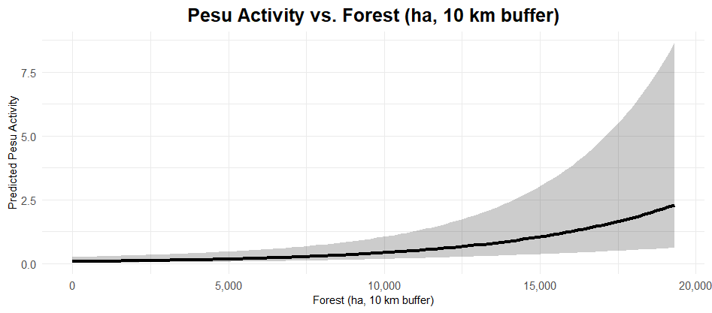

PESU Winter Results

General
We identified 7,103 acoustic passes of PESU across all years at 30 out of 48 grid cells. (Fig. 2.5). Of these, 768 (20 grid cells), 1,707 (16 grid cells), and 4,628 (22 grid cells) PESU acoustic passes were identified from winter 2020 – 2021, winter 2021 – 2022, and winter 2022 – 2023, respectively. For winter 2020 – 2021 and winter 2021 – 2022, the Pineywoods accounted for the greatest number of PESU acoustic passes across periods (with the exception of P5 in 2020 – 2021 where the Hill Country had a greater count); however, the Trans–Pecos accounted for the greatest number of PESU acoustic passes across periods (with the exception of P6 where Pineywoods had a greater count; Fig. 2.5).

Fig. 2.5. Locations of PESU during winter seasons. Note dots do not indicate exact properties of data collection, and instead are fuzzed for landowner privacy.
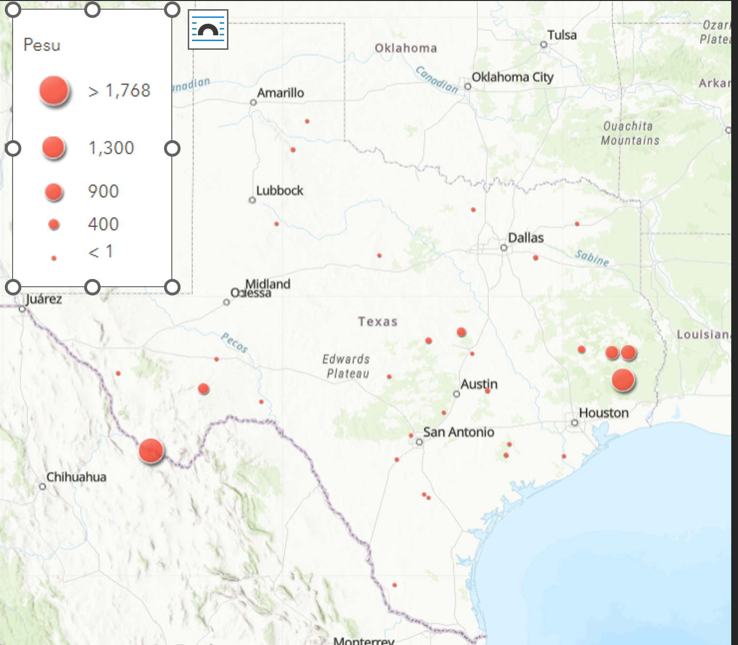

PESU Grid–level Daily Activity: habitat and weather associations

Winter 1: December 2020 – March 2021
The temperature model was the BIC top model and had ΔBIC = 65.95 above the second–best model and 100% of the cumulative weight. Only Tmin (β = 0.533, SE = 0.1747, z–value = 3.053, p–value = 0.002) significantly influenced activity (Table 2.5, Fig. 2.6). A comparison of only landcover models resulted in LAND50 being the most significant (Table 2.5), although this model had a BIC < the null model and no covariates were significant, indicating landcover was not particularly important for PESU winter activity in winter 1.

Table 2.5. Model comparison of PESU in winter 1. The model containing temperature was the BIC best model.
Model | K | BIC | Delta BIC | BICWt | Cum.Wt | LL
Temperature | 7 | 1086.0 | 0.00 | 1 | 1 | –513.56
CustomDOY | 5 | 1152.0 | 65.95 | 0 | 1 | –557.49
Period | 11 | 1155.9 | 69.87 | 0 | 1 | –537.25
Effort | 4 | 1179.7 | 93.73 | 0 | 1 | –575.08
Null | 3 | 1182.4 | 96.36 | 0 | 1 | –580.09
Distribution | 7 | 1195.2 | 109.16 | 0 | 1 | –571.70
Land50 | 11 | 1210.7 | 124.73 | 0 | 1 | –564.68
Land25 | 11 | 1222.5 | 136.49 | 0 | 1 | –570.56
Land10 | 11 | 1224.7 | 138.70 | 0 | 1 | –571.67

 | Estimate | Std. Error | z value | Pr(>|z|)
(Intercept) | –6.1020 | 0.8982 | –6.794 | 1.09e–11
s(Tmin)1 | 0.5333 | 0.1747 | 3.053 | 0.00227
s(Tmax)1 | –0.6641 | 1.4245 | –0.463 | 0.64339

Figure 2.6. Daily minimum temperature positively impacted PESU activity in winter 1.
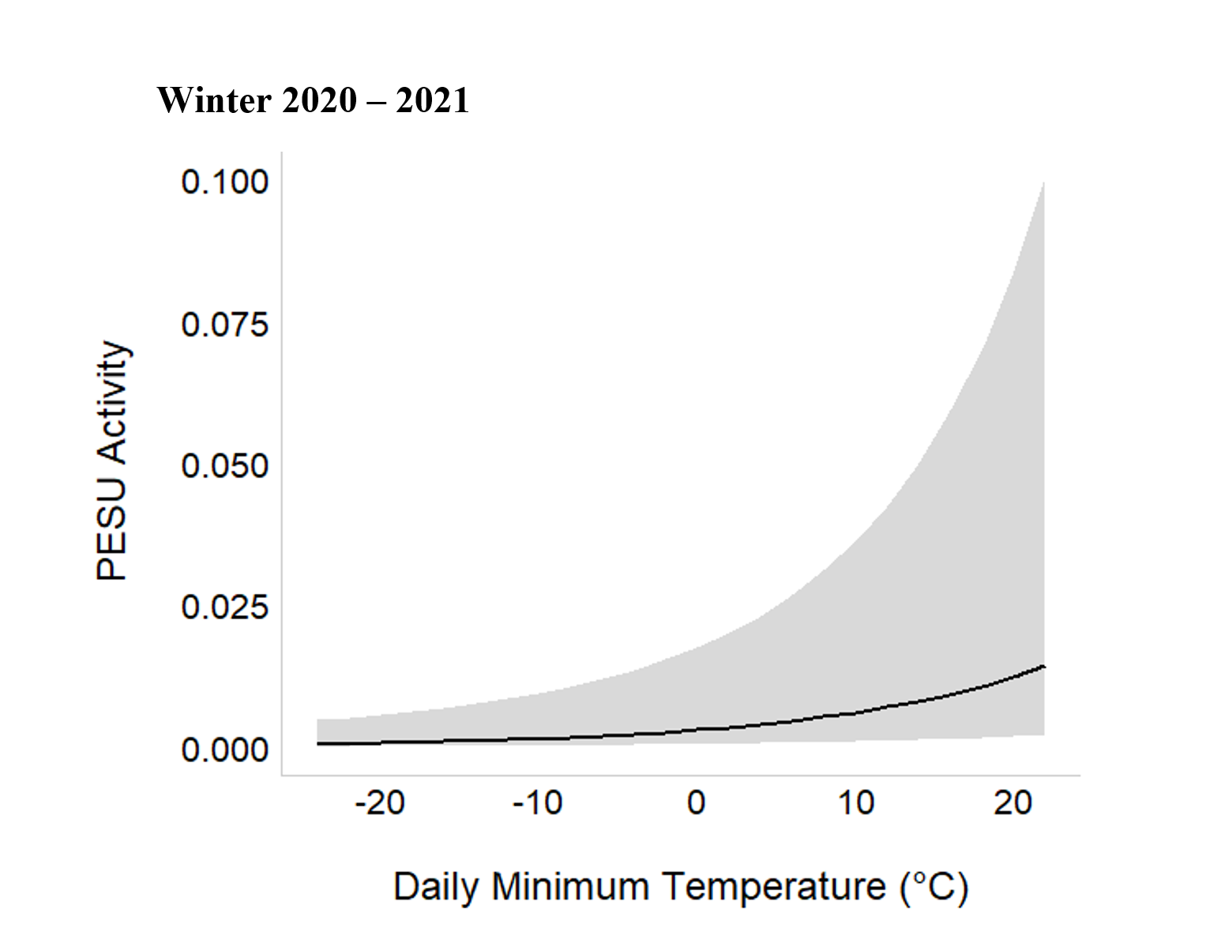

Winter 2: December 2021 – March 2022
The temperature model was the BIC top model and had ΔBIC = 51.12 above the second–best model and 100% of the cumulative weight. Only Tmax (β = 1.3769, SE = 0.2306, z–value = 5.970, p–value < 0.001) significantly influenced activity (Table 2.6, Fig. 2.7). A comparison of only landcover models resulted in LAND50 being the most significant (Table 2.6), although this model had a BIC < the null model and no covariates were significant, indicating landcover was not particularly important for PESU winter activity in winter 2.

Table 2.6. Model comparison of PESU in winter 2. The model containing temperature was the BIC best model.

Model | K | BIC | Delta BIC | BICWt | Cum.Wt | LL
Temperature | 7 | 1153.8 | 0.00 | 1 | 1 | –551.49
CustomDOY | 5 | 1205.0 | 51.12 | 0 | 1 | –584.14
Effort | 4 | 1205.5 | 51.69 | 0 | 1 | –588.09
Null | 3 | 1213.3 | 59.50 | 0 | 1 | –595.67
Period | 11 | 1217.3 | 63.49 | 0 | 1 | –568.30
Distribution | 7 | 1233.8 | 79.91 | 0 | 1 | –591.19
Land50 | 11 | 1240.5 | 86.70 | 0 | 1 | –579.91
Land25 | 11 | 1248.9 | 95.01 | 0 | 1 | –584.06
Land10 | 11 | 1254.9 | 101.01 | 0 | 1 | –587.06
 | Estimate | Std. Error | z value | Pr(>|z|)
(Intercept) | –7.6565 | 1.9879 | –3.852 | 0.00012
s(Tmin)1 | 0.1111 | 0.1729 | 0.643 | 0.52042
s(Tmax)1 | 1.3769 | 0.2306 | 5.970 | 2.38e–09

Figure 2.7. Daily minimum temperature positively impacted PESU activity in winter 2.
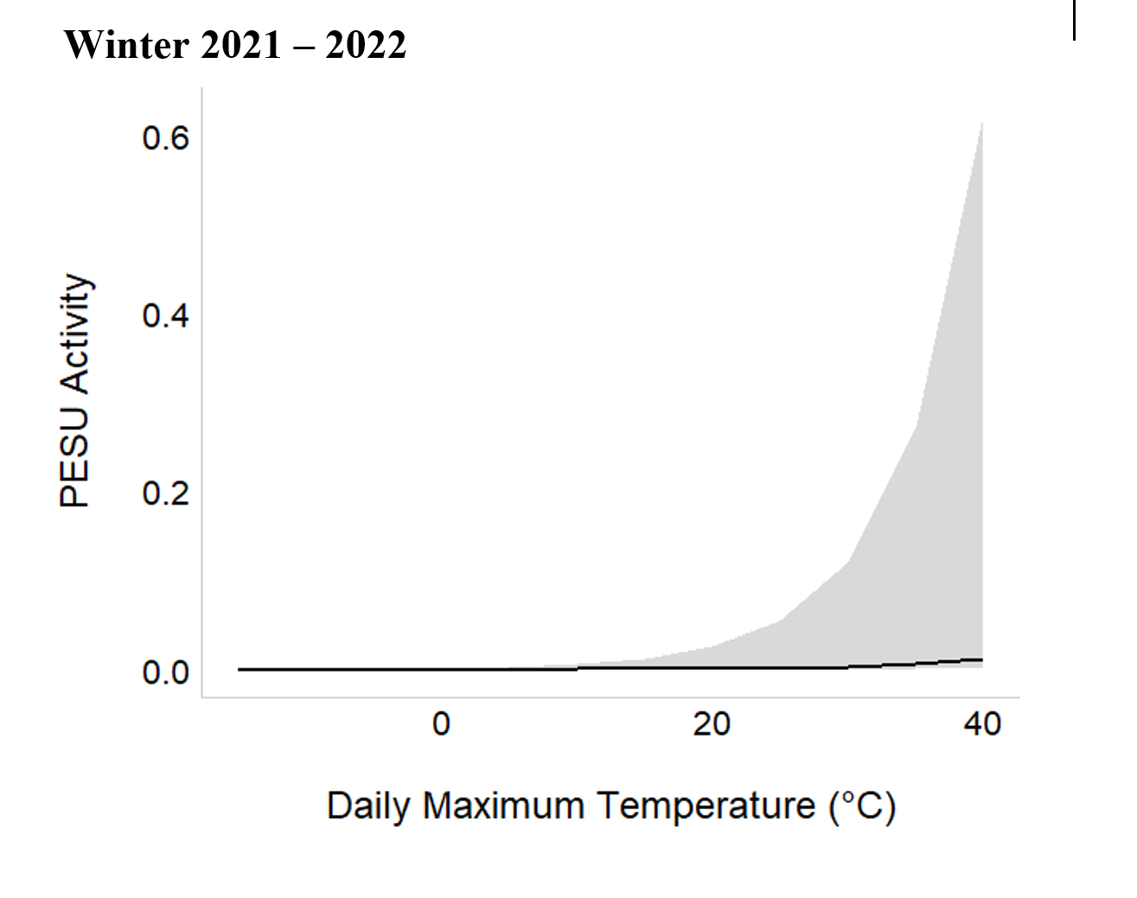

Winter 3: December 2022 – March 2023
The temperature model was the BIC top model and had ΔBIC = 21.80 above the second–best model and 100% of the cumulative weight; however, no covariates were significant (Table 2.7). The Land50 model was the best landcover scale model and had ΔBIC = 6.02 above the second–best landcover scale model, which was Land25 (Table 2.7); however, no landcover type covariates were significant in the model, similar to winters 1 and 2.

Table 2.7. Model comparison of PESU in winter 2. The model containing temperature was the BIC best model.
Model | K | BIC | Delta BIC | BICWt | Cum.Wt | LL
Temperature | 7 | 2300.5 | 0.00 | 1 | 1 | –1125.202
CustomDOY | 5 | 2322.3 | 21.80 | 0 | 1 | –1143.199
Period | 11 | 2350.3 | 49.81 | 0 | 1 | –1135.650
Null | 3 | 2458.9 | 158.33 | 0 | 1 | –1218.652
Effort | 4 | 2460.5 | 159.93 | 0 | 1 | –1215.858
Distribution | 7 | 2479.3 | 178.82 | 0 | 1 | –1214.524
Land50 | 11 | 2489.3 | 188.79 | 0 | 1 | –1205.138
Land25 | 11 | 2495.3 | 194.81 | 0 | 1 | –1208.151
Land10 | 11 | 2497.5 | 196.95 | 0 | 1 | –1209.221

In summary, the significant covariates from the best model for PESU activity were daily maximum temperature (Tmax) in winter 2021 – 2022 and daily minimum temperature (Tmin) in winter 2020 – 2021. There were no significant covariates in the best model for winter 2022 – 2023 and therefore this winter is not present in Fig. 2.8.

Fig. 2.8. Effect sizes of significant variables in grid-level daily activity mocels.
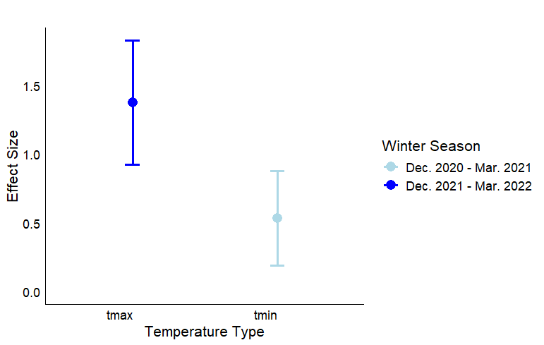

PESU Hibernation Ecology/Phenology
PESU is considered a hibernating bat, which puts the species at risk of WNS. We compared activity by periods to better understand when PESU are hibernating and when the species is active. For winter 2020 – 2021, Period 7 had the greatest number of acoustic passes (n = 222) followed by Period 8 (n = 196) (Table 2.8). For winter 2021 – 2022, Period 8 had the greatest number of acoustic passes (n = 426) followed by Period 2 (n = 302). For winter 2022 – 2023 Period 7 had the greatest number of acoustic passes (n = 2,159) followed by Period 8 (n = 1,705). Periods 3 and 4 during both winter 2020 – 2021 and winter 2021 – 2022 had the fewest PESU acoustic passes, with counts of 17 and 18, and 47 and 44, respectively. In contrast, Periods 1 and 2 recorded the fewest number of PESU acoustic passes for winter 2022 – 2023, with counts of 9 and 0 (Table 2.8). Since PESU activity was largely associated with daily minimum temperature, activity was greater during warmer periods.

Table 2.8. Total number of PESU acoustic passes from 30 grids categorized by period for three winters. The “unspecified” row represents acoustic passes from CustomDOY not assigned to a period.
Period | Winter  2020 – 2021 | Winter  2021 – 2022 | Winter  2022 – 2023 | Total
PESU | 768 | 1,707 | 4,628 | 7,103
1 | 58 | 243 | 9 | 310
2 | 75 | 302 | 0 | 377
3 | 17 | 47 | 567 | 631
4 | 18 | 44 | 453 | 515
5 | 129 | 171 | 197 | 497
6 | 51 | 175 | 440 | 666
7 | 222 | 244 | 1,693 | 2,159
8 | 196 | 426 | 1,083 | 1,705
unspecified | 2 | 55 | 186 | 243

However, periods of warmth could vary across Texas. Therefore, we plotted PESU activity by district and period as well (Fig. 2.9). These plots again indicate much greater activity in the Pineywoods region of Texas in winters 1 and 2 during all periods. This area of Texas also is often warmer than more western and northern areas so PESU may be more active in winter in this ecoregion. However, in winter 3, there was a lot of PESU activity in the Trans-Pecos region, particularly in mid- to late- winter (Fig. 2.9). This could represent a trend of PESU moving to this area or this ecoregion being warmer during winter 3 than in other winters.

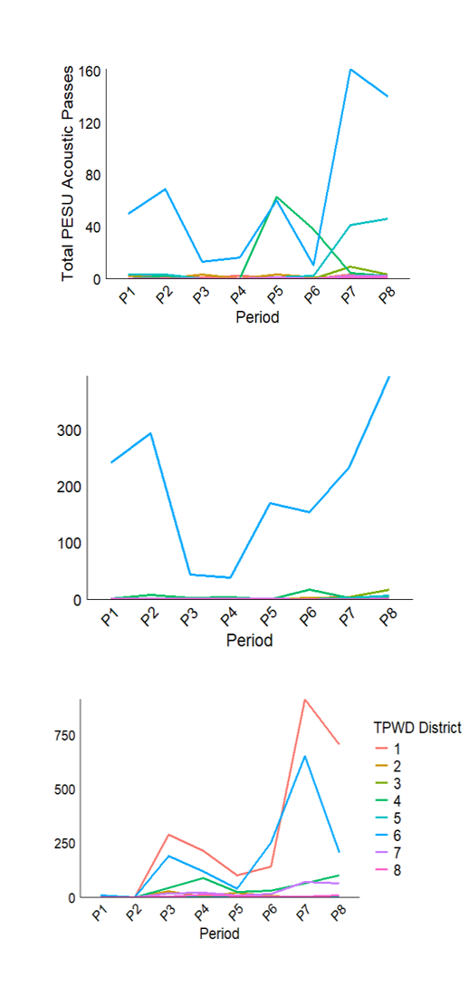
Fig. 2.9. Total number of PESU acoustic passes from 30 grids categorized by period for three winters ((top = 2020/2021; middle = 2021/2022; bottom = 2022/2023), with each line representing one of eight TPWD wildlife districts. TPWD eight wildlife districts: (1) Trans–Pecos, (2) High Plains/Panhandle, (3) Cross Timbers, (4) Hill Country, (5) Post Oak Savannah, (6) Pineywoods, (7) Oak Prairie, and (8) South Texas Plains.

For winter 2020 – 2021 and winter 2021 – 2022, predicted PESU activity slightly increased as custom DOY increases (approaches the end of winter and start of spring in March). Similarly, predicted PESU activity in winter 2022 – 2023 also slightly increased over custom DOY; however, predicted activity also increased then decreased around custom DOY 30 (January; Fig. 2.10).

Fig. 2.10. Winter activity patterns for PESU throughout Texas for three consecutive winters (e.g., Dec. 2020 – Mar. 2021, Dec. 2021 – Mar. 2022, and Dec. 2022 – Mar. 2023). Acoustic pass counts were pooled by grid by custom DOY and smoothed using generalized additive models (GAMs). Gray buffers indicate 95% confidence intervals.

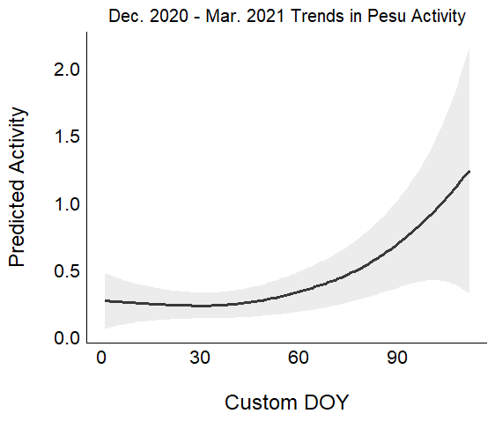  Winter 2020 – 2021 | Winter 2021 – 2022  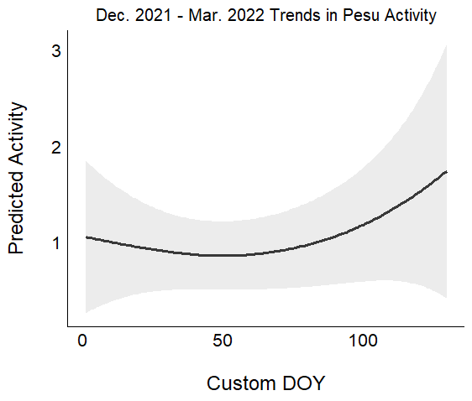 | Winter 2022 – 2023  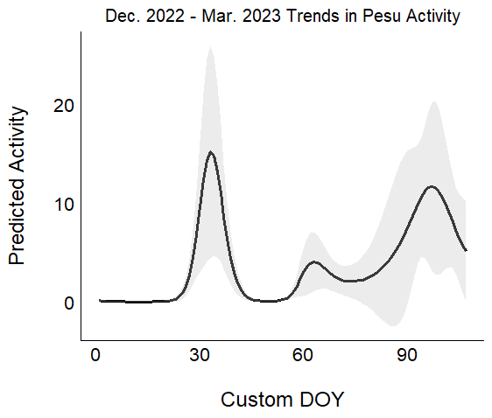
The lowest daily minimum temperatures (Tmin) of PESU acoustic passes occurred at –11° C (n = 1), followed by -9° C (n = 1), -8°C (n = 1), -7° C (n = 1), and -6° C (n = 4). As Tmin increases, the number of PESU acoustic passes also increases (Fig. 2.11). The increased activity of PESU when daily minimum temperature was around 7° C could represent areas with greater maximum daily temperatures. The highest daily maximum temperatures (Tmax) of PESU acoustic passes occurred at 36° C (n = 1) with the largest number of passes occurring at 27° C (n = 470). As Tmax increases, the number of PESU acoustic passes also increases, until ~27° C and then decreases (Fig. 2.12).

Fig. 2.11. PESU activity versus daily minimum temperature.
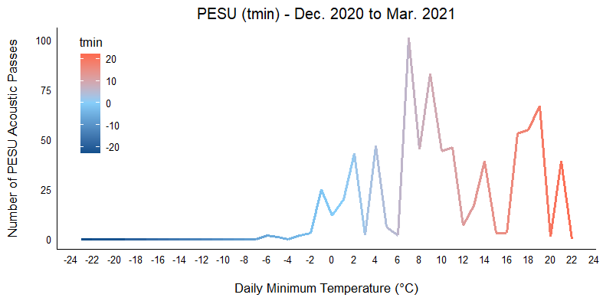

Fig. 2.12. PESU activity versus daily maximum temperature.
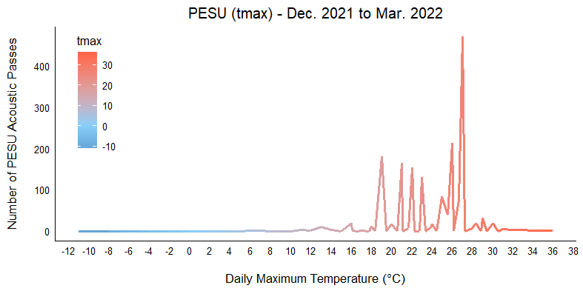

The data were not sufficient to robustly model hibernation ecology using occupancy models, sample size was too low. However, using the maps of activity by period, we can detect trends in activity visually. Models either did not converge or had extremely low beta values, indicative of sample size issues.

During winters, PESU was not active in most of the state during the coldest part of the seasons, likely due to hibernation. As mentioned above, the lowest daily minimum temperatures (Tmin) of PESU acoustic passes occurred at –11° C (n = 1), followed by -9° C (n = 1), -8° C (n = 1), -7° C (n = 1), and -6° C (n = 4). As Tmin increased, the number of PESU acoustic passes also increased. By the last period of the season, PESU was active in most of the state (Fig. 2.13). PESU activity was typically lowest during what we classified as the middle of the winter (late Jan to Feb) except during winter 3, when PESU activity was low in the early winter (Fig. 2.13).
Fig. 2.13. PESU activity across Texas during three winters in relation to daily minimum temperature.

Winter 2020/2021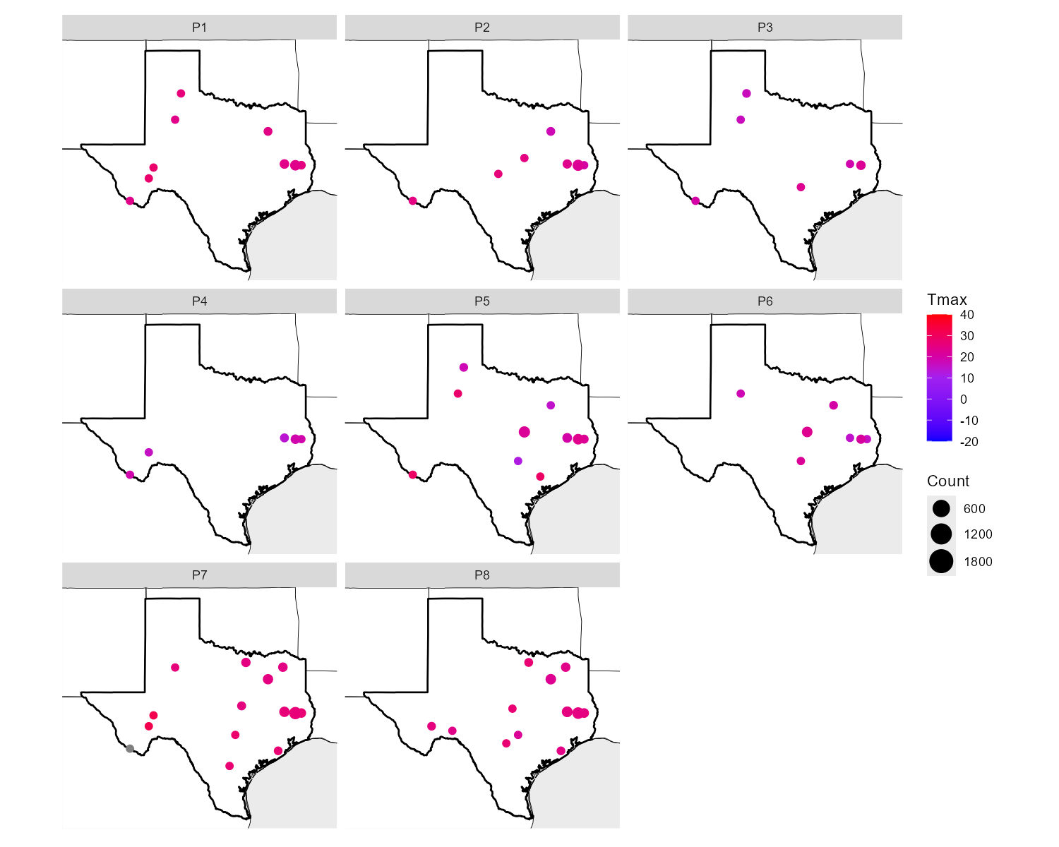

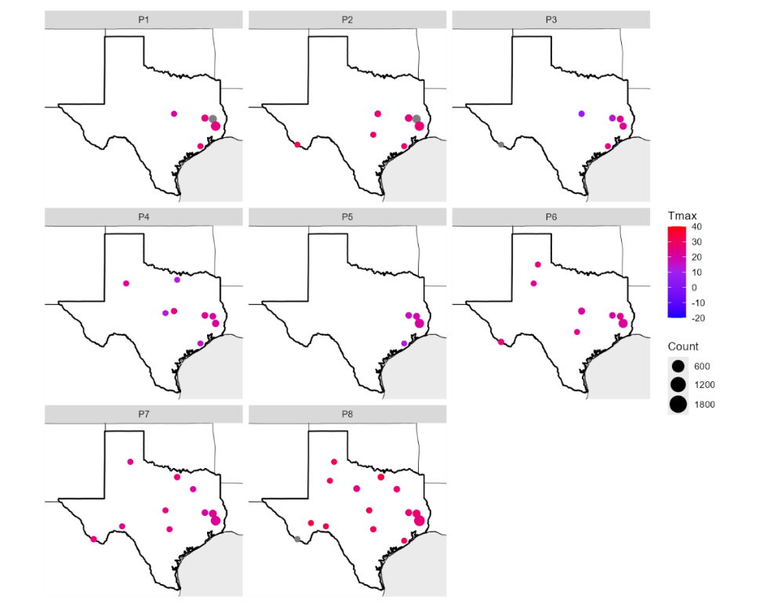
Winter 2021/2022

Winter 2022/2023

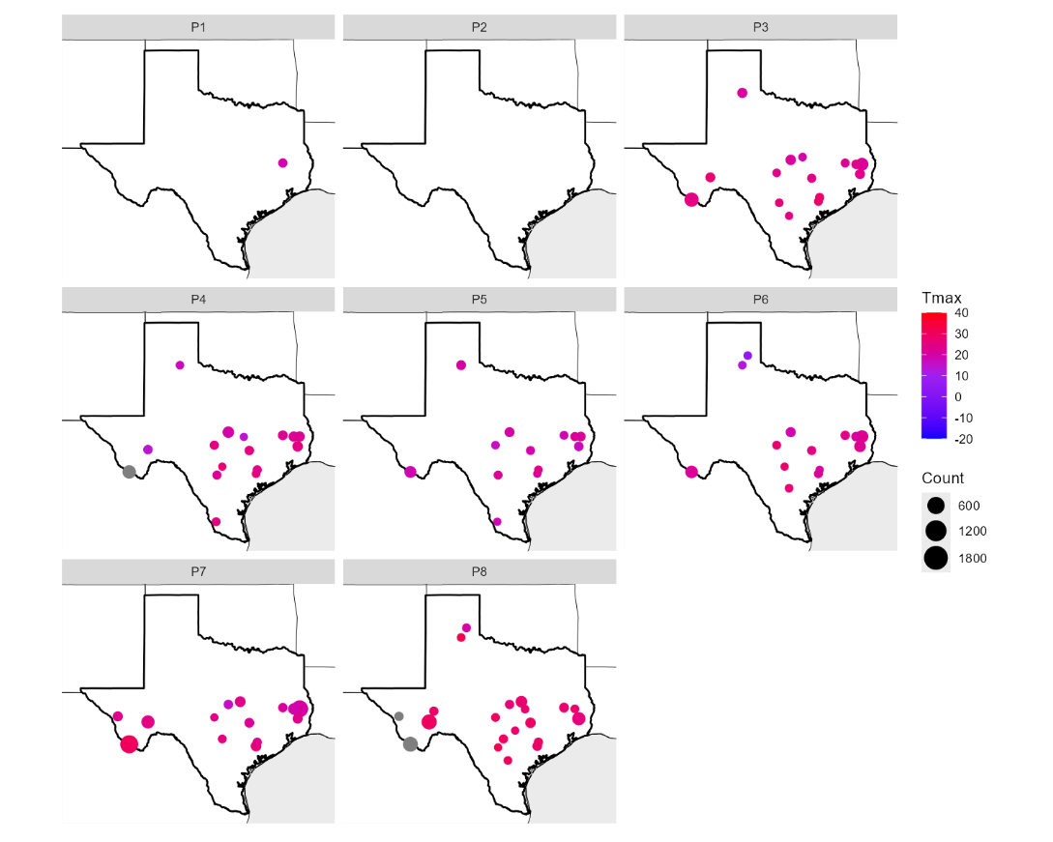

PESU Summary of Results/Discussion
In summary, PESU had greater activity in eastern Texas, but did have high activity in the Trans-Pecos, particularly during winter 3. Results indicated PESU activity was more influenced by weather than landcover at the three spatial scales we used. That could be due to the more temporal nature of activity for this species whether than spatial. In other words, PESU likely are active at all locations year-round so spatially, model results did not indicate high correlation landcover. That being said, PESU need adequate roosting, hibernation, and foraging habitats to be active in any area. Additionally, we acoustically detected PESU in Oldham and Bailey counties, which are not listed as in range for the species. Moreover, we acoustically detected PESU in two areas in which the county is partially in range, but our detectors were outside of range (Jeff Davis and Pecos) and in five additional counties that do not currently have voucher specimens, but occurrence is at least expected (Briscoe, Garza, Glasscock, Reagan, and Medina). These counties overlap the distribution of PAHE, which has a echolocation signature that is sometimes difficult to distinguish from PESU, so confirmation of identification is needed.
Results indicate broad distribution of P. subflavus across Texas as well as provide baseline information on the influences of landscape characteristics and weather on activity for three years before the first individuals were positively detected with WNS in the state. Although P. subflavus had been previously documented in various ecoregions across Texas, this study acoustically documented the species in several new areas of Texas. We recommend further verification with either field capture or genetic identification to confirm new county records. As a basic outcome, there were no areas of Texas that can be easily excluded from the probable distribution of P. subflavus based on this assessment. Understanding the potential for false negatives in determining distributional occurrence in P. subflavus is not well documented currently. Whereas site-based presence-absence was not part of the design optimization in this study, it does indicate that sites without positive detections should not be considered as unoccupied based only on the data sampled herein.
Concurrent with recent documentation, results herein suggest that although P. subflavus had historically been considered as relying on forests, the species may be more of a habitat generalist (Andersen et al. 2022);(Schratz et al. 2017) as well as more active during winter than previously thought. We did not detect sufficient activity by P. subflavus among winters to enable our planned robust modeling, but this does not mean that the species is inactive in winter; in fact, quite the contrary. The results here further contribute to our understanding that P. subflavus may be more active during winter and early spring than previously documented, which can have important implications for WNS management. Decades ago, P. subflavus was documented to be one of the last species to exit hibernacula in the spring (Barbour and Davis 1969, LaVal and LaVal 1980), and was less active in winter hibernacula than other species (Davis 1964). More recently, culvert surveys in Texas detected large numbers of P. subflavus still roosting in their winter hibernacula in late March (Sandel et al. 2001), but hibernation ecology may differ today from what was observed 30-50 years ago. Understanding winter activity is critical for the implementation of WNS treatment options that are applied to either an individual bat or the hibernacula seeking to decrease disease-related mortality (Cornelison et al. 2014) (Palmer et al. 2018) (Hoyt et al. 2019) (Rocke et al. 2019), and the treatments should be timed to minimize disturbance.
This species hibernates in various structures in the southeastern U.S., including culverts in Texas, which are candidate roost sites for WNS treatment (Meierhofer et al. 2019) (Newman et al. 2021). Moreover, because Pd depletes energy reserves by disrupting torpor cycles (Reeder et al. 2012) (Warnecke et al. 2012, Verant et al. 2014) bats that intermittently arouse from Pd-infected hibernacula to forage may benefit by supplementing their energy reserves. Many bat species in temperate areas, particularly at lower latitudes, are documented to forage, at least periodically, during winter (Boyles et al. 2006) (Whitaker Jr and Rissler 1993) (Viele et al. 2002), and bats remain active throughout winter regardless of Pd prevalence, with levels of activity positively related to ambient temperature at dusk in other southeastern U.S. states (Johnson et al. 2012) (Bernard and McCracken 2017). Similarly, P. subflavus activity corresponds to temperature in east Texas and Louisiana with bouts of inactivity recorded only at the lowest sunset temperatures (e.g., <5 °C) (Andersen, McGuire et al. 2022) Andersen et al. 2024, (Stevens 2024), and down to -4° C in North Carolina (Parker Jr et al. 2020). Although sample size was too low for winter activity analyses in our sample set, P. subflavus was active during all three of the 4-day samples in December of the winter seasons in our study. And because we defined season based on phenology, the spring seasons represented March, which can still be relatively cold in much of Texas. During the spring seasons, activity was related to temperature, but we recorded a single bat pass at -0.6° C and another just below 0° C, and 400 passes at temperature < 10° C during spring seasons.
The summative results suggest that P. subflavus populations were stable throughout the study based on the three-year results. However, WNS has since been detected in Texas P. subflavus and population declines may follow similar trends to other areas of the U.S. (Ford et al. 2011, Pettit and O'Keefe 2017, Huebschman 2019, Cheng et al. 2021). Although we did not examine roost or hibernacula sites, the availability of cold hibernacula and non-subterranean roosts may be important for conservation of P. subflavus populations in warmer climates, including Texas. Cold hibernacula may decrease hibernation energy requirements and limit Pd growth, whereas non-subterranean roosts may decrease fungal growth with thermal instability (Newman et al. 2021, Loeb and Winters 2022). Researchers once thought the apparent slower spread of WNS through bat populations in the southern U.S. states indicated greater resilience to the pathogen due to shorter winters. However, relatively warmer hibernacula temperatures in southern states may actually increase growth rates of Pd and increase severity of WNS infections (Langwig et al. 2016). As WNS continues to spread among Texas bats in the coming years, active conservation and management of this taxon will be essential for ensuring population stability and recovery. Additionally, previous models of WNS impact in Texas predicted P. subflavus in northern Texas would be more susceptible than populations in southern Texas (Meierhofer et al. 2021), but so far the WNS-related fatalities are located in the central part of the state (TPWD 2024). Now that our results confirm the species’ range likely encompasses more of the state than previously documented, research to determine why WNS mortality events have been geographically concentrated in Central Texas to date is crucially needed. Considering the variable activity by region and by season, more research is warranted.

Task 1B: Myotis velifer

MYVE Introduction
The first documented fatalities from white-nose syndrome in Myotis velifer occurred in March 2020 in Texas. Texas is at the center of the invasion of white-nose syndrome in MYVE as the only state that has suffered losses of the species due to the disease. In 2017, Pseudogymnascus destructans (Pd), the fungus that causes WNS, was detected in northern Texas on MYVE, which was the first recorded detection of the fungus on the species; however, the first population die-off was in central Texas, ~600 km away from the original detection of Pd. (TPWD 2024 News Release). The fungus was also detected on Perimyotis subflavus in northern Texas, which had a similar occurrence and the first documented fatalities from WNS in Texas on this species also occurred in central Texas. Because northern Texas is significantly colder than central Texas and the location where Pd was first detected, it was expected that hibernating bats in this region would be more affected by WNS. It was originally thought that more southern bat populations would be less susceptible to WNS due to a shorter hibernation period as central Texas is significantly warmer than the northern region and has greater availability of food and water to overwintering bats (Reynolds et al. 2015, Meierhofer et al. 2019, Meierhofer et al. 2021). Until February 2024, MYVE was the only species known to have succumbed to WNS in Texas; however three individual PESU reportedly died from WNS in February 2024 and WNS is spreading through the state.
Due to the timing of the first WNS fatalities in central Texas (February and March 2020) it is possible that diseased bats had been infected at a different location, such as northern Texas, and migrated to central Texas before succumbing to the disease. Alternately, hibernating MYVE in central Texas are more susceptible to WNS than conspecifics to the north due to some unknown factor. It is important to better understand the hibernation timing and movements of MYVE in Texas to identify locations for management, project future spread, and to understand potential variation in susceptibility. We do not expect individuals to migrate from western Texas because MYVE are not thought to overwinter in the area. In fact, from November 1 – March 15, MYVE is thought to be restricted to the central and north central parts of the state (Ammerman et al. 2012). However, it is not known the extent to which MYVE migrate in Texas, nor is it known if there are differences in hibernation timing throughout the state. A previous genetic study on MYVE suggested substantial gene flow, and weak regional fidelity (Parlos 2008), suggesting movement, but further research is warranted.

MYVE Fall Results

General
We identified 26,204 calls as MYVE over three Fall seasons at 26 grid cells (Table 3.1, Fig. 3.1).

Table 3.1. The number of MYVE calls, grid cells, vetted calls, and calls/detector night for each year.
Estimate | Fall 2020 | Fall 2021 | Fall 2022
Number Active Cells | 42 | 43 | 38
Cells w/Manually Vetted Calls | 25 | 26 | 18
Call count | 15,534 | 8,122 | 2,548
Calls/detector Night | 647.2 | 338.4 | 106.2

Fig. 3.1. Locations of MYVE activity in Texas during Fall seasons. Note dots do not indicate exact properties of data collection, and instead are fuzzed for landowner privacy.
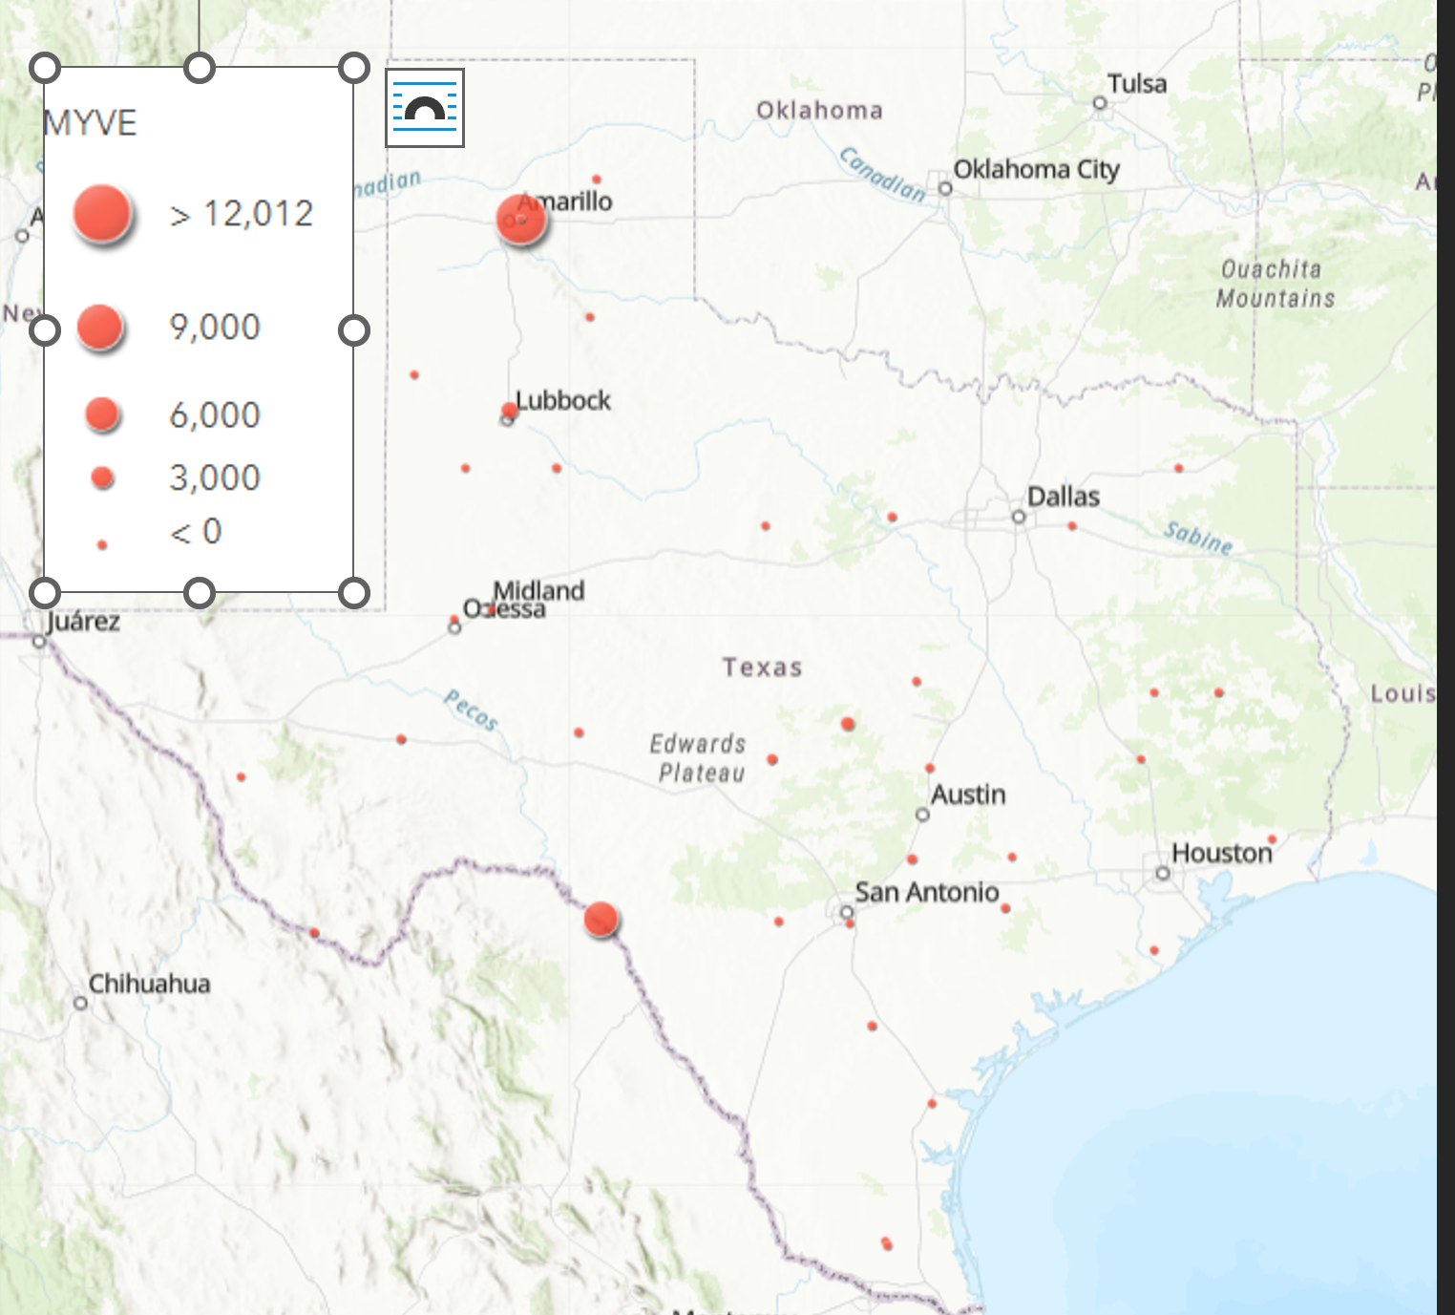

MYVE Grid Level Activity: habitat and weather associations

Fall 2020
The 50-km Wet model was the BIC top model and had ΔBIC = 0 and had 37% cumulative weight. The-25 km Wet model was the second BIC top model and had a ΔBIC = 2 (Table 3.2). Both models indicated a negative relationship with MYVE activity (Fig. 3.2).

Table 3.2. Model output for MYVE grid-level activity in Fall 2020.
Modnames | K | BIC | Delta_BIC | ModelLik | BICWt | LL | Cum.Wt
50km_Wet | 4 | 2746.119 | 0 | 1.00E+00 | 3.70E-01 | -1359.135 | 0.370
25km_Wet | 4 | 2748.235 | 2.1162 | 3.47E-01 | 1.28E-01 | -1360.193 | 0.498
50km_Water | 4 | 2749.088 | 2.969 | 2.27E-01 | 8.38E-02 | -1360.62 | 0.5822
District | 10 | 2749.313 | 3.194 | 2.02E-01 | 7.49E-02 | -1339.845 | 0.657
25km_Crop | 4 | 2749.578 | 3.459 | 1.77E-01 | 6.56E-02 | -1360.864 | 0.722

Term | Estimate | Std. Error | z value | P-value
(Intercept) | 0.631 | 0.495 | 1.275 | 0.202
Wet50 | -1.868 | 0.801 | -2.332 | 0.02
Term | Estimate | Std. Error | z value | P-value
(Intercept) | 0.671 | 0.49 | 1.369 | 0.171
Wet25 | -1.689 | 0.8 | -2.112 | 0.035

Fig. 3.2. MYVE activity was negatively associated with wetlands at the 25-km and 50-km scales.

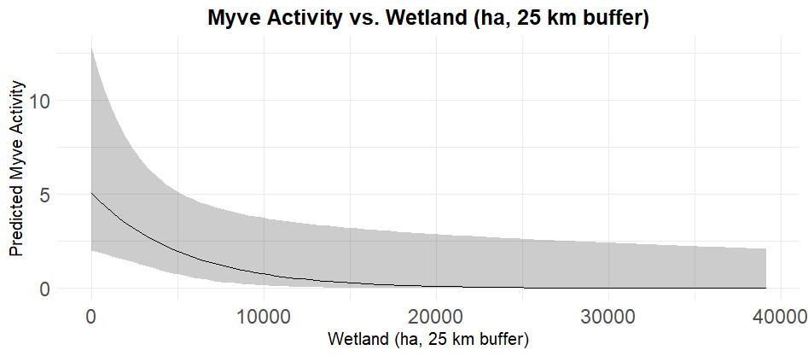

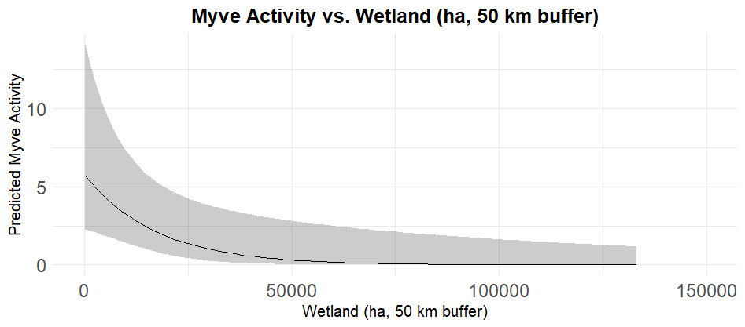

Fall 2021
The maximum temperature °C was the BIC top model and had ΔBIC = 0 and had 99% cumulative weight; however, maximum temperature was not a significant predictor of MYVE activity (Table 3.3). The 50-km Wet model was the BIC top model for all landcover variables ΔBIC = 117 with results indicating a negative relationship between MYVE activity and wetlands at the 50-km scale (Table 3.3, Fig. 3.4).

Table 3.3. Model output for MYVE grid-level activity in Fall 2021.
Modnames | K | BIC | Delta_BIC | ModelLik | BICWt | LL | Cum.Wt
Maximum Temperature°C | 5 | 2005.414 | 0 | 1.00E+00 | 9.99E-01 | -984.98 | 0.999
Temp_2021 | 7 | 2019.132 | 13.71824 | 1.05E-03 | 1.05E-03 | -984.75 | 1
Minimum Temperature°C | 4 | 2087.449 | 82.03471 | 1.54E-18 | 1.53E-18 | -1029.54 | 1
Period | 8 | 2105.581 | 100.1676 | 1.77E-22 | 1.77E-22 | -1023.97 | 1
50km_Wet | 4 | 2123.311 | 117.89694 | 2.51E-26 | 2.50E-26 | -1047.24 | 1

Term | Estimate | Std. Error | z value | P-value
(Intercept) | 0.446 | 0.827 | 0.539 | 0.59
Scale(TMAX) | -0.029 | 0.023 | -1.234 | 0.217
Term | Estimate | Std. Error | z value | P-value
(Intercept) | 0.021 | 0.529 | 0.039 | 0.969
Wet50 | -2.568 | 0.995 | -2.581 | 0.01

Fig. 3.4. MYVE activity was negatively influenced by wetlands at the 50-km scale in Fall 2021.
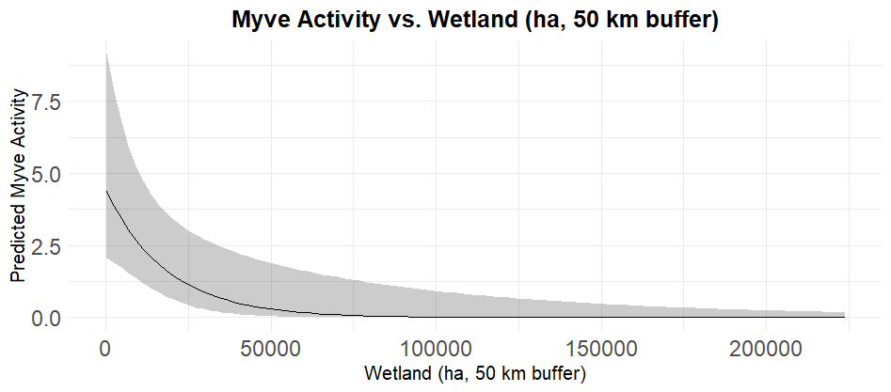

Fall 2022
The Julian date model was the BIC top model and had ΔBIC = 0 and had 99% cumulative weight (Table 3.4, Fig. 3.5). Results indicated irregular activity depending on Julian date, likely ue to varying weather conditions. The 50-km Wet was the BIC top model for all landcover variables ΔBIC = 84; however, this variable was not a significant predictor of MYVE activity (Table 3.4).

Table 3.4. Model output for MYVE grid-level activity in Fall 2022.
Modnames | K | BIC | Delta_BIC | ModelLik | BICWt | LL | Cum.Wt
Julian | 4 | 1395.451 | 0 | 1.00E+00 | 9.95E-01 | -684.09 | 0.995
Period | 8 | 1406.196 | 10.744 | 4.64E-03 | 4.62E-03 | -675.83 | 0.999
Maximum Temperature°C | 5 | 1419.541 | 24.089 | 5.87E-06 | 5.85E-06 | -692.73 | 0.999
Temp_2022 | 7 | 1428.178 | 32.726 | 7.82E-08 | 7.79E-08 | -690.23 | 1
Minimum Temperature°C | 4 | 1432.332 | 36.881 | 9.80E-09 | 9.76E-09 | -702.53 | 1
50km_Wet | 4 | 1479.987 | 84.536 | 4.40E-19 | 4.38E-19 | -726.36 | 1

Term | Estimate | Std. Error | z value | P-value
(Intercept) | 6.255 | 1.02 | 6.133 | 0.00
Julian | -0.027 | 0.003 | -9.351 | <0.01
Term | Estimate | Std. Error | z value | P-value
(Intercept) | -1.331 | 0.707 | -1.884 | 0.06
Wet50 | -2.145 | 1.295 | -1.656 | 0.098

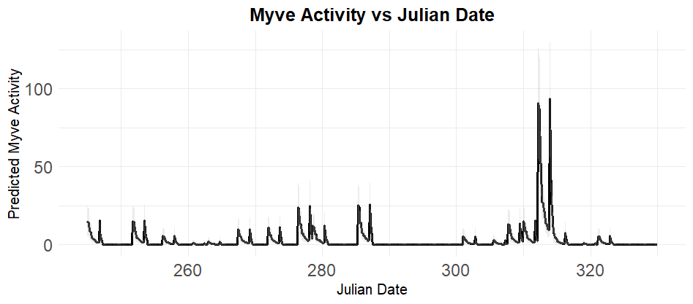
Fig. 3.5. MYVE activity was correlated with Julian Date with regression in Fall 2002.
.
In fall seasons, MYVE activity was significantly higher in Northern Texas during periods 3, 4, 5, and 6 (Fig. 3.6), suggesting consistent use of this region throughout the fall season, with peak activity in Period 6. In South Texas, activity was significantly higher during periods 3, 4, 5, and 6, with a general increasing trend in Period, suggesting increasing importance of this region as fall progresses. MYVE activity in West Texas suggests significantly higher activity during period 5, suggesting concentrated use of this region in late fall. MYVE activity in East Texas is significantly higher in periods 5 and 6 (Fig. 3.6), suggesting this region of Texas is an important factor for MYVE activity, later in the fall season.

Fig. 3.6. MYVE activity by Texas region and period during Fall seasons (three years pooled).
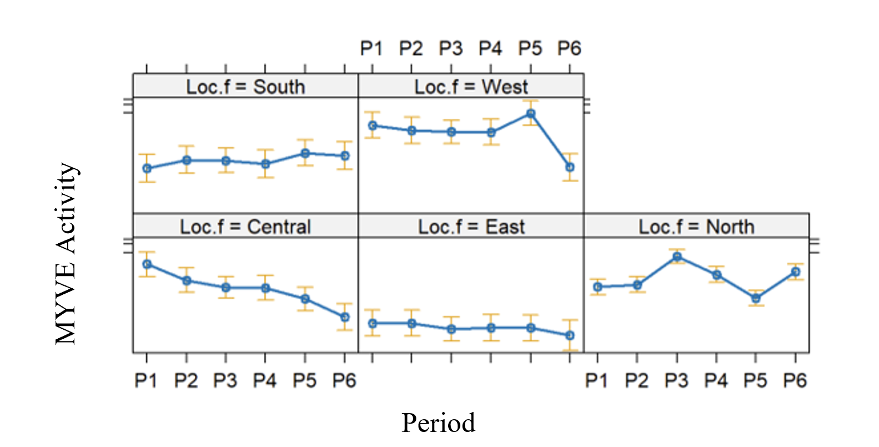

MYVE Winter Results

General
We identified 3,971 acoustic passes of MYVE across all years at 25 out of 48 grid cells. Of these, 795 (22 grid cells), 1,637 (17 grid cells), and 1,539 (18 grid cells) MYVE acoustic passes were identified from winter 2020 – 2021, winter 2021 – 2022, and winter 2022 – 2023, respectively (Fig. 3.7).

Fig. 3.7. Locations and activity levels of MYVE across Texas in Winter Seasons. Note dots do not indicate exact properties of data collection, and instead are fuzzed or omitted for landowner privacy.
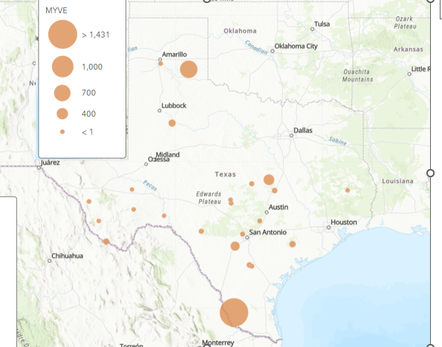

MYVE Grid–level Daily Activity: habitat and weather associations

Winter 1: December 2020 – March 2021
The temperature model was the BIC top model and had ΔBIC = 27.03 above the second–best model and 100% of the cumulative weight (Table 3.5); however, no covariates were significant. The Land50 model was the best landcover scale model and had ΔBIC = 5.17 above the second–best landcover scale model, which was Land25; however, no landcover type covariates were significant in the model the both models did not compete with the null model (Table 3.5).

Table 3.5. Model comparison of MYVE in Winter 1. The model containing temperature was the BIC best model.

Model | K | BIC | Delta BIC | BICWt | Cum.Wt | LL
Temperature | 7 | 1614.3 | 0.00 | 1 | 1 | -781.40
CustomDOY | 5 | 1641.4 | 27.03 | 0 | 1 | -802.18
Period | 11 | 1644.9 | 30.58 | 0 | 1 | -781.76
Null | 3 | 1713.6 | 99.29 | 0 | 1 | -845.71
Effort | 4 | 1720.8 | 106.49 | 0 | 1 | -845.61
Distribution | 7 | 1732.4 | 118.08 | 0 | 1 | -840.31
Land50 | 11 | 1752.0 | 137.72 | 0 | 1 | -835.33
Land25 | 11 | 1757.2 | 142.89 | 0 | 1 | -837.92
Land10 | 11 | 1762.3 | 147.94 | 0 | 1 | -840.44

Winter 2: December 2021 – March 2022
The temperature model was the BIC top model and had ΔBIC = 60.16 above the second–best model and 100% of the cumulative weight (Table 3.6). Only Tmax (β = 0.6963, SE = 0.2153, z–value = 3.233, p–value = 0.001) significantly influenced activity (Fig. 3.8). The Land50 model was the best landcover scale model and had ΔBIC = 8.31 above the second–best landcover scale model, which was Land25; however, no landcover type covariates were significant in the model (Table 3.6)

Table 3.6. Model comparison of MYVE in winter 2. The model containing temperature was the BIC best model.
Model | K | BIC | Delta BIC | BICWt | Cum.Wt | LL
Temperature | 7 | 1129.2 | 0.00 | 1 | 1 | -539.17
CustomDOY | 5 | 1189.4 | 60.16 | 0 | 1 | -576.34
Period | 11 | 1206.5 | 77.29 | 0 | 1 | -562.89
Effort | 4 | 1207.1 | 77.87 | 0 | 1 | -588.86
Null | 3 | 1210.8 | 81.62 | 0 | 1 | -594.41
Distribution | 7 | 1238.6 | 109.37 | 0 | 1 | -593.61
Land50 | 11 | 1259.0 | 129.79 | 0 | 1 | -589.14
Land25 | 11 | 1261.7 | 132.46 | 0 | 1 | -590.47
Land10 | 11 | 1265.1 | 135.90 | 0 | 1 | -592.19

 | Estimate | Std. Error | z value | Pr(>|z|)
(Intercept) | -7.8732 | 2.0981 | -3.753 | 0.00012
s(Tmin)1 | 0.6364 | 0.9584 | 0.664 | 0.50668
s(Tmax)1 | 0.6963 | 0.2153 | 3.233 | 0.00122

Fig. 3.8. Maximum daily temperature influenced MYVE activity in winter 2.

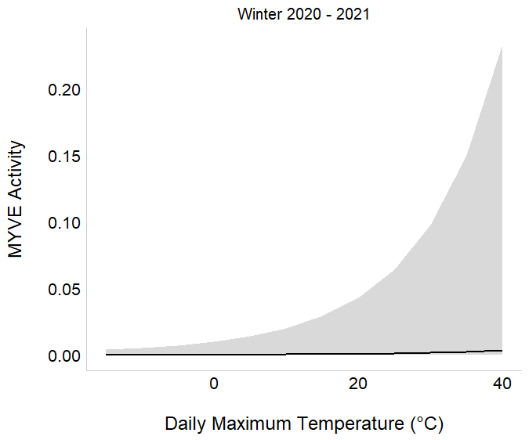

Winter 3: December 2022 – March 2023
The temperature and CustomDOY models were competing as the BIC top models with ΔBIC = 1.49 making up 68% and 100% of the cumulative model weight, respectively (Table 3.7). Only Tmax (β = -0.7545, SE = 0.2410, z–value = -3.130, p–value = 0.002) significantly influenced activity (Table 3.7, Fig. 3.9). The Land50 model was the best landcover scale model and had ΔBIC = 4.67 above the second–best landcover scale model, which was Land25; however, no landcover type covariates were significant in the model.

Table 3.7. Model comparison of MYVE in winter 3. The model containing temperature was the BIC best model.
Model | K | BIC | Delta BIC | BICWt | Cum.Wt | LL
Temperature | 7 | 1307.7 | 0.00 | 0.677 | 0.677 | -781.40
CustomDOY | 5 | 1309.2 | 1.49 | 0.322 | 1 | -802.18
Period | 11 | 1322.4 | 14.69 | 0 | 1 | -781.76
Effort | 4 | 1422.0 | 114.30 | 0 | 1 | -845.71
Null | 3 | 1422.4 | 114.71 | 0 | 1 | -845.61
Distribution | 7 | 1446.9 | 139.21 | 0 | 1 | -840.31
Land50 | 11 | 1462.6 | 154.88 | 0 | 1 | -835.33
Land25 | 11 | 1467.3 | 159.55 | 0 | 1 | -837.92
Land10 | 11 | 1470.6 | 162.87 | 0 | 1 | -840.44

 | Estimate | Std. Error | z value | Pr(>|z|)
(Intercept) | -6.5804 | 1.4698 | -4.477 | 7.57e-06
s(Tmin)1 | 2.8608 | 1.8698 | 1.530 | 0.12603
s(Tmax)1 | -0.7545 | 0.2410 | -3.130 | 0.00175

Figure 3.9. Maximum daily temperature influenced MYVE activity in winter 3.
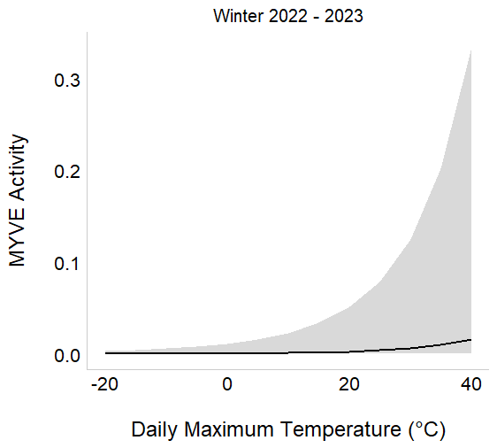
In summary, daily maximum temperature (Tmax) was the only significant covariate for MYVE activity, specifically for winter 2021 – 2022 and winter 2022 – 2023. There were no significant covariates in the best model for winter 2020 – 2021 and therefore this winter is not present in Fig. 3.10.

Fig. 3.10. Daily maximum temperature was the only significant predictor MYVE activity during winters.
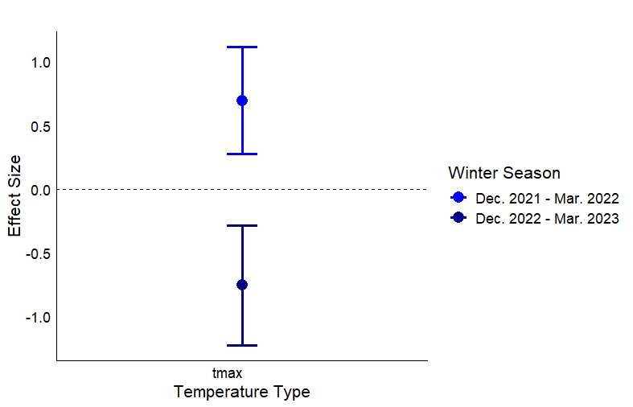

MYVE Hibernation Ecology/Phenology
Similar to PESU, MYVE is considered a hibernating bat and is susceptible to WNS. Thus, understanding when and where MYVE is hibernating and, oppositely, active, is important for conservation. For winter 2020 – 2021, Period 8 had the greatest number of acoustic passes (n = 306) followed by Period 7 (n = 158; Table 3.8. For winter 2021 – 2022, Period 4 had the greatest number of acoustic passes (n = 367) followed by Period 2 (n = 354). For winter 2022 – 2023, Period 8 had the greatest number of acoustic passes (n = 1,042) followed by Period 7 (n = 288). Periods 1 and 6 during winter 2020 – 2021 had the fewest MYVE acoustic passes, with counts of 31 and 7. Periods 1 and 7 during winter 2021 – 2022 had the fewest MYVE acoustic passes, with counts of 49 and 45. Periods 1 and 2 during winter 2022 – 2023 had the fewest MYVE acoustic passes, with counts of 10 and 0 (Table 3.8).

Table 3.8. Total number of MYVE acoustic passes from 25 grids categorized by period for three winters. The “unspecified” row represents acoustic passes from CustomDOY not assigned to a period.
Period | Winter  2020 – 2021 | Winter  2021 – 2022 | Winter  2022 – 2023 | Total
MYVE | 795 | 1,637 | 1,539 | 3,971
1 | 31 | 49 | 10 | 90
2 | 40 | 354 | 0 | 394
3 | 59 | 147 | 25 | 231
4 | 54 | 367 | 54 | 475
5 | 124 | 93 | 25 | 242
6 | 7 | 143 | 22 | 172
7 | 158 | 45 | 288 | 491
8 | 306 | 150 | 1,042 | 1,498
unspecified | 16 | 289 | 73 | 378

Sample size of MYVE activity during winter was too low for the regression analysis that included an interactive effect between region of the state and period. However, we were able to visually assess district by period. For winter 2020 – 2021 and winter 2021 – 2022, the South Texas Plains accounted for the greatest number of MYVE acoustic passes across Periods 1 – 7 (Fig. 3.11). The High Plains/Panhandle accounted for the greatest number of MYVE acoustic passes in Period 8 for all winters. Additionally, the Hill Country accounted for the greatest number of MYVE acoustic passes in Period 7 for winter 2022 – 2023, while Periods 1 – 6 experienced relatively few passes in comparison (Fig. 3.11).

Fig. 3.11. Winter activity of MYVE by TPWD district and period. Lines represent total number of MYVE acoustic passes from 25 grid cells categorized by period for three winters, with each line representing one of eight TPWD wildlife districts. TPWD eight wildlife districts: (1) Trans–Pecos, (2) High Plains/Panhandle, (3) Cross Timbers, (4) Hill Country, (5) Post Oak Savannah, (6) Pineywoods, (7) Oak Prairie, and (8) South Texas Plains.

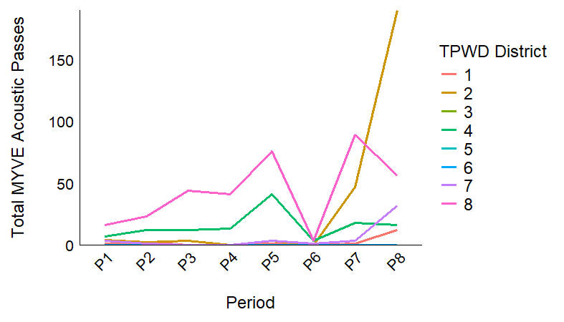  Winter 2020 – 2021 | Winter 2021 – 2022  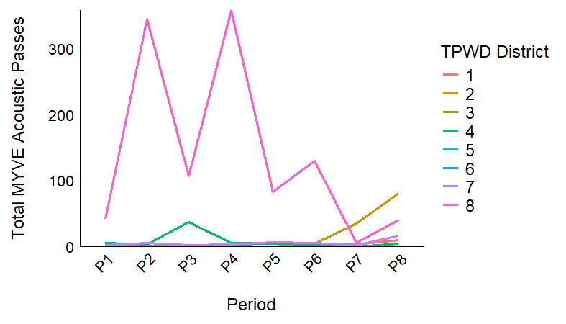 | 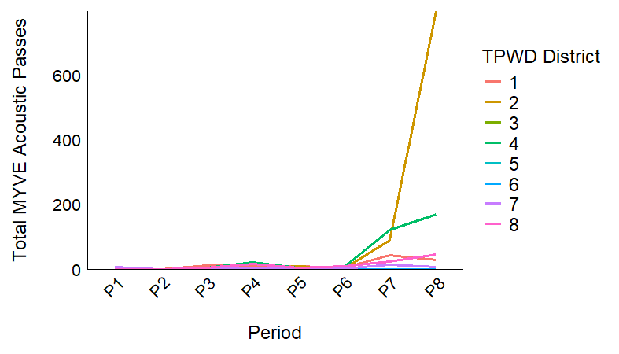  Winter 2022 – 2023
For winter 2020 – 2021 and winter 2022 – 2023, predicted MYVE activity slightly increased as custom DOY increases (approaches the end of winter and start of spring in March) until around custom DOY 90 (beginning of March) when predicted activity considerably increased (Fig. 3.12). In contrast, predicted MYVE activity in winter 2021 – 2022 slightly decreases over custom DOY (Fig. 3.12).

Fig. 3.12. Winter activity patterns for MYVE throughout Texas for three consecutive winters (e.g., Dec. 2020 – Mar. 2021, Dec. 2021 – Mar. 2022, and Dec. 2022 – Mar. 2023). Acoustic pass counts were pooled by grid by custom DOY and smoothed using generalized additive models (GAMs). Gray buffers indicate 95% confidence intervals.
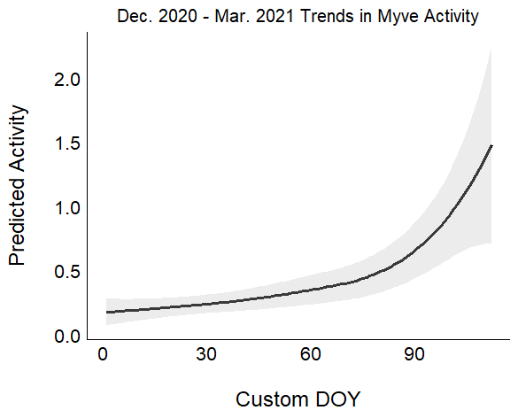  Winter 2020 – 2021 | Winter 2021 – 2022  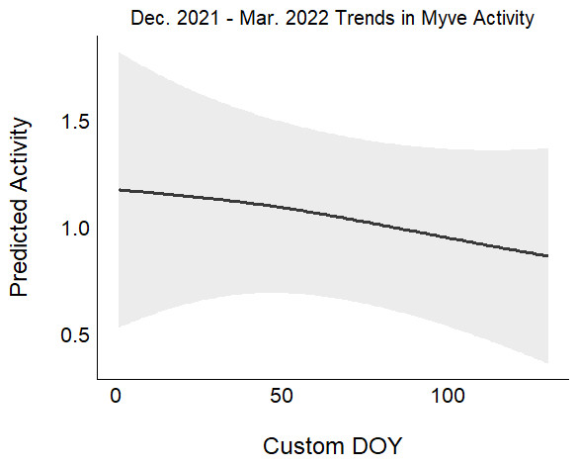 | Winter 2022 – 2023  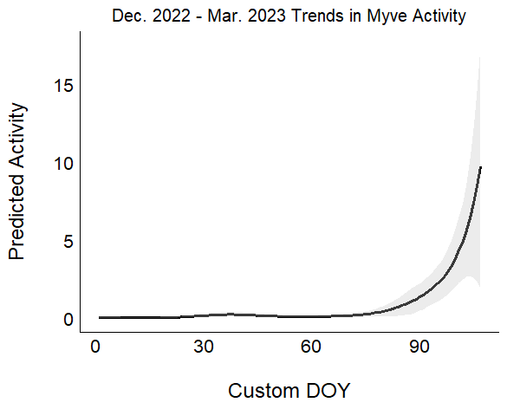
As mentioned in the grid-level activity results section, maximum temperature was a significant predictor of MYVE activity in winters 2 and 3. During Winter 2, the greatest daily maximum temperatures (Tmax) of MYVE acoustic passes occurred at 36° C (n = 1) with the largest number of passes occurring at 31° C (n = 368). Peak Tmax ranges of acoustic passes occur around 13 to 15° C and 29 to 31° C. During Winter 3, the highest daily maximum temperatures (Tmax) of MYVE acoustic passes occurred at 39°C (n = 1) with the largest number of passes occurring at 17°C (n = 236). As Tmax increases from 17°C, the number of MYVE acoustic passes decreases. The lowest maximum temperature with MYVE activity is around 12° C.
Fig. 3.13. MYVE activity was significantly affected by maximum temperature in winters 2 and 3.
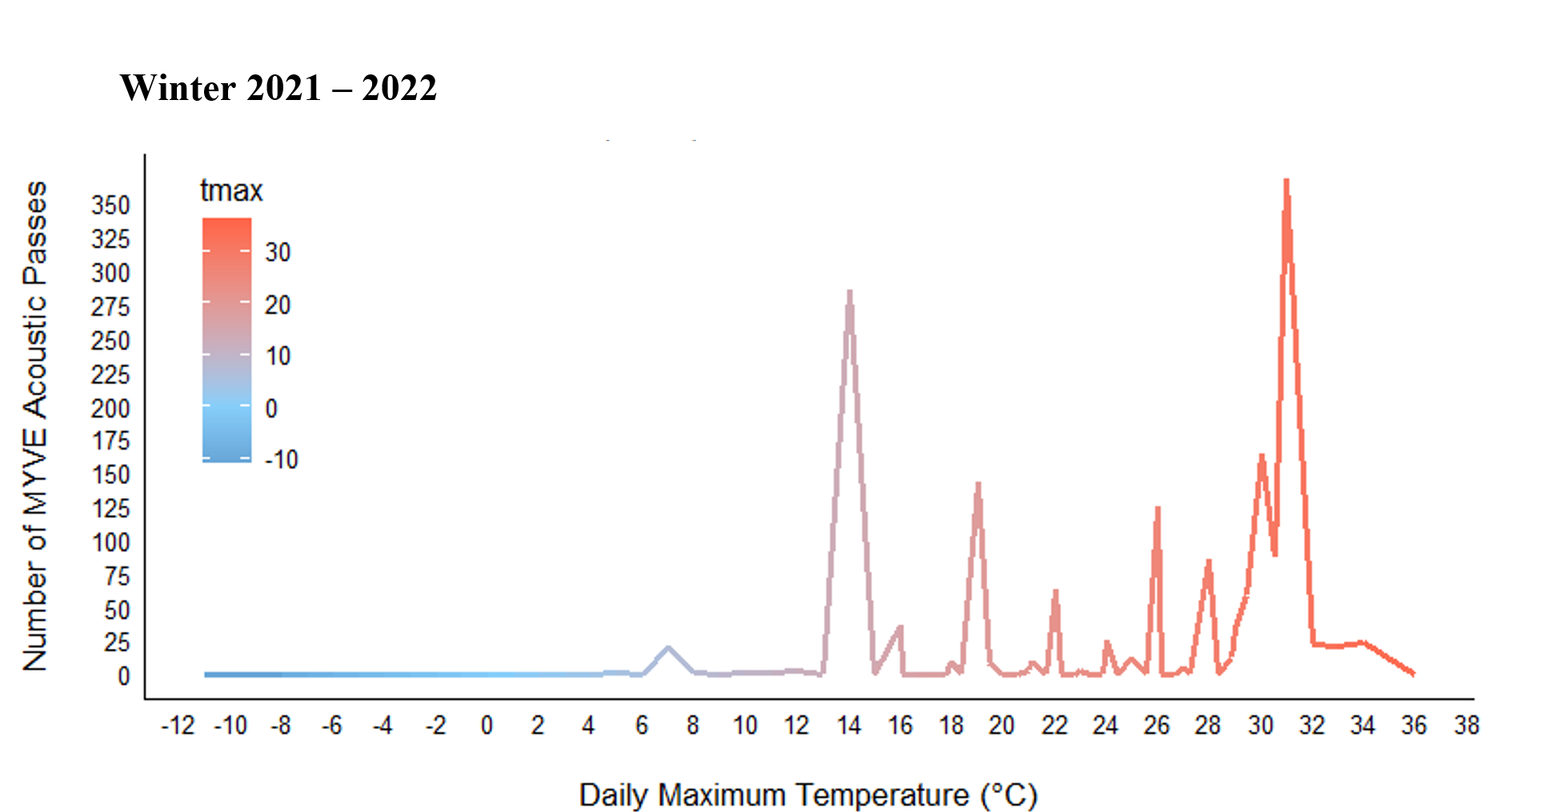

Winter 2022/2023
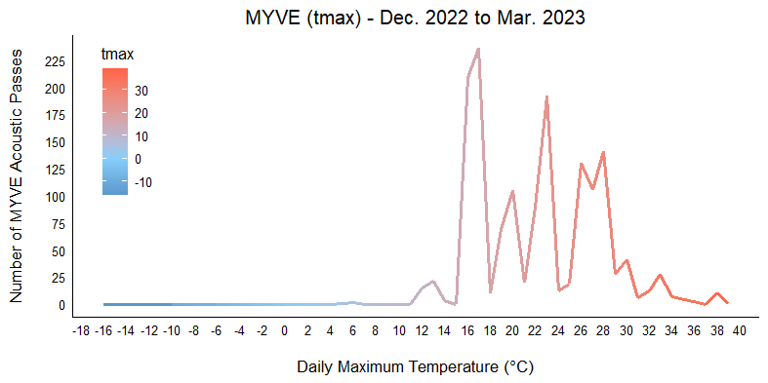
Additionally, we visualized location and temperature of MYVE by period across each winter. The three winters had varying results. In winter 1, MYVE active in much of Texas during all periods with a lack of activity in northern and west Texas during colder periods (Fig. 3.14). During winter 2, MYVE activity halted in period 2 across the entire state and was low in the first several periods before increasing during 6-8 (Fig. 3.14). Winter 3 showed a similar pattern to winter 1, with greater activity throughout the season (Fig. 3.14).

Fig. 3.14. Locations of Myotis velifer across Texas Winter 2020/2021, Winter 2021/2022, and Winter 2022/2023. Each season is divided by a 4-day period that occurred every ~10 days. Colors represent the maximum Temperature of that period during activity.
Winter 2020/2021
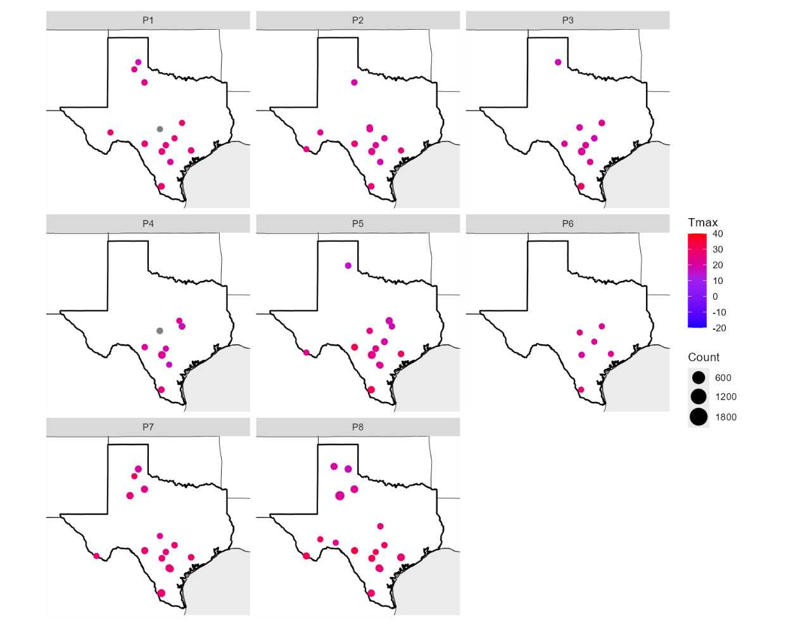

Winter 2021/2022
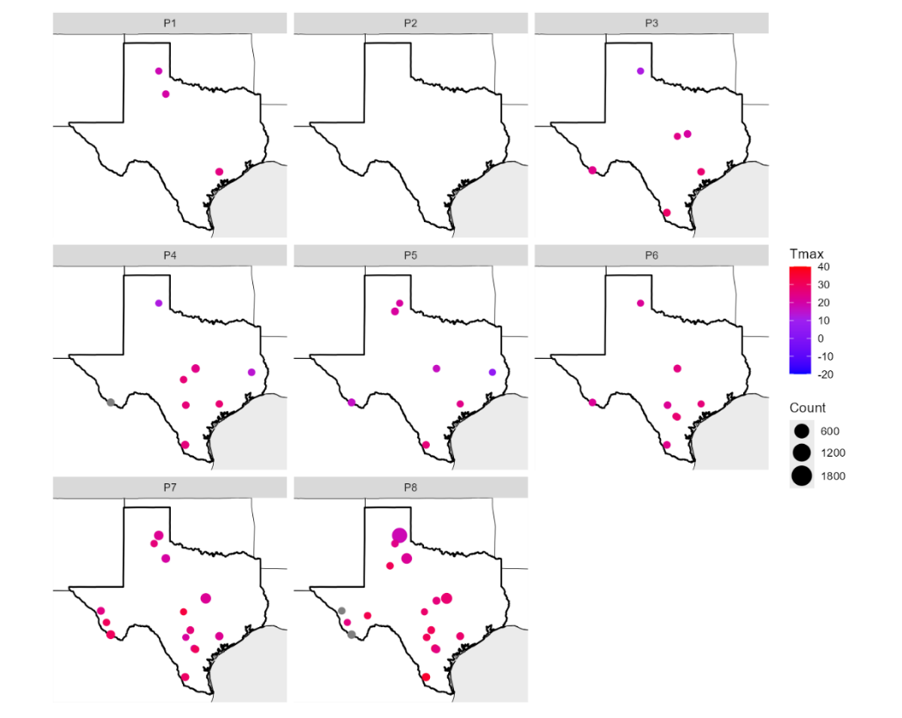
Winter 2022/2023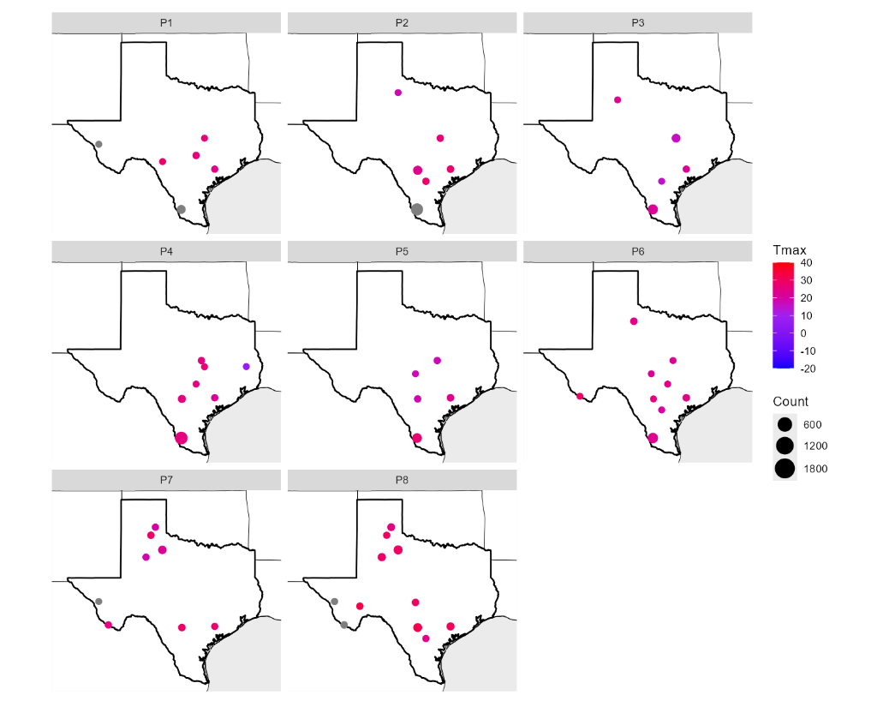

MYVE Summary of Results/Discussion
Results confirm the currently published distribution of MYVE across Texas as well as provide baseline information on the influences of landscape characteristics and weather on activity for three years following the first detection of WNS on the species in the state. Expectedly, MYVE activity was greatest in South Texas Plains Ecoregion. There were less grid cells with detections in Fall seasons as the three years progressed, but not during winter. Additionally, this study acoustically documented MYVE species in counties without records but within range according to Schmidly & Bradley (2016). For two years of the study, MYVE was detected outside of its published range in Trinity County, which is further east than on record. We recommend verifying these detections, especially those outside the published range, with either field capture or genetic identification for county records. False negative detections are possible in our study as we only sampled for four nights per season. Several studies report needing anywhere from 1.5 to 91 detector nights per site to reach 95% confidence in absence depending on the species, season, and number of detectors per site (Deeley et al. 2021; Hauer et al. 2023).
Our results show that MYVE exhibit moderate winter activity in some parts of the state, suggesting shorter torpor durations compared to northern Myotis species that have been decimated by Pd. There was only 1 period (winter 2, period 2) in which no MYVE activity was detected across the state, otherwise, MYVE remained active at the easternmost part of their range as well as in southern Texas during most of the winter. However, the initial assumption that shorter winters slowed WNS spread and gave greater pathological resilience to bat populations proved to be short-sighted. Relatively warmer hibernacula temperatures in southern states may accelerate growth rates of Pd, exacerbating the severity of WNS infections (Langwig et al. 2016). Although MYVE night-roosting habits remain poorly understood, other Myotis species utilize anthropogenic structures such as bridges and buildings (Lacki et al. 2007). M. velifer usually roosts in colonies of 2,000–5,000 individuals (Fitch et al. 1981). The 2020 massive die-off of MYVE in central Texas (TPWD 2020) stresses the urgent need for active conservation, monitoring, and management to prevent further population declines. Previous models of WNS impact in Texas predicted the Texas panhandle populations would be more susceptible than central Texas populations, but at the time no MYVE populations had died off en masse (Meierhofer et al. 2021). Understanding winter activity is critical for the implementation of WNS treatment options that are applied to either an individual bat or the hibernacula seeking to decrease disease-related mortality (Cornelison et al. 2014; Palmer et al. 2018; Hoyt et al. 2019; Rocke et al. 2019), and the treatments should be timed to minimize disturbance.

Task 1C: Lasiurus spp. (Lasiurus cinereus and Red bats)

Lasiurus Introduction
Every year, thousands of bats are killed at unprecedented numbers by wind energy developments (Arnett and Baerwald 2013; Cryan and Barclay 2009; Frick et al. 2017). The increasing mortalities of bats at wind farms may jeopardize the future of wind energy as a renewable energy source and raise concerns over the conservation of various bat species. In the United States, Eastern red bats (Lasiurus borealis) and hoary bats (Lasiurus cinereus) are two of the most impacted by wind energy, with fatalities disproportionately higher than those of other species (Kunz et al 2007; Arnett and Baerwald 2013). Hoary bats, for example, are projected to experience drastic population-level declines by as much as 90% over the next 50 years from wind energy alone (Frick et al. 2017). However, wind energy is continuing to rapidly advance and is projected to increase capacity.
According to the U.S Energy Information Administration, in 2023, Texas alone produced over 119.84 billion kilowatt-hours of wind energy, contributing to over a quarter of the nation’s wind energy production (EIA). Texas is currently the top-producing state of wind energy in the United States, increasing mortality risks for species residing in or migrating through Texas. Many bat species are also being impacted by other threats such as white-nose syndrome, habitat loss, and climate change, with some bat species, such as the tri-colored bat, displaying drastic population declines by more than 90% due to WNS (Cheng et al 2021). Migratory and tree-roosting species have not been as impacted by WNS but currently represent the largest numbers of mortalities found at wind energy facilities, accounting for 80% of mortalities (Arnett and Baerwald 2013). To combat the threat of wind energy development on bats, mitigation strategies must be implemented to ensure the conservation of species at risk.
Understanding bat activity and the factors that influence it could help in effectively applying curtailment strategies. Previous research shows that weather patterns may predict bat activity and fatalities at wind farms; thus, mitigation efforts that focus on curtailment during high-risk weather periods may reduce bat fatalities substantially (Arnett et al. 2008). Most bat fatalities occur in the summer and fall during nights with relatively low wind speeds (<6.0 m s^-1) (Arnett et al. 2010; Arnett et al. 2008). Bats have been observed to restrict flight activity during periods of harsh weather (low temperatures, high winds (>6.0 m s⁻¹), precipitation) (Erkert 1982; Erickson and West 2002; Arnett et al. 2011) indicating that factors of weather may help in understanding how to apply curtailment. Insect availability is another significant factor in bat activity, as insect and bat activity are greatest within two hours of sunset; thus, restricting operations during these times may help reduce fatalities (Arnett et al 2008; Bennett et al 2022).
Lasiurus borealis, Lasiurus cinereus, and Lasionycteris noctivagans have the most reported mortalities at wind energy facilities across the United States. These species are considered solitary, tree-roosting, and forest-dwelling due to their roost selection of trees (Cryan 2003). L. borealis and L. cinereus prefer to roost in the foliage of trees while L. noctivagans can be found roosting in the cavities and snags of dead or dying trees (Ammerman et al. 2012). These species are also presumed to be migratory, with evidence of migrations reported over the past century (Cryan 2003). Lasiurus species (L. borealis, L. cinereus) have been documented to travel over long distances during fall migration (Ammerman et al 2012; Cryan 2003). L. cinereus has been recorded in scattered localities across Texas and evidence suggests that sexes of this species segregate geographically during different seasons (Ammerman et al 2012). Female hoary bats are more abundant in the eastern part of the United States during summer months, whereas males are more common in mountainous, western regions (Ammerman et al 2012). Eastern red bats (L. borealis) and western red bats (L. blossevillii) display similar characteristics and behaviors, making them difficult to identify without the use of genetic testing (Ammerman et al. 2012; James 2021). Red bats occur throughout the U.S., with a large proportion of individuals occurring in the eastern regions of the U.S. during the summer (Cryan 2003). In Texas, L. borealis can be found across the state but remains one of the most common species found in the eastern regions of Texas (Ammerman et al. 2012). During the winter, L. borealis females are found in the more southern regions of their range while males are more common in northern regions (Ammerman et al. 2012). Throughout the summer months, the range of L. borealis expands northward, but differences in sex distribution are not clear (Ammerman et al. 2012). L. noctivagans is also considered a tree-roosting and highly migratory species, but unlike Lasiurus species, silver-haired bats prefer to roost in hollow tree cavities, woodpecker holes, and in snags or behind loose bark (Ammerman et al. 2012). Distribution of this species across the U.S is broad but scattered among regions (Ammerman et al. 2012). In Texas, L. noctivagans has been recorded in scattered, regions across the state (Ammerman et al. 2012). Records of L. noctivagans also exhibit segregated sex distributions during different seasons (Ammerman et al. 2012; Cryan 2003). Most summer records of this species display high male counts with relatively low female counts, suggesting segregation between the sexes may occur (Ammerman et al. 2012; Cryan 2003).
Despite several decades of research, knowledge surrounding bat activity, occupancy, and migration patterns is still severely limited making it difficult to establish the management of species affected by wind energy. Furthermore, bats potentially being federally listed could also complicate the issue by increasing levels of regulation and leading to an overall decrease in wind energy production. Filling knowledge gaps regarding occupancy and activity of bats in Texas could aid in future facility siting, placement, and operation to avoid areas where these species may be most active.

LACI Fall Results

General
We identified 3,954 calls as LACI over three Fall seasons at 46 grid cells (Table 4.1, Fig. 4.1).

Table 4.1. The number of LACI calls, grid cells, vetted calls, and calls/detector night for each year.
Estimate | Fall 2020 | Fall 2021 | Fall 2022
Number Active Cells | 42 | 48 | 38
Cells w/Manually Vetted Calls | 40 | 46 | 34
Call count | 1,858 | 1,317 | 779
Calls/detector Night | 77.4 | 54.9 | 32.4

Fig. 4.1. Location of LACI activity for 3 Fall seasons across Texas. Note dots do not indicate exact properties of data collection, and instead are fuzzed or omitted for landowner privacy.
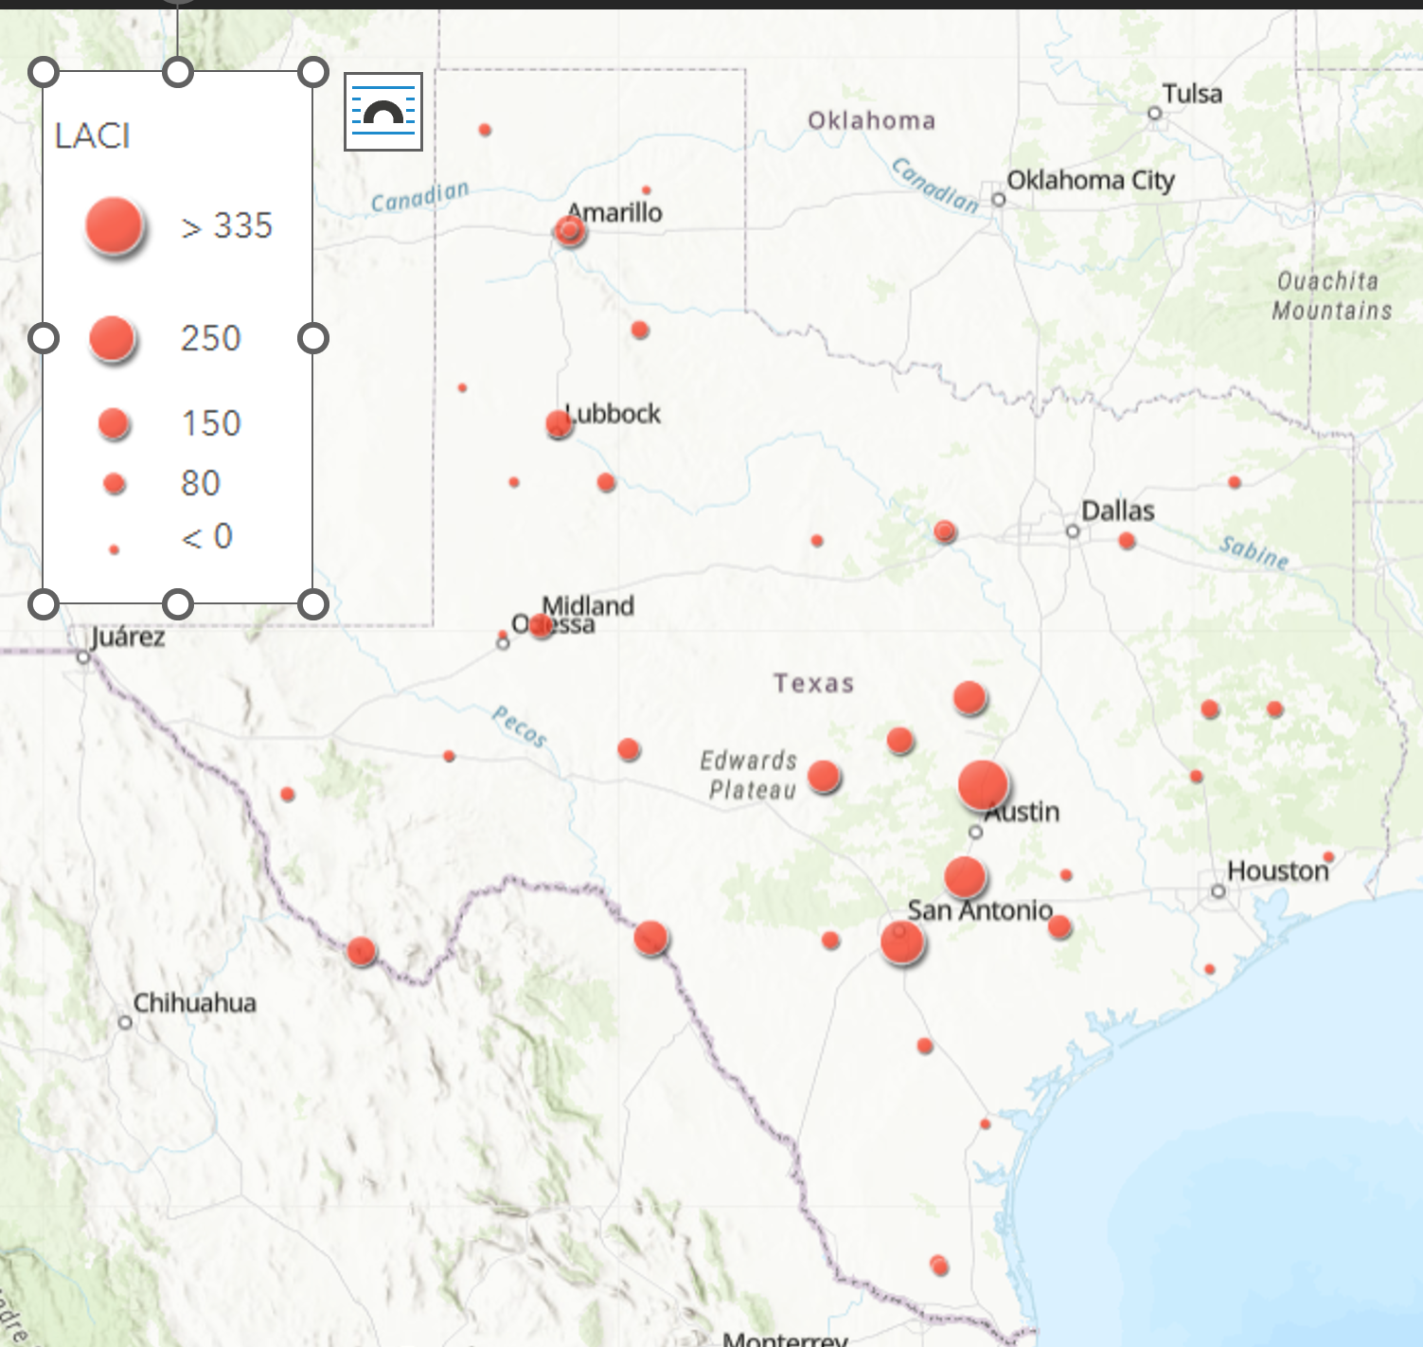

LACI Grid-Level Results: habitat and weather associations

Fall 2020
The maximum temperature °C was the BIC top model and had ΔBIC = 0 and had 99% cumulative weight (Table 4.2). The 50-km Water was the BIC top model for all landcover variables ΔBIC = 22 (Table 4.2). However, neither variable were significant predictors of LACI activity.

Table 4.2. Model output for LACI grid-level activity in Fall 2020.
Modnames | K | BIC | Delta_BIC | ModelLik | BICWt | LL | Cum.Wt
Maximum Temperature°C | 5 | 3003.77 | 0 | 1.00E+00 | 9.96E-01 | -1484.481 | 0.995
Minimum Temperature°C | 4 | 3015.40 | 11.632 | 2.98E-03 | 2.96E-03 | -1493.779 | 0.998
Temp_2020 | 7 | 3017.08 | 13.309 | 1.29E-03 | 1.28E-03 | -1484.174 | 0.999
Elevation | 4 | 3025.15 | 21.377 | 2.28E-05 | 2.27E-05 | -1498.651 | 0.999
50km_Urban | 4 | 3025.83 | 22.064 | 1.62E-05 | 1.61E-05 | -1498.995 | 0.999

Term | Estimate | Std. Error | z value | P-value
(Intercept) | -0.484 | 0.43 | -1.126 | 0.26
Scale(TMAX) | 0.014 | 0.013 | 1.074 | 0.283
Term | Estimate | Std. Error | z value | P-value
(Intercept) | 0.021 | 0.19 | 0.109 | 0.914
Urban50 | 0.33 | 0.176 | 1.878 | 0.06

Fall 2021
The maximum temperature °C was the BIC top model and had ΔBIC = 0 and had 99% cumulative weight (Table 4.3). The 10 km Barren was the BIC top model for all landcover variables ΔBIC = 337 (Table 4.3). However, no variable was a significant predictor of LACI activity.

Table 4.3. Model output for LACI grid-level activity in Fall 2021.
Modnames | K | BIC | Delta_BIC | ModelLik | BICWt | LL | Cum.Wt
Maximum Temperature°C | 5 | 2553.535 | 0 | 1.00E+00 | 9.96E-01 | -1259.042 | 0.996
Temp_2021 | 7 | 2564.683 | 11.148 | 3.79E-03 | 3.78E-03 | -1257.526 | 1
Minimum Temperature°C | 4 | 2779.753 | 226.218 | 7.54E-50 | 7.51E-50 | -1375.697 | 1
Period | 8 | 2784.062 | 230.527 | 8.74E-51 | 8.71E-51 | -1363.217 | 1
Julian | 4 | 2870.426 | 316.891 | 1.54E-69 | 1.54E-69 | -1420.806 | 1
10km_Barren | 4 | 2891.339 | 337.804 | 4.43E-74 | 4.42E-74 | -1431.263 | 1

Term | Estimate | Std. Error | z value | P-value
(Intercept) | -1.002 | 0.614 | -1.633 | 0.103
Scale(TMAX) | -0.001 | 0.017 | -0.059 | 0.953
Term | Estimate | Std. Error | z value | P-value
(Intercept) | -0.341 | 0.15 | -2.273 | 0.023
Barren10 | 0.219 | 0.132 | 1.66 | 0.097

Fall 2022
The minimum temperature °C was the BIC top model and had ΔBIC = 0 and had 84% cumulative weight. The 50 km Barren was the BIC top model for all landcover variables ΔBIC = 45. Both daily maximum temperature and urban landcover at the 50-km scale had a positive influence on LACI activity (Figs. 4.3 and 4.4)

Table 4.4. Model output for LACI grid-level activity in Fall 2022.
Modnames | K | BIC | Delta_BIC | ModelLik | BICWt | LL | Cum.Wt
Minimum Temperature°C | 4 | 1835.195 | 0 | 1.00E+00 | 8.39E-01 | -903.968 | 0.838
Julian | 4 | 1838.633 | 3.437 | 1.79E-01 | 1.50E-01 | -905.685 | 0.989
Temp_2022 | 7 | 1844.766 | 9.571 | 8.35E-03 | 7.00E-03 | -898.532 | 0.996
Maximum Temperature°C | 5 | 1846.019 | 10.823 | 4.46E-03 | 3.74E-03 | -905.970 | 0.999
Period | 8 | 1857.886 | 22.691 | 1.18E-05 | 9.92E-06 | -901.680 | 1
50km_Urban | 4 | 1880.054 | 44.859 | 1.82E-10 | 1.52E-10 | -926.395 | 1
Term | Estimate | Std. Error | z value | P-value
(Intercept) | -1.631 | 0.252 | -6.465 | <0.01
Scale(TMIN) | 0.075 | 0.011 | 7.044 | <0.01
Term | Estimate | Std. Error | z value | P-value
(Intercept) | -0.544 | 0.177 | -3.082 | 0.002
Urban50 | 0.326 | 0.149 | 2.19 | 0.029

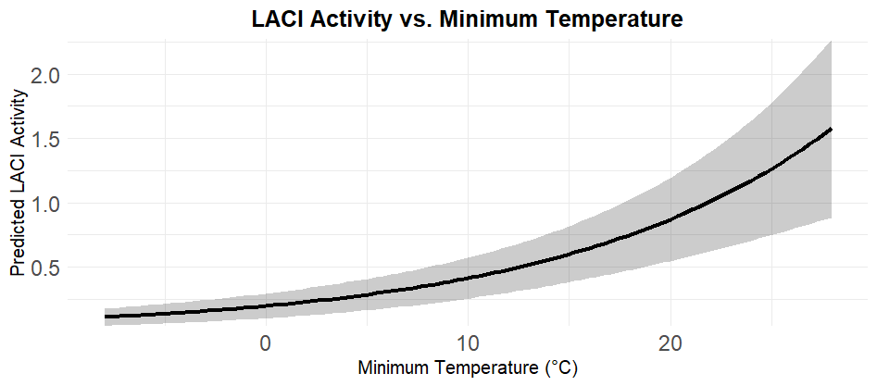
Fig. 4.2. Daily minimum temperature had a positive correlation with LACi activity.

Fig. 4.3. Urban landcover at the 50-km scale had a positive correlation with LACI activity.
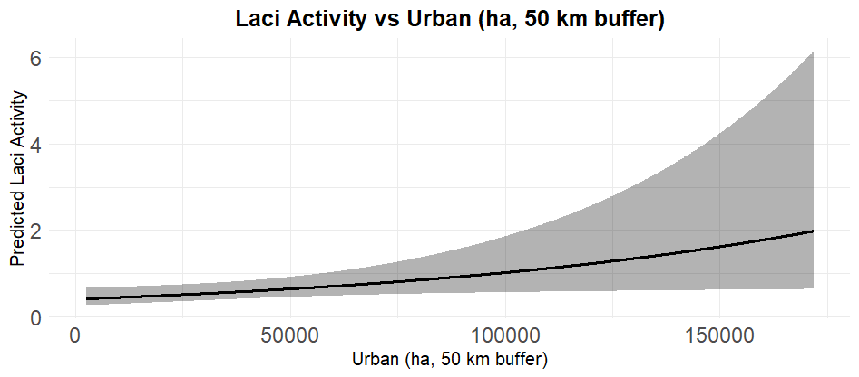

LACI Winter Results

General
We identified 7,500 acoustic passes of LACI across all years at 46 out of 48 grid cell (Fig. 4.4)s. Of these, 2,888 (40 grid cells), 1,018 (34 grid cells), and 3,594 (30 grid cells) LACI acoustic passes were identified from winter 2020 – 2021, winter 2021 – 2022, and winter 2022 – 2023, respectively.

Fig. 4.4. Locations of LACI during three Winter seasons across Texas. Note dots do not indicate exact properties of data collection, and instead are fuzzed or omitted for landowner privacy.
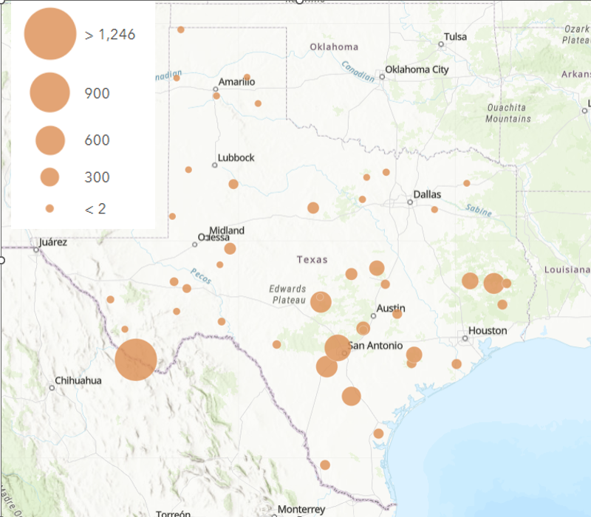

LACI Grid–level Daily Activity: habitat and weather associations

Winter 1: December 2020 – March 2021
The CustomDOY model was the BIC top model and had ΔBIC = 20.79 above the second–best model and 100% of the cumulative weight; however, CustomDOY was not significant (Table 4.5). The Land25 and Land50 models were the best landcover scale models and had ΔBIC = 1.83 (Table 4.5); however, no landcover type covariates were significant in these models.

Table 4.5. Model comparison of LACI in winter 1. The model containing custom DOY was the BIC best model.

Model | K | BIC | Delta BIC | BICWt | Cum.Wt | LL
CustomDOY | 5 | 2917.6 | 0.00 | 1 | 1 | -1440.29
Temperature | 7 | 2938.4 | 20.79 | 0 | 1 | -1443.41
Period | 11 | 2951.6 | 33.99 | 0 | 1 | -1435.09
Null | 3 | 3340.8 | 423.26 | 0 | 1 | -1659.31
Effort | 4 | 3346.1 | 428.58 | 0 | 1 | -1658.28
Distribution | 7 | 3358.3 | 440.72 | 0 | 1 | -1653.25
Land25 | 11 | 3389.9 | 472.34 | 0 | 1 | -1654.26
Land50 | 11 | 3391.7 | 474.17 | 0 | 1 | -1655.18
Land10 | 11 | 3394.6 | 477.06 | 0 | 1 | -1656.62

Winter 2: December 2021 – March 2022
The temperature model was the BIC top model and had ΔBIC = 208.79 above the second–best model and 100% of the cumulative weight (Table 4.6). Both Tmin (β = 0.6963, SE = 0.2153, z–value = 3.233, p–value = 0.001) and Tmax (β = 0.6963, SE = 0.2153, z–value = 3.233, p–value = 0.001) significantly influenced activity (Fig. 4.5). All landcover scale models were within ΔBIC = 2 of each other; however, no landcover type covariates were significant in any of these models (Table 4.6).

Table 4.6. Model comparison of LACI in winter 2. The model containing temperature was the BIC best model.
Model | K | BIC | Delta BIC | BICWt | Cum.Wt | LL
Temperature | 7 | 2137.5 | 0.00 | 1 | 1 | -1043.33
Period | 11 | 2346.3 | 208.79 | 0 | 1 | -1132.79
CustomDOY | 5 | 2348.8 | 211.28 | 0 | 1 | -1156.06
Effort | 4 | 2495.6 | 358.05 | 0 | 1 | -1233.11
Null | 3 | 2550.1 | 412.56 | 0 | 1 | -1264.04
Distribution | 7 | 2564.2 | 426.67 | 0 | 1 | -1256.41
Land50 | 11 | 2596.9 | 459.33 | 0 | 1 | -1258.07
Land25 | 11 | 2598.3 | 460.79 | 0 | 1 | -1258.80
Land10 | 11 | 2598.7 | 461.20 | 0 | 1 | -1259.00

 | Estimate | Std. Error | z value | Pr(>|z|)
(Intercept) | -2.1307 | 0.3452 | -6.172 | 6.76e-10
s(Tmin)1 | 0.4255 | 0.1432 | -2.971 | 0.00297
s(Tmax)1 | 1.4688 | 0.1524 | 9.637 | < 2e-16

Fig. 4.5. LACI activity was negatively correlated with minimum temperature and positively correlated with daily maximum temperature in winter 2.
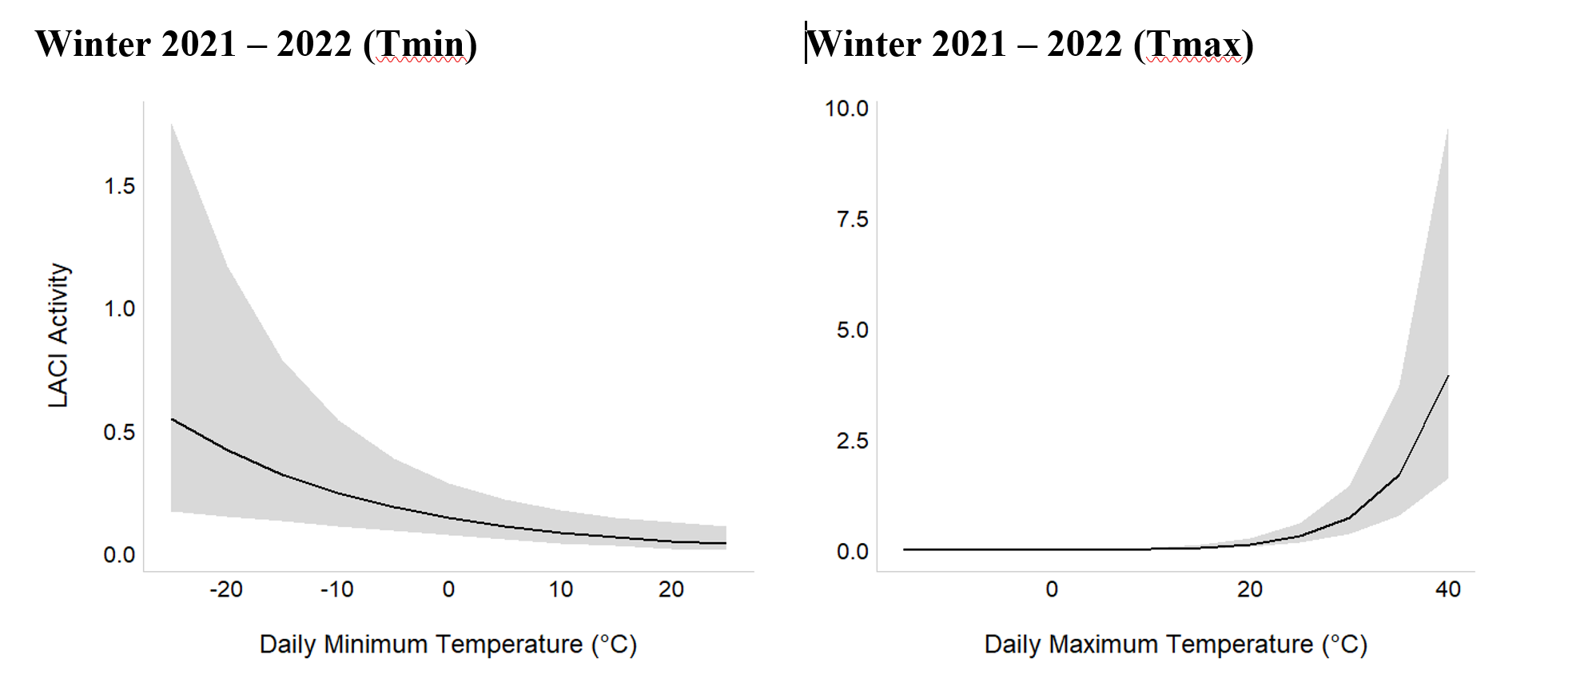

Winter 3: December 2022 – March 2023
The CustomDOY model was the BIC top model and had ΔBIC = 2.73 above the second–best model and 80% of the cumulative weight; however, CustomDOY was not significant (Table 4.7). The Land50 model was the best landcover scale model and had ΔBIC = 2.03 above the second–best landcover scale model, which was Land25; however, no landcover type covariates were significant in the model (Table 4.7).

Table 4.7. Model comparison of LACI in winter 3. The model containing temperature was the BIC best model.
Model | K | BIC | Delta BIC | BICWt | Cum.Wt | LL
CustomDOY | 5 | 2883.3 | 0.00 | 0.797 | 0.797 | -1423.68
Temperature | 7 | 2886.0 | 2.73 | 0.203 | 1 | -1417.95
Period | 11 | 2913.9 | 30.57 | 0 | 1 | -1417.41
Effort | 4 | 3018.8 | 198.47 | 0 | 1 | -1526.51
Null | 3 | 3088.6 | 205.31 | 0 | 1 | -1533.52
Distribution | 7 | 3107.5 | 224.17 | 0 | 1 | -1528.58
Land50 | 11 | 3124.4 | 241.12 | 0 | 1 | -1522.68
Land25 | 11 | 3126.4 | 243.15 | 0 | 1 | -1523.70
Land10 | 11 | 3127.8 | 244.52 | 0 | 1 | -1524.38

In summary, daily maximum temperature (Tmax) and daily minimum temperature (Tmin) were only significant covariates for LACI activity in winter 2021 – 2022. There were no significant covariates in the best models for winter 2020 – 2021 and winter 2022 – 2023, therefore these winters are not present in Fig. 4.6.

Fig. 4.6. Daily maximum temperature and daily minimum temperature were significant predictors of LACI activity during winter 2.
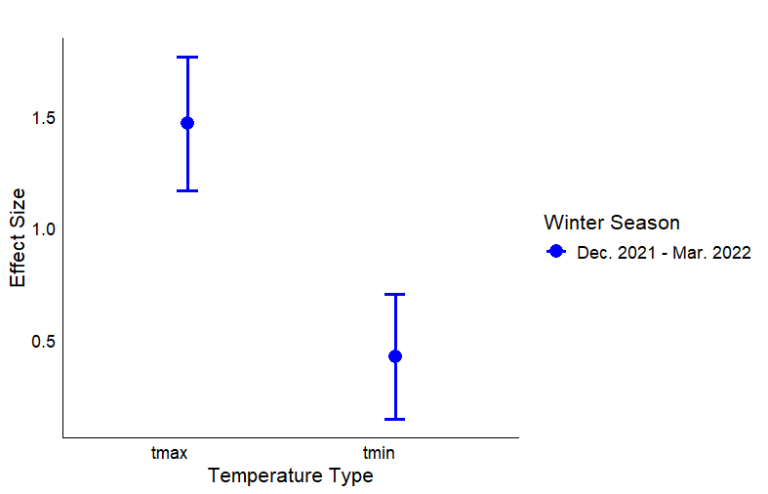

LACI Migration and Hibernation Ecology
LACI is considered a migratory species, but also can hibernate and go through bouts of torpor. However, the species does not seem to be susceptible to WNS. Understanding migration routes of the species is important for wind turbine siting. Thus, we conducted the regression analysis that examined the interaction between period and geographic area of the state. Based on this assessment, LACI activity was significantly greater in East Texas during period 6, indicating that this region plays a crucial role in LACI activity during late fall (Fig. 4.7). Similarly, LACI activity was notably greater in South Texas during period 6, suggesting that this area is also a significant contributor to LACI activity during late fall.
Fig. 4.7. The interactive effect between geographic location in the state and fall season period.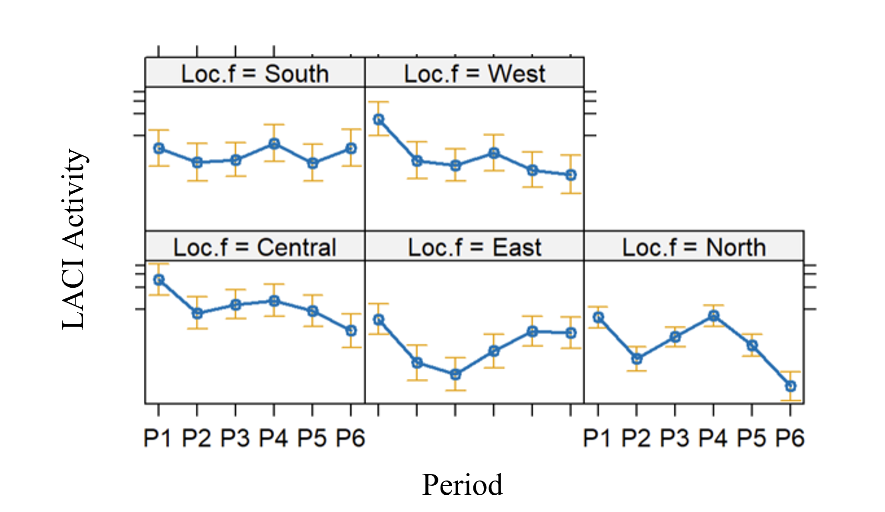

The visualizations of LACI activity by period across Texas during the Falls indicate that the species remained active in several geographic areas and Ecoregions during Falls (Fig. 4.8). During Fall 2020, there appeared to be lower activity in the northernmost regions of Texas early in the season and late in the season; however Fall 2021 and Fall 2022 showed variations in this pattern. Fall 2021 had greater activity early in the Fall season across the state with activity decreasing around the periphery of the state as the season progressed (Fig. 4.8). Fall 2022 showed a similar pattern to 2021 with activity decreasing on the peripheries of the state; however, activity remained in pockets across west Texas, central Texas, and north central Texas. Due to these varying patterns, a definitive migratory route is difficult to identify (Fig. 4.8). It is possible that fall migration routes change slightly based on weather conditions.

Fig. 4.8. LACI activity by period across Texas during Fall seasons.

Fall 2020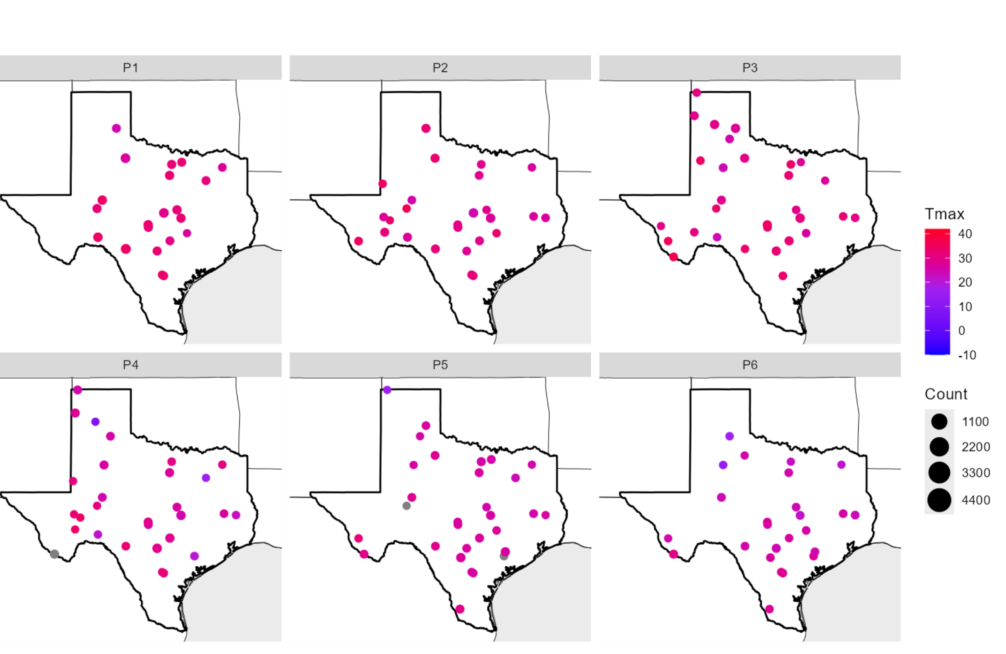

Fall 2021
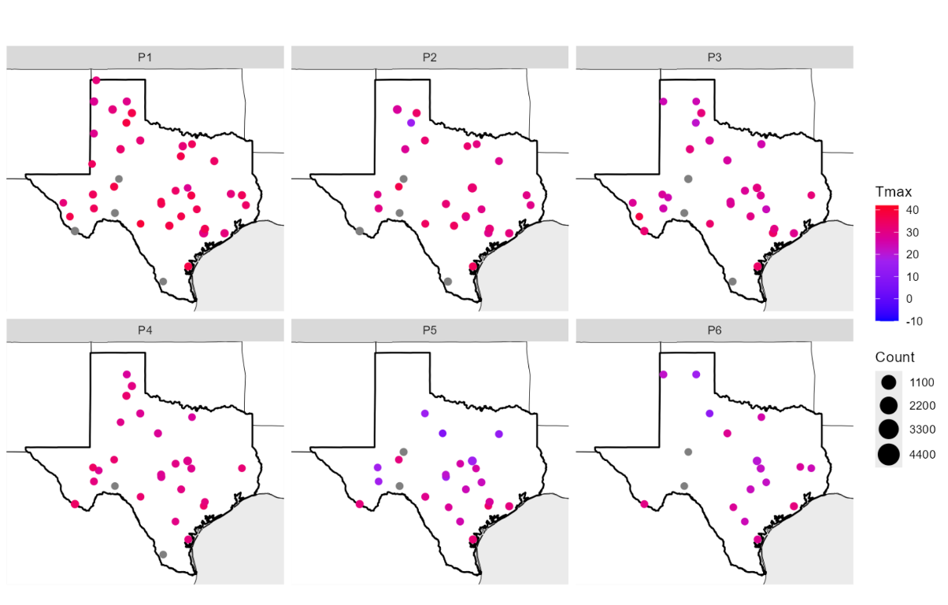

Fall 2022
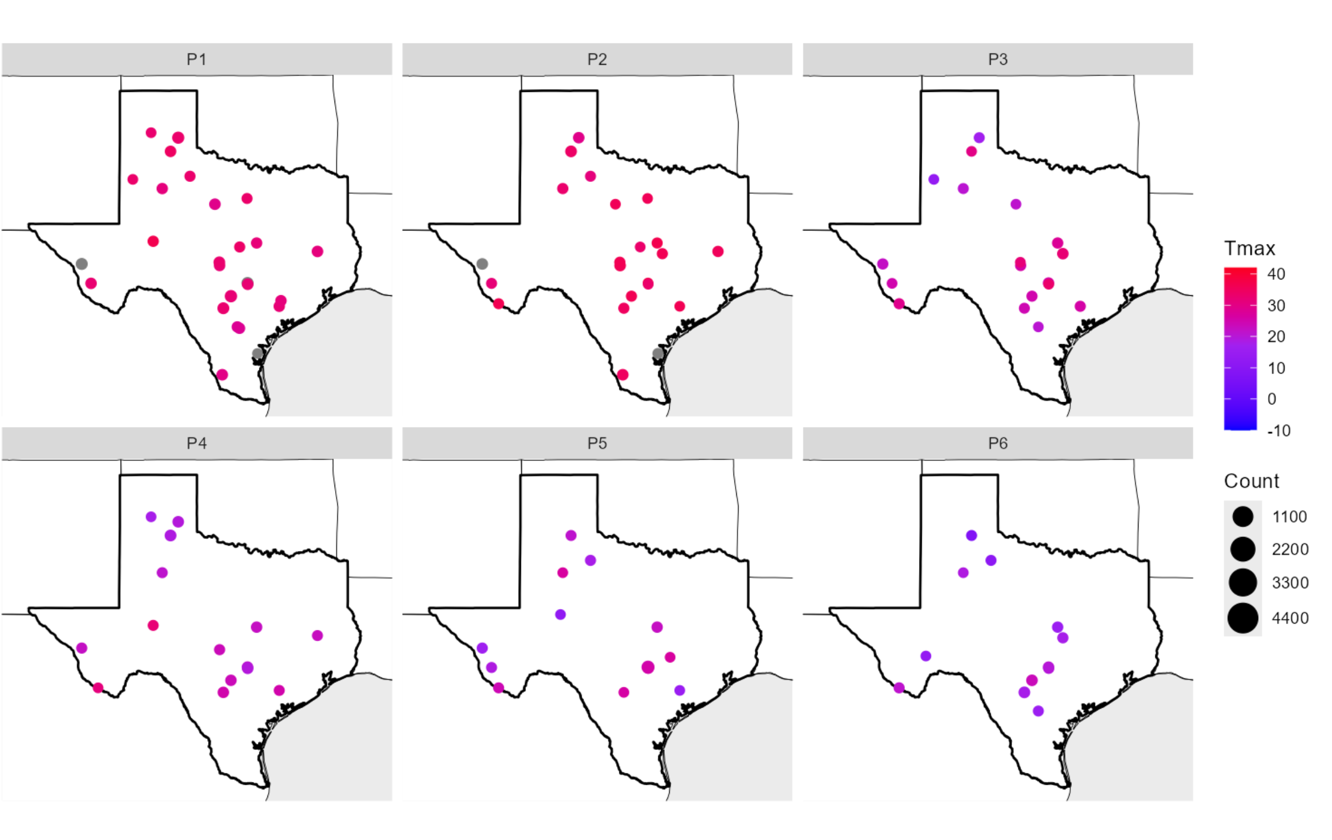

We also assessed winter ecology of LACI as the species is known to hibernate and migration is a two-way movement. During winter seasons, LACI were active during all periods in 2021 (Fig. 4.9); however, activity decrased in north, west, and east Texas during the middle of the winter (Fig. 4.9). A similar trend was detected in winter 2022. In 2023, there was little LACI activity in early winter, and only in central and far west Texas. Activity increased throughout the entire state as spring approached. For winter 2020 – 2021 and winter 2021 – 2022, the South Texas Plains accounted for the greatest number of LACI acoustic passes across several Periods (4 – 7 for winter 2020 – 2021, 2 – 6 for winter 2021 – 2022; Fig. 4.10). The South Texas Plains, Pineywoods, and Hill Country accounted for the greatest number of acoustic passes in winter 2020 – 2021 (Period 7), winter 2021 – 2022 (Period 8), and winter 2022 – 2023 (Period 8), respectively. Additionally, the High Plains/Panhandle accounted for the greatest number of acoustic passes for Period 8 in winter 2020 – 2021, and Periods 4 and 6 in winter 2022 – 2023.

Fig. 4.9. LACI activity across Texas during three winter seasons.
Winter 2020/2021
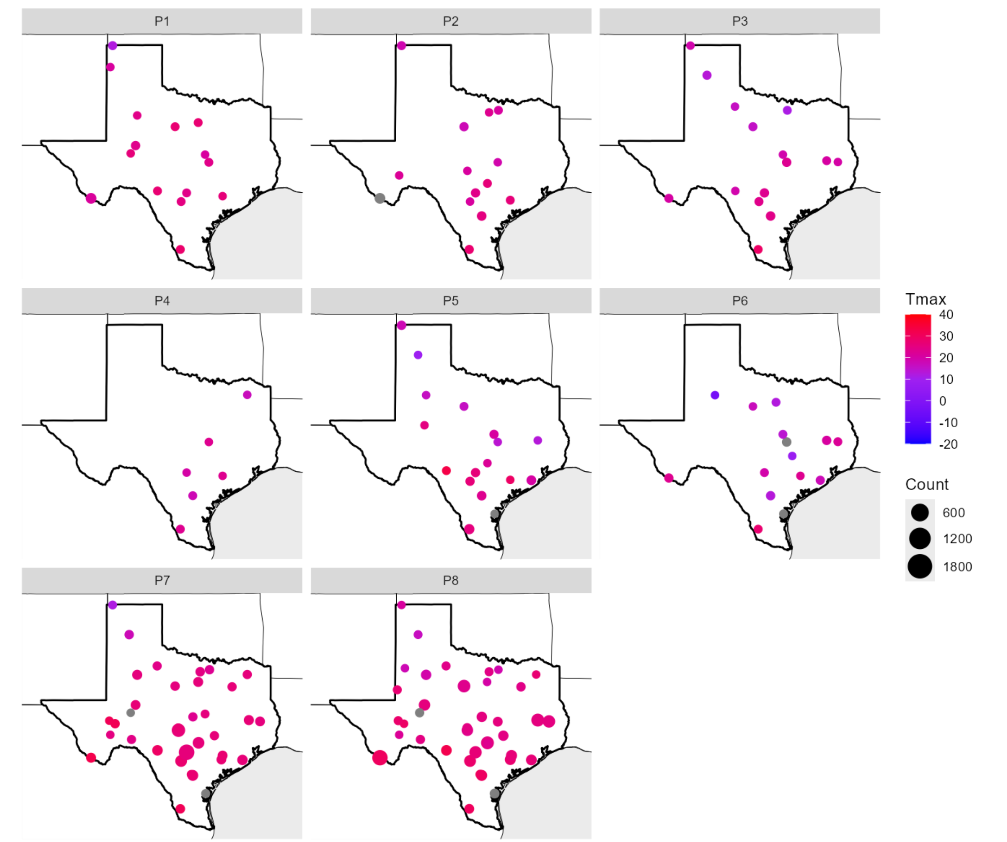

Winter 2021/2022
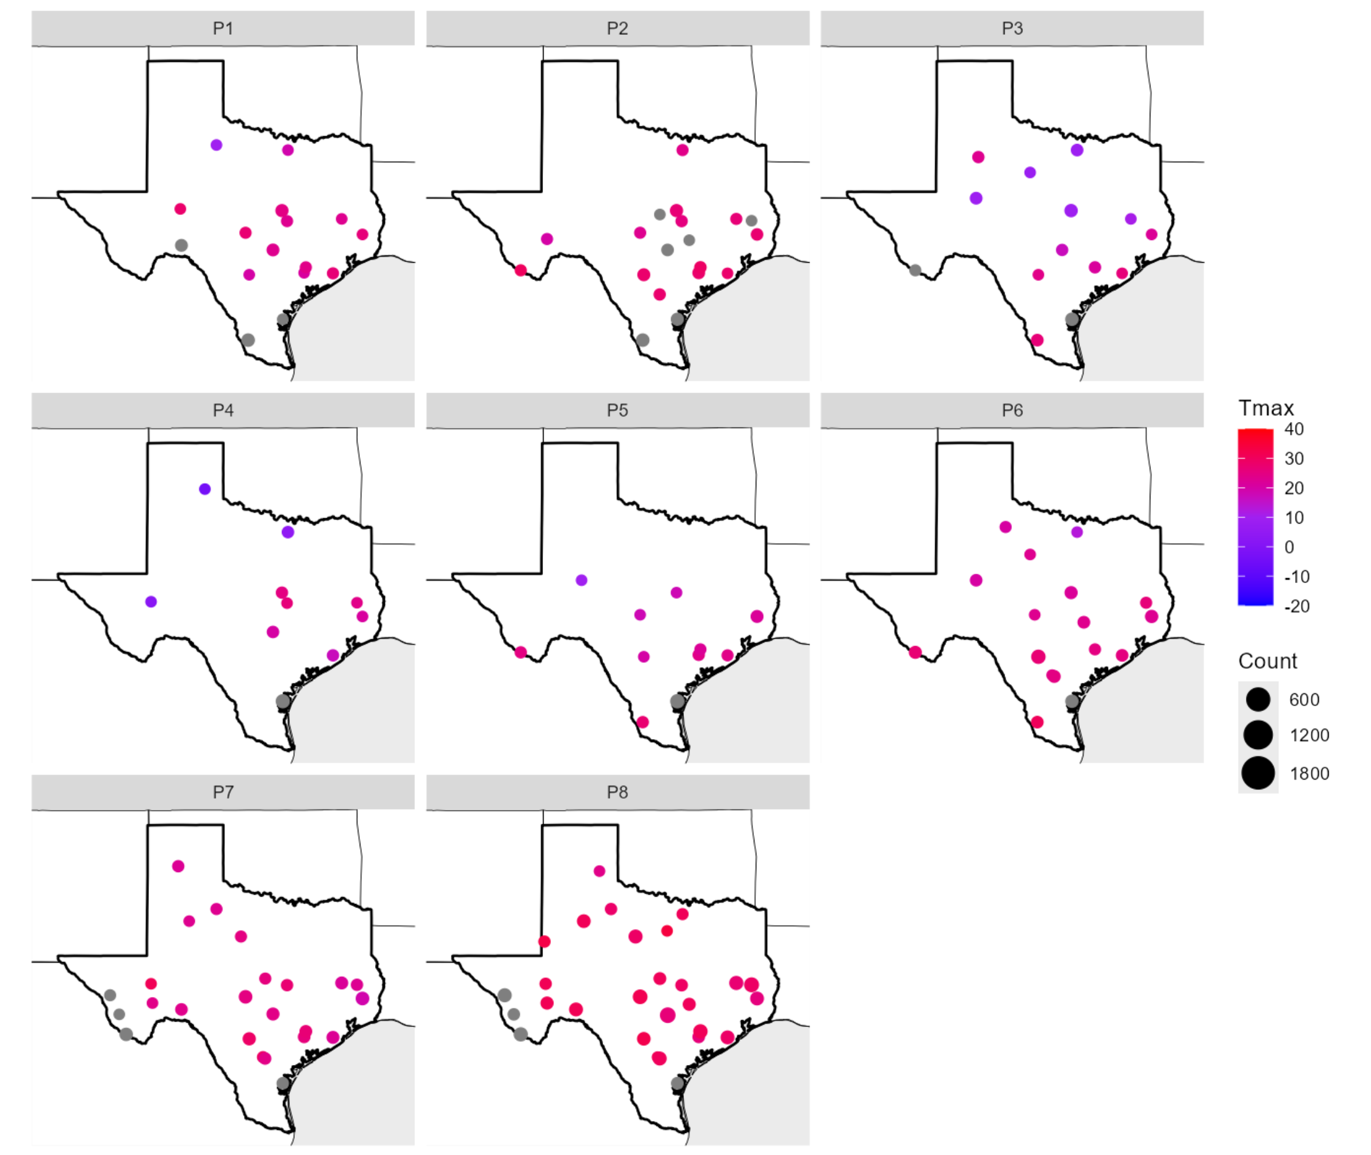
Winter 2022/2023
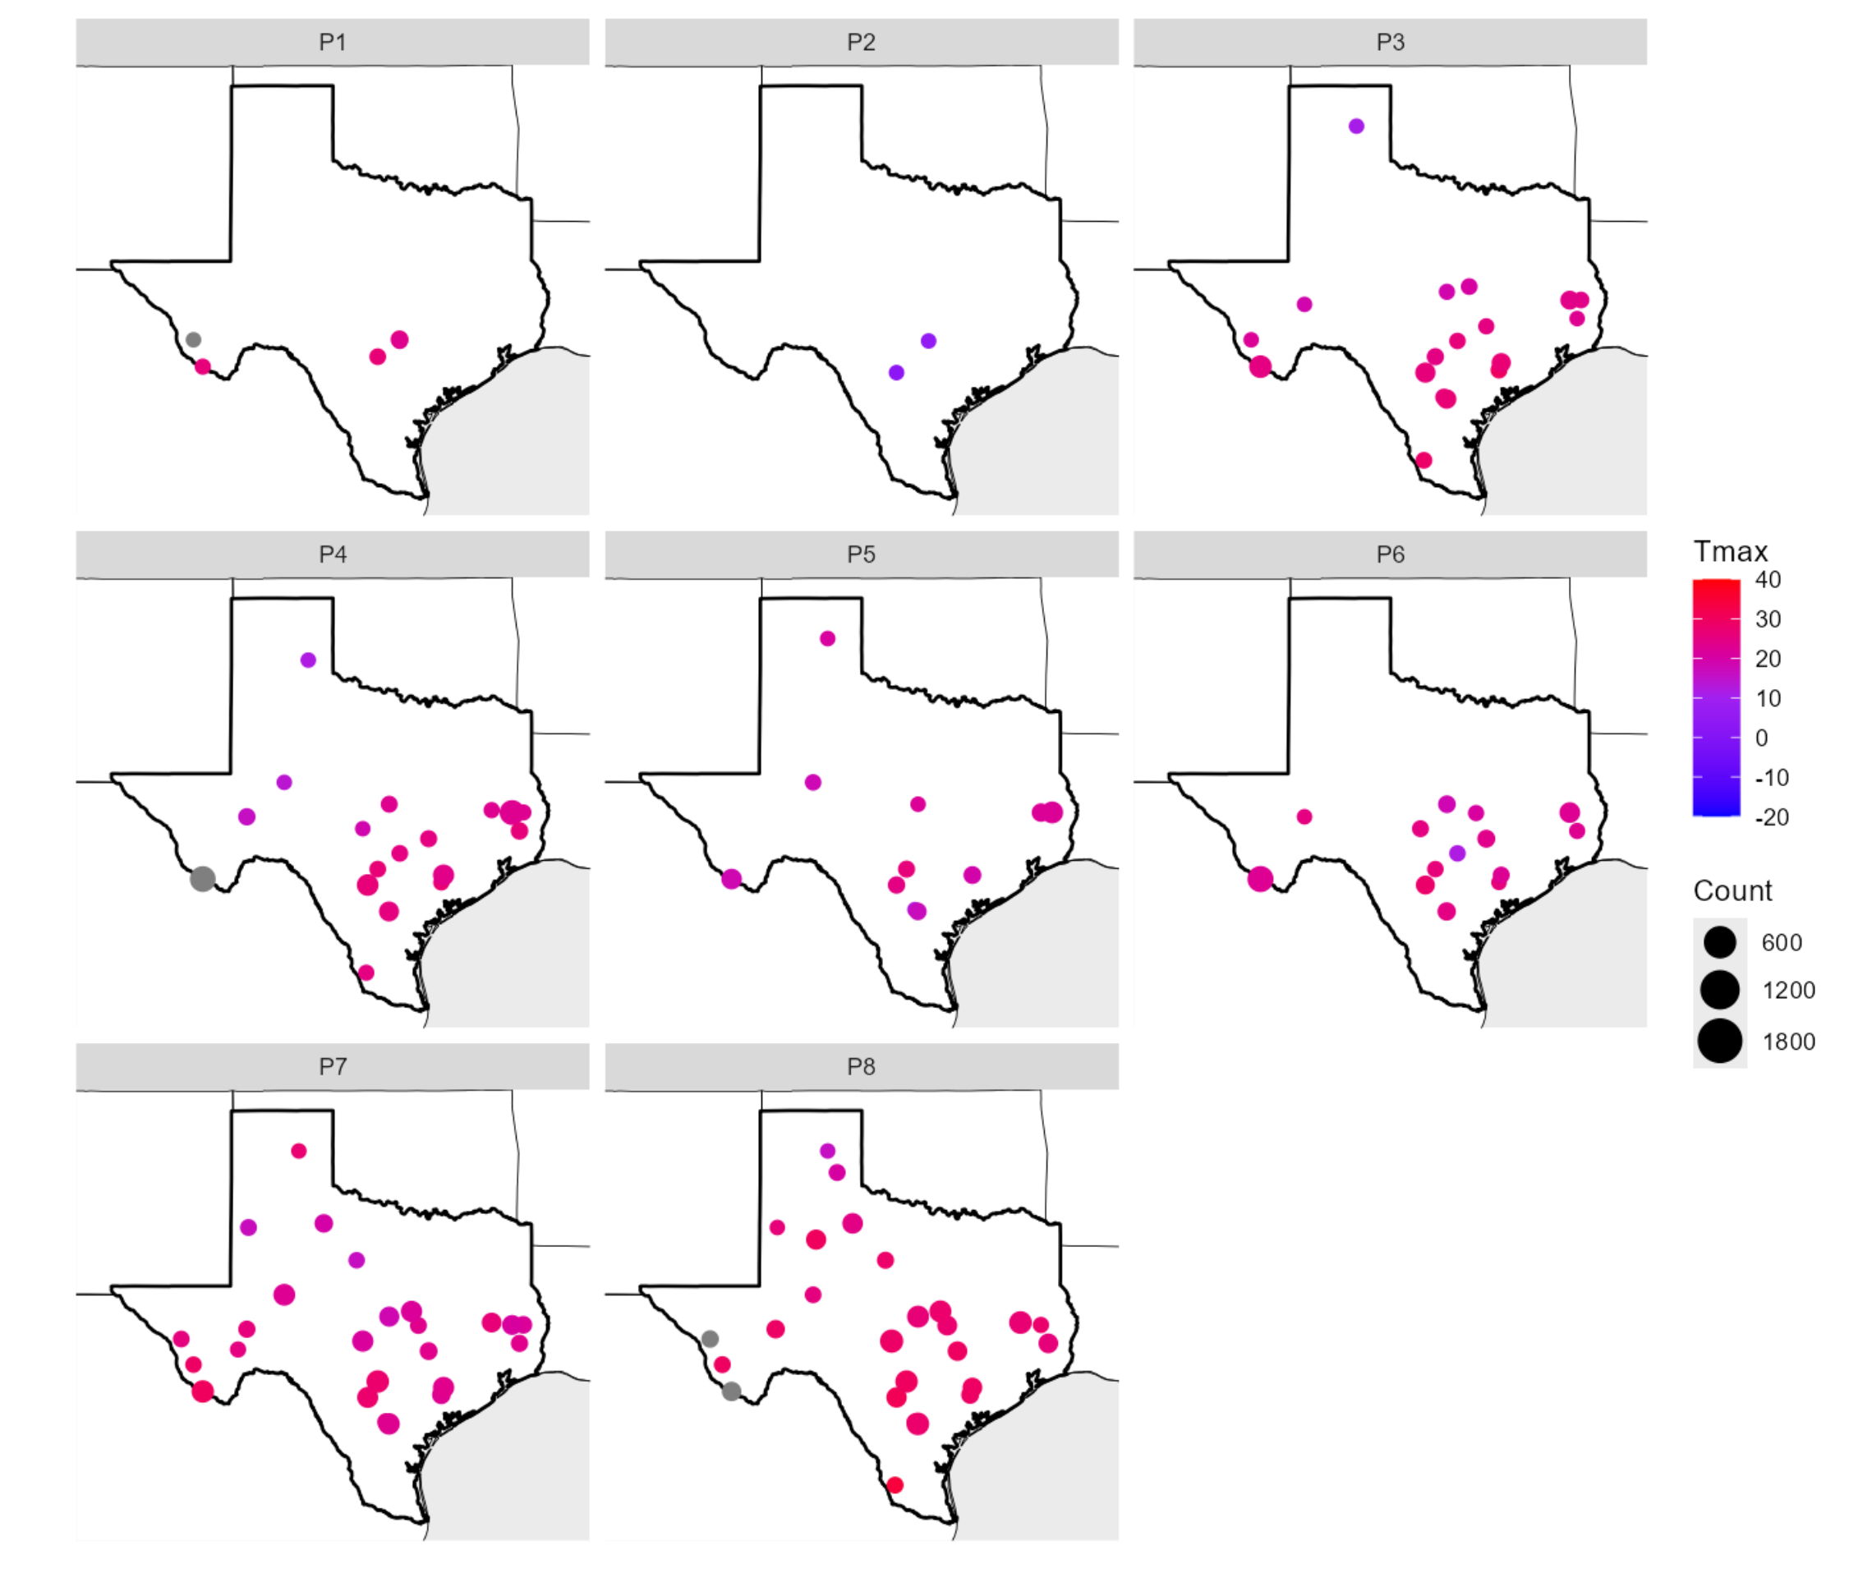

For winter 2020 – 2021 and winter 2021 – 2022, the South Texas Plains accounted for the greatest number of LACI acoustic passes across several Periods (4 – 7 for winter 2020 – 2021, 2 – 6 for winter 2021 – 2022; Fig. 4.10). The South Texas Plains, Pineywoods, and Hill Country accounted for the greatest number of acoustic passes in winter 2020 – 2021 (Period 7), winter 2021 – 2022 (Period 8), and winter 2022 – 2023 (Period 8), respectively. Additionally, the High Plains/Panhandle accounted for the greatest number of acoustic passes for Period 8 in winter 2020 – 2021, and Periods 4 and 6 in winter 2022 – 2023.

Fig. 4.10. The interactive effect between geographic location in the state and winter season period.

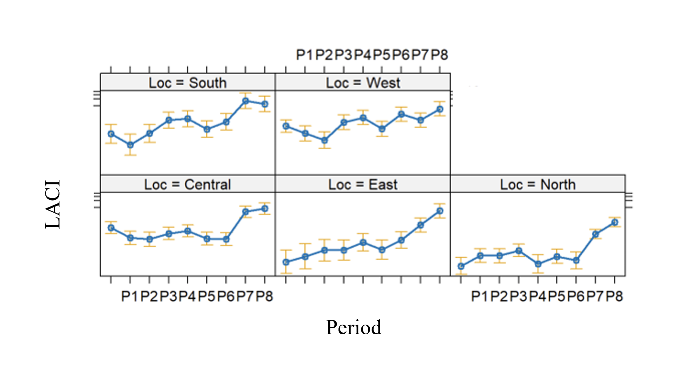

We plotted LACI activity based on minimum and maximum temperature for winter 2 since this relationship was significant. The lowest daily minimum temperatures (Tmin) of LACI acoustic passes occurred at –13°C (n = 1), followed by -9° C (n = 3), -8° C (n = 3), -7° C (n = 3), and -6° C (n = 5; Fig. 4.8). As Tmin increases, the number of LACI acoustic passes also increases to ~7° C (n = 93), then slightly decreased. The highest daily maximum temperatures (Tmax) of LACI acoustic passes occurred at 36° C (n = 1) with the largest number of passes occurring at 28°C (n = 85). Peak Tmax ranges of acoustic passes occur around 21 to 32° C (Fig. 4.11). The highest daily maximum temperatures (Tmax) of LACI acoustic passes occurred at 36° C (n = 1) with the largest number of passes occurring at 28° C (n = 85). Peak Tmax ranges of acoustic passes occur around 21 to 32°C (Fig. 4.11).

Fig. 4.11. Daily minimum and maximum temperatures with LACI activity in winter in Texas.
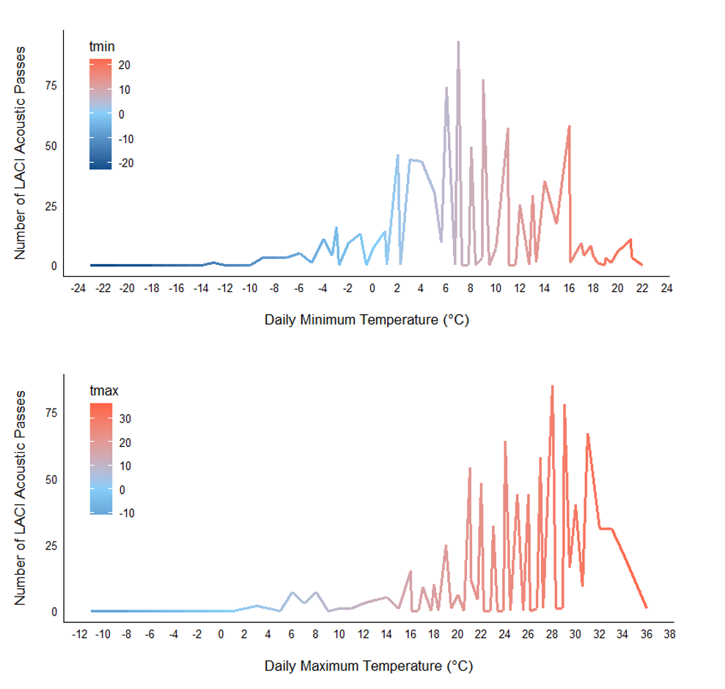

For winter 2020 – 2021 and winter 2021 – 2022, the South Texas Plains accounted for the greatest number of LACI acoustic passes across several Periods (4 – 7 for winter 2020 – 2021, 2 – 6 for winter 2021 – 2022). The South Texas Plains, Pineywoods, and Hill Country accounted for the greatest number of acoustic passes in winter 2020 – 2021 (Period 7), winter 2021 – 2022 (Period 8), and winter 2022 – 2023 (Period 8), respectively. Additionally, the High Plains/Panhandle accounted for the greatest number of acoustic passes for Period 8 in winter 2020 – 2021, and Periods 4 and 6 in winter 2022 – 2023.

For winter 2020 – 2021, Period 8 had the greatest number of acoustic passes (n = 1,526) followed by Period 7 (n = 972; Table 4.5). For winter 2021 – 2022, Period 8 had the greatest number of acoustic passes (n = 451) followed by Period 7 (n = 131). For winter 2022 – 2023 Period 8 had the greatest number of acoustic passes (n = 1,028) followed by Period 7 (n = 867). Periods 3 and 4 during winter 2020 – 2021 had the fewest LACI acoustic passes, with counts of 44 and 8. Period 4 during winter 2021 – 2022 had the fewest LACI acoustic passes, with 45 acoustic passes. Periods 1 and 2 during winter 2022 – 2023 had the fewest LACI acoustic passes, with counts of 21 and 2 (Table 4.8).

Table 4.8 Total number of LACI acoustic passes from 46 grids categorized by period for three winters.The “unspecified” row represents acoustic passes from CustomDOY not assigned to a period.
Period | Winter  2020 – 2021 | Winter  2021 – 2022 | Winter  2022 – 2023 | Total
LACI | 2,888 | 1,018 | 3,594 | 7,500
1 | 64 | 55 | 21 | 140
2 | 73 | 83 | 2 | 158
3 | 44 | 59 | 280 | 383
4 | 8 | 45 | 641 | 694
5 | 77 | 55 | 201 | 333
6 | 45 | 112 | 378 | 535
7 | 972 | 131 | 867 | 1,970
8 | 1,526 | 451 | 1,028 | 3,005
unspecified | 79 | 27 | 176 | 282

Red Bats Fall Results

General
We identified 12,815 calls as REDS over three Fall seasons at 40 grid cells (Table 4.9, Fig. 4.12).

Table 4.9. The number of Red bat calls, grid cells, vetted calls, and calls/detector night for each year.
Estimate | Fall 2020 | Fall 2021 | Fall 2022
Number Active Cells | 42 | 43 | 38
Cells w/Manually Vetted Calls | 34 | 40 | 27
Call count | 3,991 | 5,417 | 3,407
Calls/detector Night | 95.0 | 225.7 | 141.9

Fig. 4.12. Locations of red bats during three fall seasons. Note dots do not indicate exact properties of data collection, and instead are fuzzed for landowner privacy.
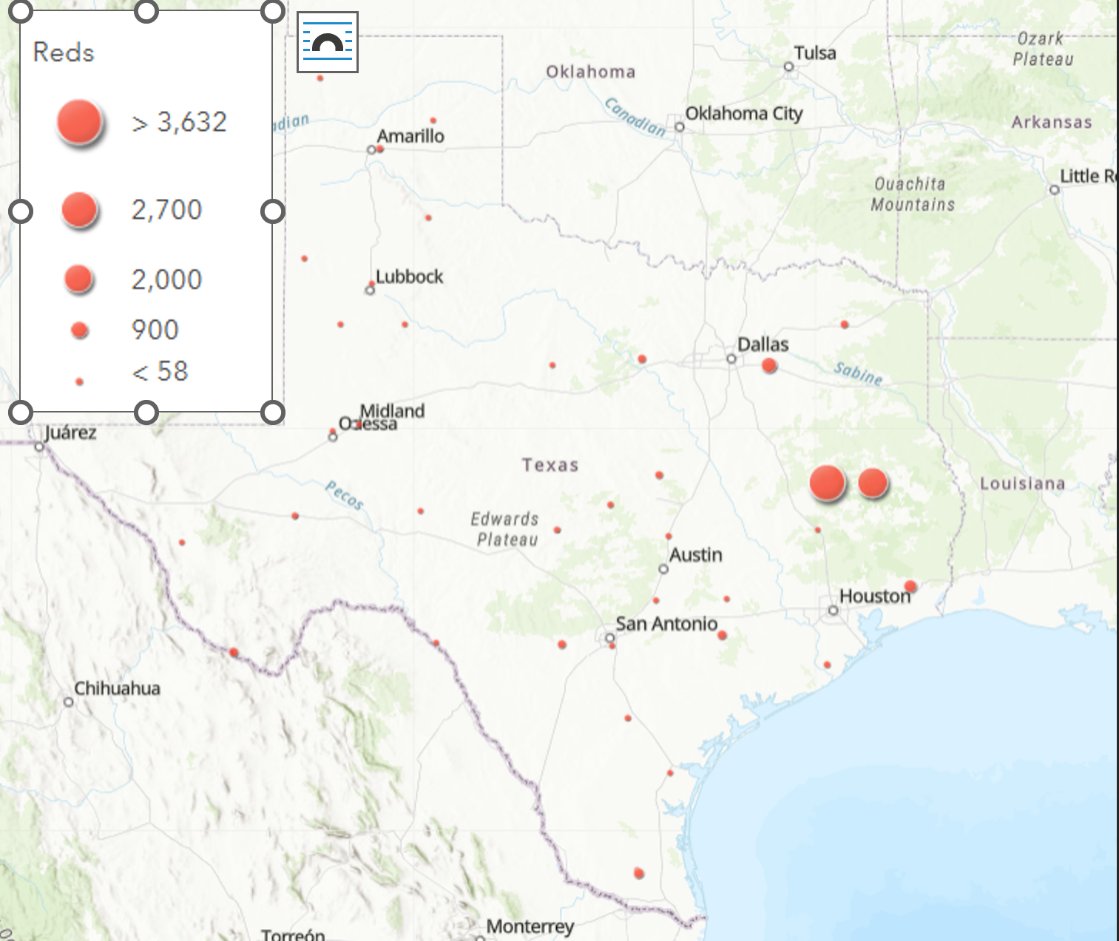

Red Bats Grid-Level Results: habitat and weather associations

Fall 2020
The maximum temperature °C was the BIC top model and had ΔBIC = 0 and had 99% cumulative weight (Table 4.10). The 50-km Water was the BIC top model for all landcover variables ΔBIC = 145 and WAT50 was a significant predictor of activity (Table 4.10, Fig. 4.13).

Table 4.10. Model output for red bats grid-level activity in Fall 2020.
Modnames | K | BIC | Delta_BIC | ModelLik | BICWt | LL | Cum.Wt
Maximum Temperature°C | 5 | 2348.812 | 0 | 1.00E+00 | 9.92E-01 | -1157 | 0.991
Temp_2020 | 7 | 2358.398 | 9.586 | 8.29E-03 | 8.22E-03 | -1154.831 | 1
50km_Water | 4 | 2494.017 | 145.204 | 2.95E-32 | 2.92E-32 | -1233.084 | 1
Julian | 4 | 2500.173 | 151.361 | 1.36E-33 | 1.35E-33 | -1236.162 | 1
Longitude | 4 | 2504.678 | 155.865 | 1.43E-34 | 1.41E-34 | -1238.414 | 1

Term | Estimate | Std. Error | z value | P-value
(Intercept) | -0.92 | 0.63 | -1.461 | 0.144
Scale(TMAX) | 0.004 | 0.018 | 0.24 | 0.81
Term | Estimate | Std. Error | z value | P-value
(Intercept) | 0.277 | 0.205 | 1.347 | 0.178
Water50 | 1.028 | 0.164 | 6.263 | <0.01

Fig. 4.13. Red bat activity was positively correlated with water at the 50-km scale in Fall 2020.
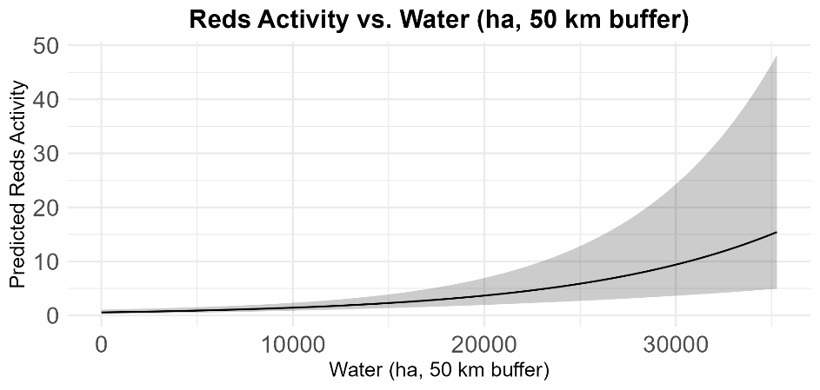

Fall 2021
The maximum temperature °C was the BIC top model and had ΔBIC = 0 and had 99% cumulative weight (Table 4.11). The 50-km Water was the BIC top model for all landcover variables ΔBIC = 151 and WAT50 was a significant predictor of red bat activity (Table 4.11, Fig. 4.14).

Table 4.11. Model output for red bats grid-level activity in Fall 2021.
Modnames | K | BIC | Delta_BIC | ModelLik | BICWt | LL | Cum.Wt
Maximum Temperature°C | 5 | 2535.599 | 0 | 1.00E+00 | 9.99E-01 | -1250.074 | 0.999
Temp_2021 | 7 | 2549.554 | 13.954 | 9.33E-04 | 9.32E-04 | -1249.962 | 1
Minimum Temperature°C | 4 | 2960.808 | 425.209 | 4.64E-93 | 4.64E-93 | -1466.224 | 1
50km_Water | 4 | 3016.426 | 480.827 | 3.89E-105 | 3.88E-105 | -1493.806 | 1
Longitude | 4 | 3021.25 | 485.651 | 3.49E-106 | 3.48E-106 | -1496.218 | 1

Term | Estimate | Std. Error | z value | P-value
(Intercept) | -1.581 | 0.742 | -2.131 | 0.033
Scale(TMAX) | 0.022 | 0.019 | 1.202 | 0.23
Term | Estimate | Std. Error | z value | P-value
(Intercept) | 0.895 | 0.188 | 4.771 | 0
Water50 | 0.604 | 0.137 | 4.412 | 0

Fig. 4.14. Red bat activity was positively correlated with water at the 50-km scale in Fall 2021.
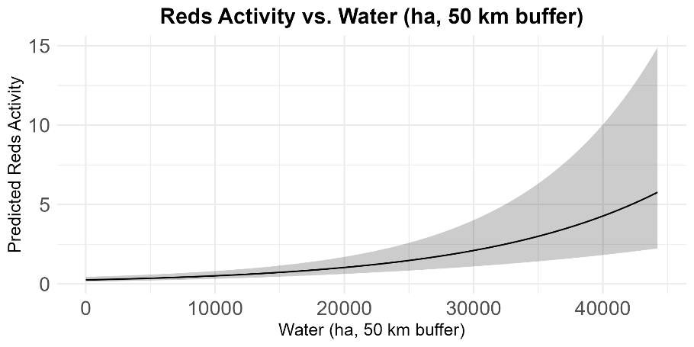

Fall 2022
The maximum temperature °C was the BIC top model and had ΔBIC = 0 and had 99% cumulative weight (Table 4.12). The 50-km Forest was the BIC top model for all landcover variables ΔBIC = 66 and was positively correlated with red bat activity (Table 4.12 and Fig. 4.15).
Table 4.12. Model output for red bats grid-level activity in Fall 2022.
Modnames | K | BIC | Delta_BIC | ModelLik | BICWt | LL | Cum.Wt
Maximum Temperature°C | 5 | 1452.157 | 0 | 1.00E+00 | 9.98E-01 | -709.0393 | 0.997
Temp_2022 | 7 | 1464.326 | 12.169 | 2.28E-03 | 2.27E-03 | -708.3122 | 1
50km_Water | 4 | 1515.658 | 63.501 | 1.63E-14 | 1.62E-14 | -744.1978 | 1
Longitude | 4 | 1517.949 | 65.79 | 5.17E-15 | 5.16E-15 | -745.3432 | 1
50km_Forest | 4 | 1518.439 | 66.28 | 4.04E-15 | 4.04E-15 | -745.5885 | 1
Term | Estimate | Std. Error | z value | P-value
(Intercept) | -0.808 | 0.684 | -1.18 | 0.238
Scale(TMAX) | 0.026 | 0.021 | 1.208 | 0.227
Term | Estimate | Std. Error | z value | P-value
(Intercept) | 0.534 | 0.266 | 2.006 | 0.045
Water50 | 0.773 | 0.189 | 4.081 | <0.01

Fig. 4.17. Red b

Fig. 4.15. Red bat activity was positively correlated with Forest cover in Fall 2022.
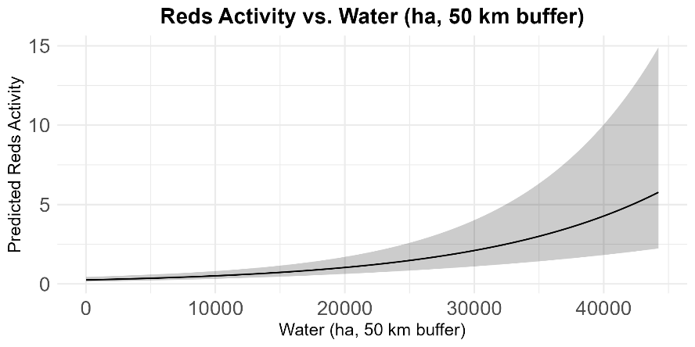

Red Bats Winter Results

General
We identified 21,893 acoustic passes of Reds across all years at 40 out of 48 grid cells (Fig. 4.16). Of these, 6,943 (36 grid cells), 5,618 (34 grid cells), and 9,332 (29 grid cells) Reds acoustic passes were identified from winter 2020 – 2021, winter 2021 – 2022, and winter 2022 – 2023, respectively. The Land10 and Land50 models were the best landcover scale models and had ΔBIC = 1.57; however, this model had a BIC lower than the null so was considered noncompeting (Table 4.13).

Fig. 4.16. Locations of red bats during winter seasons. Note dots do not indicate exact properties of data collection, and instead are fuzzed or omitted for landowner privacy.
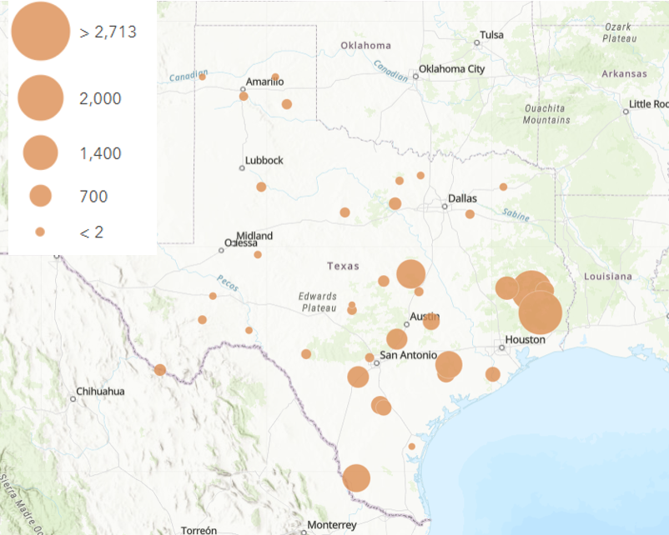

Red Bats Grid-Level Results: habitat and weather associations

Winter 1: December 2020 – March 2021
The period model was the BIC top model and had ΔBIC = 146.17 above the second–best model and 100% of the cumulative weight (Table 4.13). Only Tmin (β = 0.5684, SE = 0.0932, z–value = 6.098, p–value < 0.001) influenced activity (Table 4.13; Fig. 4.17).

Table 4.13. Model output for red bats in Winter 1.
Model | K | BIC | Delta BIC | BICWt | Cum.Wt | LL
Temperature | 7 | 4572.1 | 0.00 | 1 | 1 | -2260.27
CustomDOY | 5 | 4718.2 | 146.17 | 0 | 1 | -2340.62
Period | 11 | 4721.5 | 149.44 | 0 | 1 | -2320.06
Effort | 4 | 5107.0 | 534.94 | 0 | 1 | -2538.70
Null | 3 | 5112.1 | 540.02 | 0 | 1 | -2544.95
Distribution | 7 | 5119.7 | 547.68 | 0 | 1 | -2533.98
Land10 | 11 | 5147.3 | 575.25 | 0 | 1 | -2532.97
Land50 | 11 | 5148.9 | 576.82 | 0 | 1 | -2533.75
Land25 | 11 | 5152.5 | 580.39 | 0 | 1 | -2535.54
 | Estimate | Std. Error | z value | Pr(>|z|)
(Intercept) | -1.3310 | 0.3970 | -3.353 | 0.0008
s(Tmin)1 | 0.5684 | 0.0932 | 6.098 | 1.07e-09
s(Tmax)1 | 0.3732 | 2.0874 | 0.179 | 0.8581

Fig. 4.17. Red bat activity was positively correlated with daily minimum temperature during winter 1.
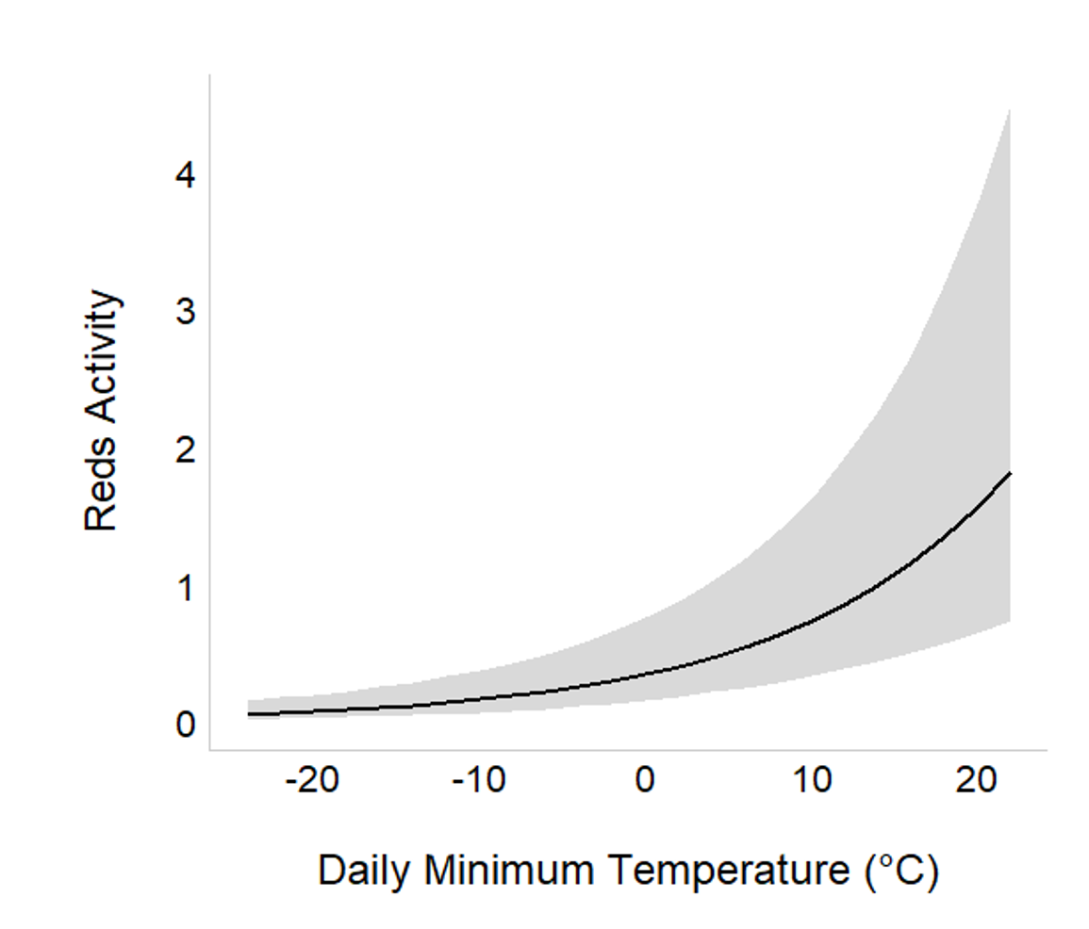

Winter 2: December 2021 – March 2022
The temperature model was the BIC top model and had ΔBIC = 197.90 above the second–best model and 100% of the cumulative weight (Table 4.14). Only Tmin (β = 0.2644, SE = 0.1183, z–value = 2.234, p–value = 0.0255) significantly influenced activity (Table 4.14, Fig. 4.18). The Land25 model was the best landcover scale model and had ΔBIC = 3.39 above the second–best landcover scale model, which was Land10 (Table 4.14); however, no landcover type covariates were significant in the model and the BIC was lower than the null so it was considered noncompeting.

.
Table 4.14. Model outputs of red bats during winter 2.
Model | K | BIC | Delta BIC | BICWt | Cum.Wt | LL
Temperature | 7 | 3866.4 | 0.00 | 1 | 1 | -1907.76
Period | 11 | 4064.3 | 197.90 | 0 | 1 | -1991.79
CustomDOY | 5 | 4083.0 | 216.54 | 0 | 1 | -2023.13
Effort | 4 | 4145.4 | 278.98 | 0 | 1 | -2058.02
Null | 3 | 4173.6 | 307.21 | 0 | 1 | -2075.81
Distribution | 7 | 4179.1 | 312.72 | 0 | 1 | -2063.88
Land25 | 11 | 4205.0 | 338.63 | 0 | 1 | -2062.16
Land10 | 11 | 4208.4 | 342.02 | 0 | 1 | -2063.85
Land50 | 11 | 4209.3 | 342.87 | 0 | 1 | -2064.28

 | Estimate | Std. Error | z value | Pr(>|z|)
(Intercept) | -1.2606 | 0.4606 | -2.737 | 0.0062
s(Tmin)1 | 0.2644 | 0.1183 | 2.234 | 0.0255
s(Tmax)1 | -0.2574 | 0.6492 | -0.396 | 0.6918

Fig. 4.18. Red bat activity was positively correlated with daily minimum temperature in winter 2.
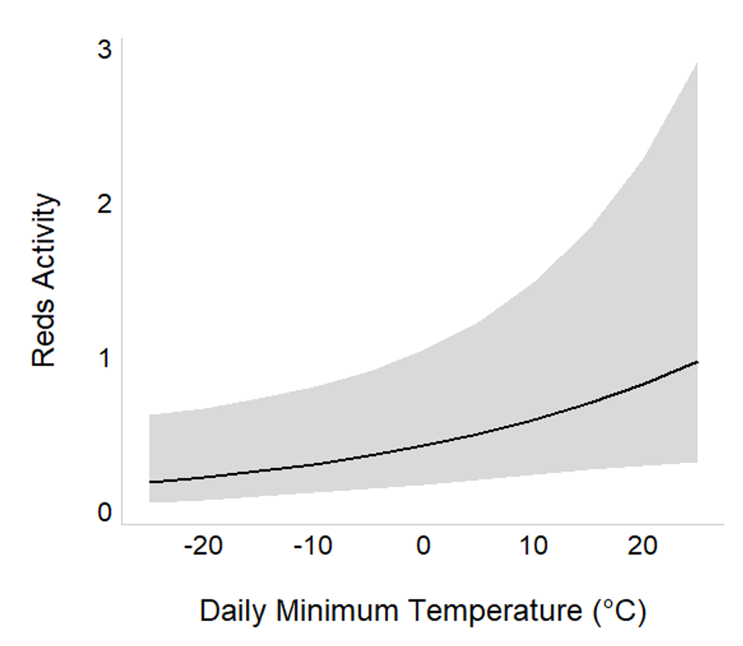

Winter 3: December 2022 – March 2023
The temperature model was the BIC top model and had ΔBIC = 110.63 above the second–best model and 100% of the cumulative weight (Table 4.15). Only Tmin (β = 0.7047, SE = 0.1501, z–value = 4.694, p–value < 0.001) significantly influenced activity (Table 4.15, Fig. 4.19). The Land50 model was the best landcover scale model and had ΔBIC = 2.16 above the second–best landcover scale model, which was Land25; however, no landcover type covariates were significant in the model and the models had BIC < than the null so was considered noncompeting (Table 4.15)

Table 4.15. Model outputs for red bats during winter 3.
Model | K | BIC | Delta BIC | BICWt | Cum.Wt | LL
Temperature | 7 | 3622.9 | 0.00 | 1 | 1 | -1786.40
CustomDOY | 5 | 3733.6 | 110.63 | 0 | 1 | -1848.81
Period | 11 | 3765.6 | 142.70 | 0 | 1 | -1843.29
Effort | 4 | 3870.2 | 247.30 | 0 | 1 | -1920.74
Null | 3 | 3887.9 | 264.97 | 0 | 1 | -1933.17
Distribution | 7 | 3899.7 | 276.77 | 0 | 1 | -1924.70
Land50 | 11 | 3920.4 | 297.49 | 0 | 1 | -1920.68
Land25 | 11 | 3922.6 | 299.65 | 0 | 1 | -1921.77
Land10 | 11 | 3925.5 | 302.59 | 0 | 1 | -1923.24

 | Estimate | Std. Error | z value | Pr(>|z|)
(Intercept) | -1.9773 | 0.5307 | -3.726 | 0.00019
s(Tmin)1 | 0.7047 | 0.1501 | 4.694 | 2.68e-06
s(Tmax)1 | -1.5056 | 0.9649 | -1.560 | 0.11867

Fig. 4.19. Red bat activity was positively correlated with daily minimum temperature in winter 3.
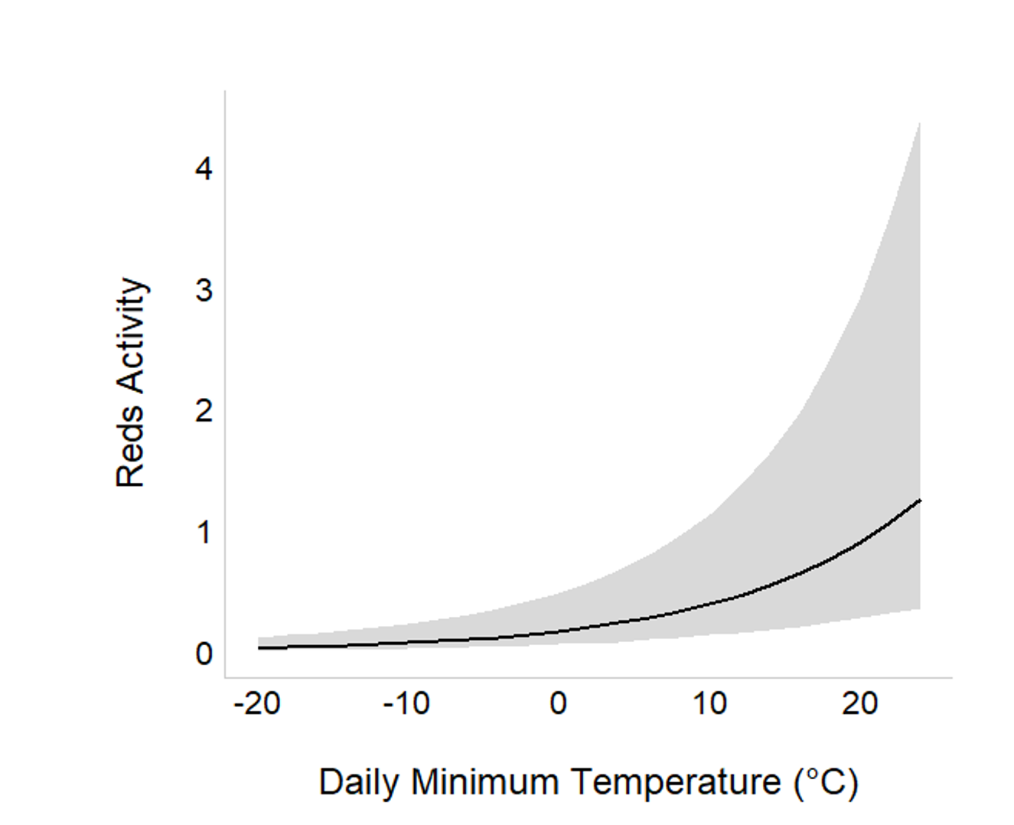

In summary, daily minimum temperature (Tmin) was the only significant Temperature covariate for Reds activity for all winters. From the best landcover scale model in winter 2020 – 2021, several landcover type covariates (i.e., Forest, Shrub, Grass, Barren, Urban, Wet) were significant. There were no significant landcover type covariates in the best models for winter 2021 – 2022 and winter 2022 – 2023, therefore these winters are not present in Fig. 4.21

Fig. 4.21. Model outputs from daily grid-level activity models over 3 winter seasons.
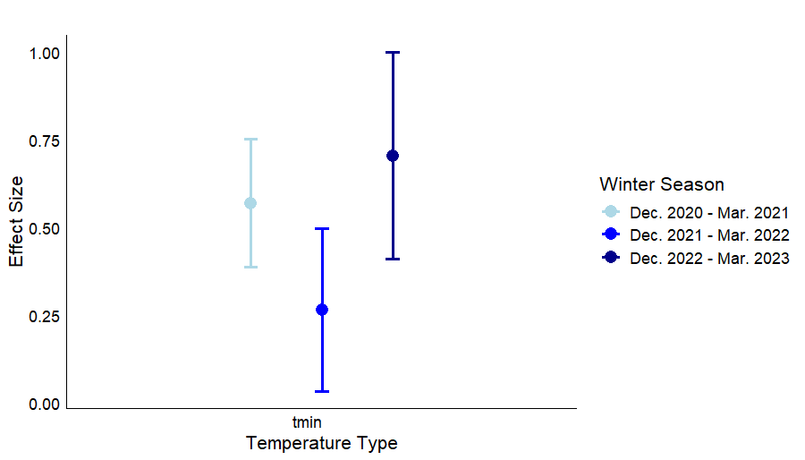

Red Bats Migration and Hibernation Ecology
Although red bats migrate, the species also can go through bouts of torpor and hibernation. However, the species does not seem to be susceptible to WNS. Understanding migration routes of the species is important for wind turbine siting. Thus, we conducted the regression analysis that examined the interaction between period and geographic area of the state.

During fall seasons, red bat activity was significantly greater in West Texas during periods 3, 4, and 5, suggesting activity is concentrated in mid-fall, with lower activity at the beginning and end of the fall season (Fig. 4.20). REDS activity in East Texas shows a significant increase during period 5, suggesting heightened activity later in the fall season within this region. REDS activity in North Texas showed a decreasing trend, with significantly lower activity in period 6, suggesting reduced activity and presence as fall progresses. Based on the visualizations of red bat activity during fall seasons, most activity occurs in the central and eastern part of the state, particularly as fall progresses, except in the Big Bend region (Fig. 4.21). However, if Fall 2021 (unlike Fall 2020 and Fall 2023), red bats were detected more through the western area of the state (Fig. 4.21).

Fig. 4.20. Interactive effect of geographic area and period on red bat activity during three winters in Texas.
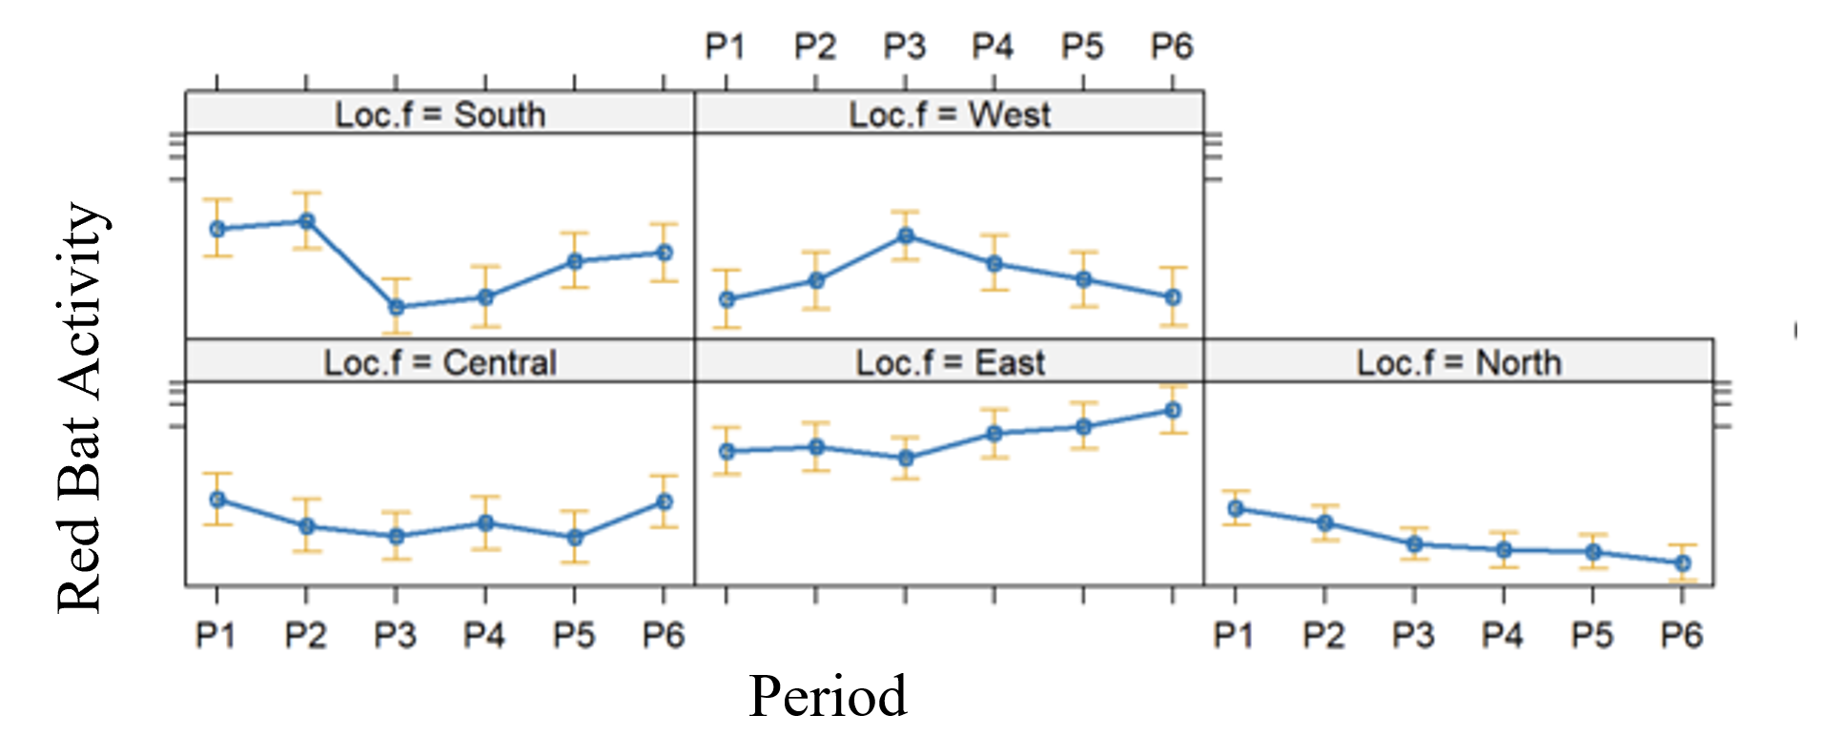

Fig. 4.21. Locations of red bats across Texas during Fall 2020, Fall 2021, and Fall 2022.
Each season is divided by a 4-day period that occurred every ~10 days. Colors represent the maximum Temperature of that period during activity.

Fall 2020
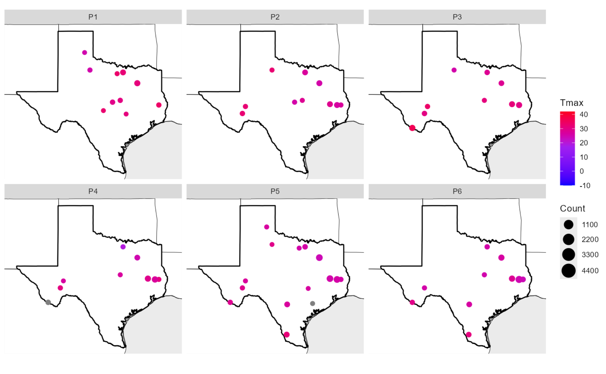
Fall 2021
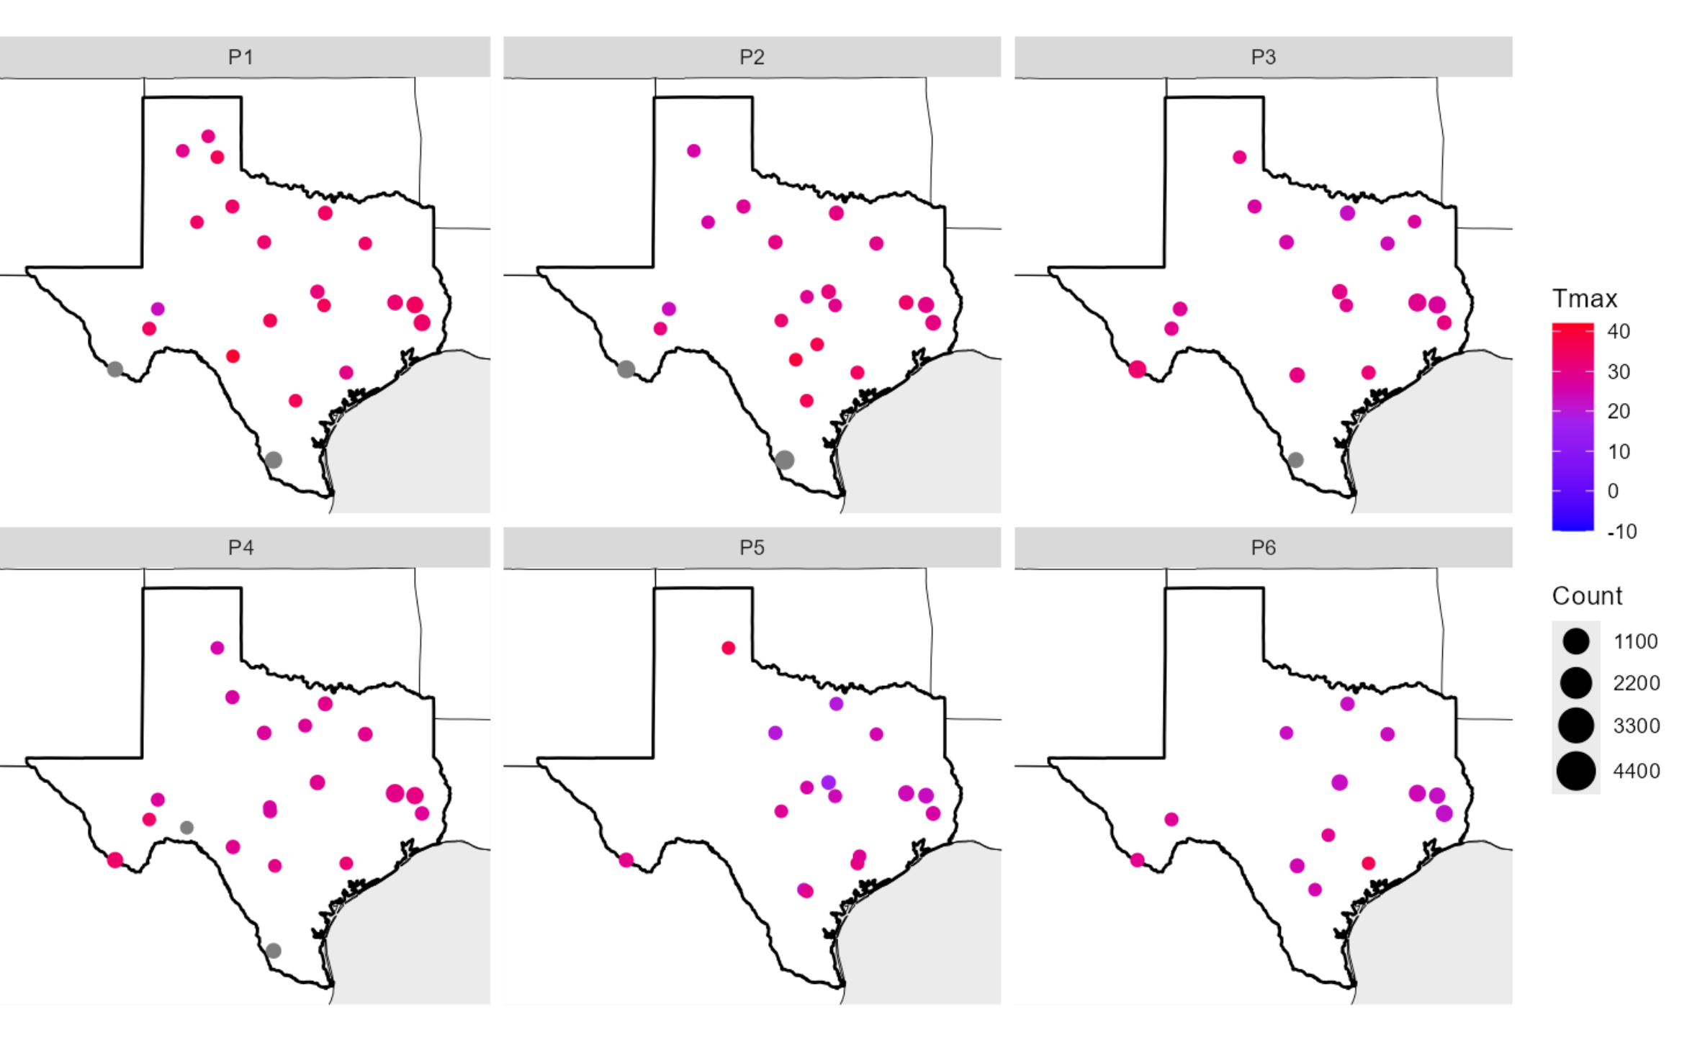

Fall 2022
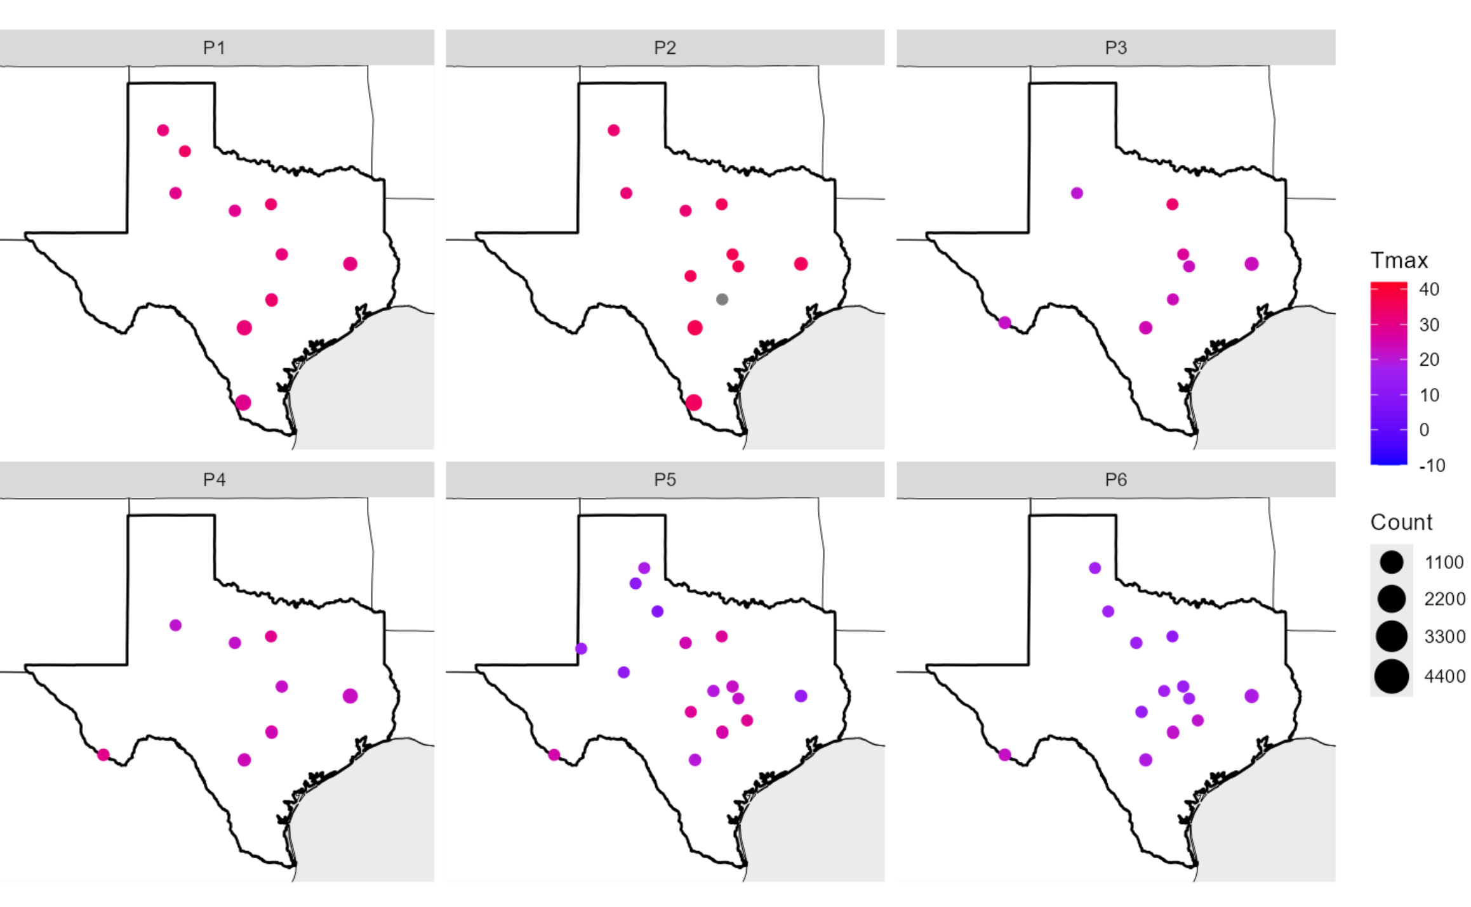

During winter seasons, Red bats activity was lowest in west Texas and western Central Texas and increased in all districts during periods 7 and 8 (Fig. 4.22). For winter 2020 – 2021, the South Texas Plains accounted for a notable number of red bat acoustic passes compared to other districts across Periods 2 – 8 while the Oak Prairie accounted for the greatest number of acoustic passes overall in Period 7 (Fig. 4.24). For winter 2021 – 2022, the South Texas Plains and Pineywoods accounted for the greatest number of Reds acoustic passes overall; predominantly the South Texas Plains from Periods 1 – 4 and Pineywoods from Periods 5 – 8. Pineywoods was also the district with the greatest number of acoustic passes for the entire winter of 2022 – 2023. For winter 2020 – 2021, Period 8 had the greatest number of acoustic passes (n = 2,646) followed by Period 7 (n = 2,490). For winter 2021 – 2022, Period 8 had the greatest number of acoustic passes (n = 1,464) followed by Period 2 (n = 1,370). For winter 2022 – 2023 Period 8 had the greatest number of acoustic passes (n = 2,575) followed by Period 4 (n = 1,858). Periods 4 and 6 during winter 2020 – 2021 had the fewest Reds acoustic passes, with counts of 150 and 133. Periods 4 and 5 during winter 2021 – 2022 had the fewest Reds acoustic passes, with 272 and 308. Periods 1 and 2 during winter 2022 – 2023 had the fewest Reds acoustic passes, with counts of 293 and 1.

Fig. 4.22. Interactive effect of geographic location and period on red bat activity during three winter seasons in Texas.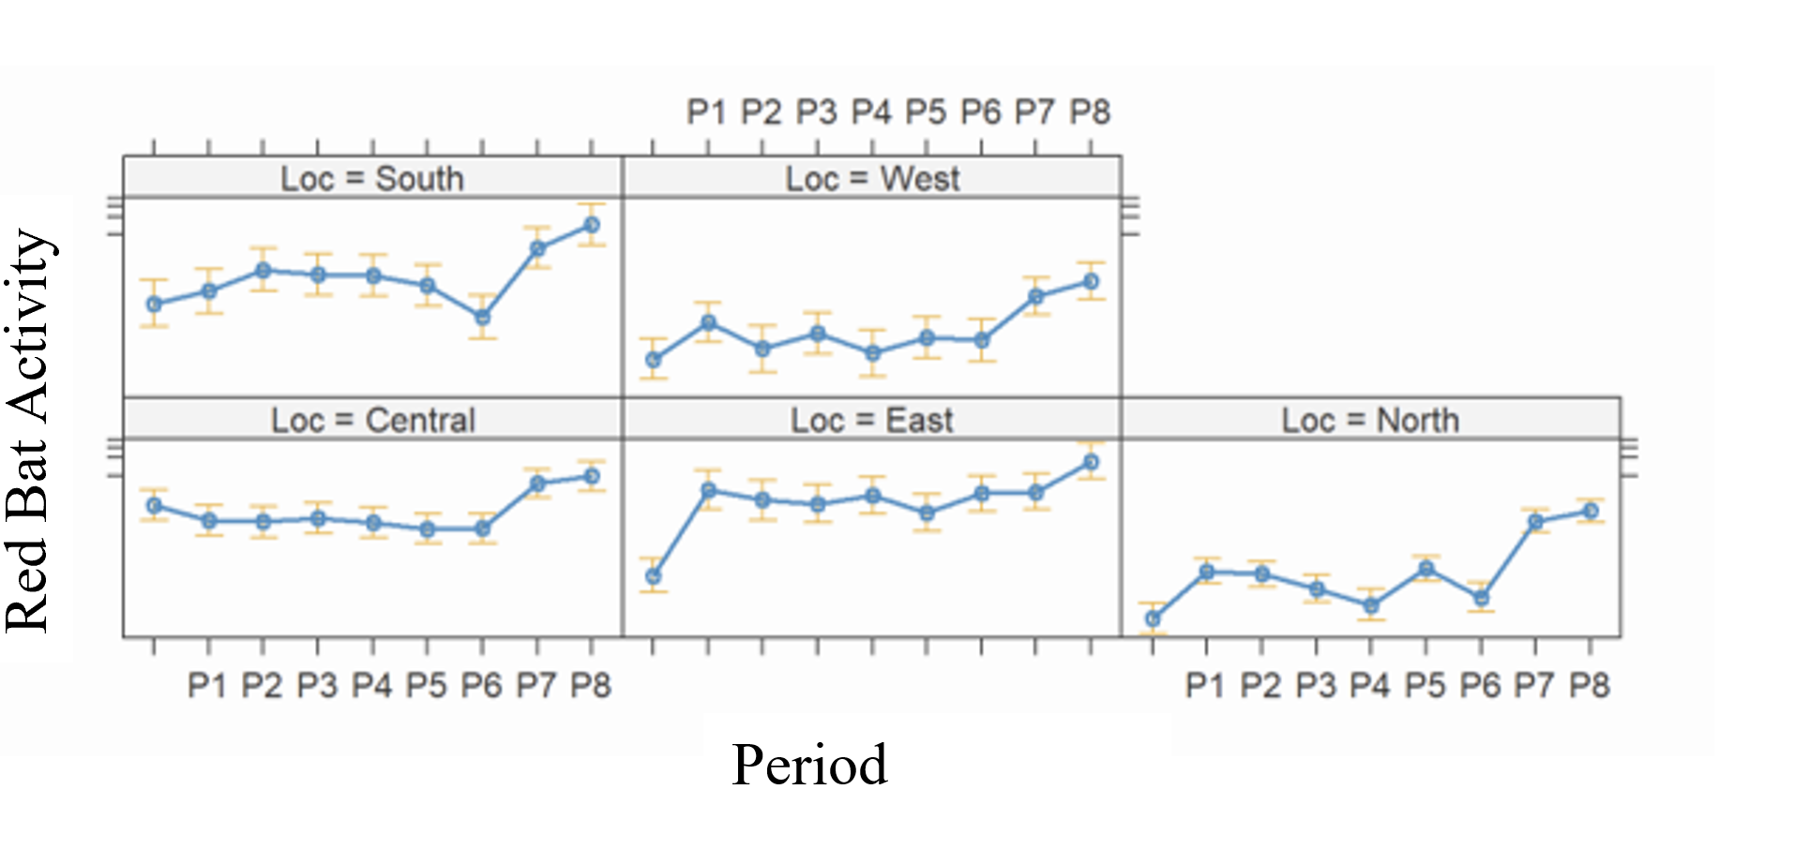
Additionally, red bats were not active during the coldest time periods, likely due to torpor or hibernation (Fig. 4.23). Based on the visualizations in Fig. 4.23, red bats appeared active across the state except during cold periods when they are not active, particularly in western and northern Texas. Red bats remained active in southern Texas during most of the winter.

Fig. 4.23. Locations of red bats across Texas during and Winter 2020/2021, Winter 2021/2022, and Winter 2022/2023. Each season is divided by a 4-day period that occurred every ~10 days. Colors represent the maximum Temperature of that period during activity.

Winter 2020/2021
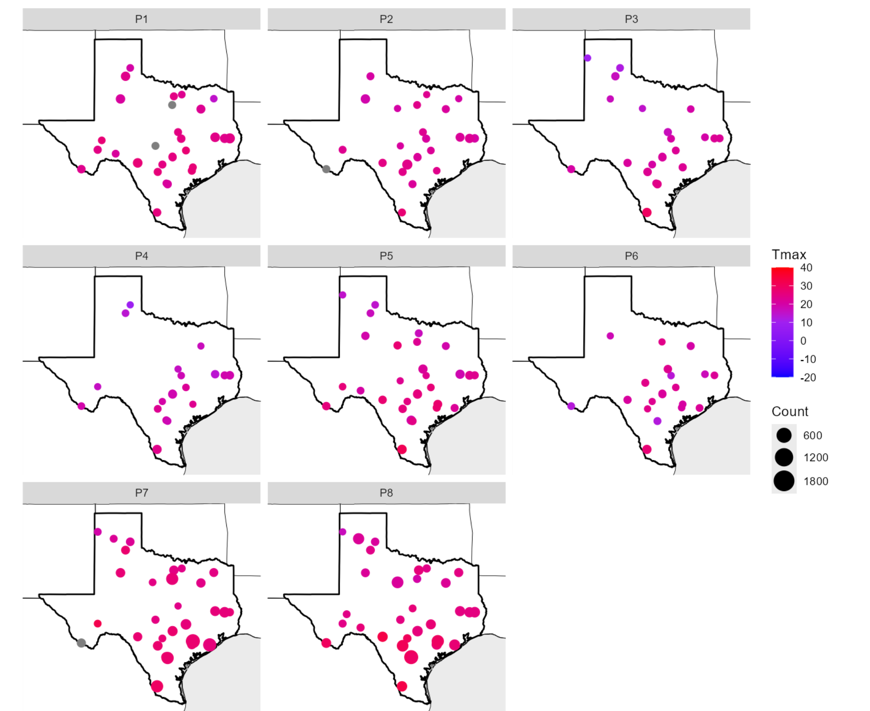

Winter 2021/2022
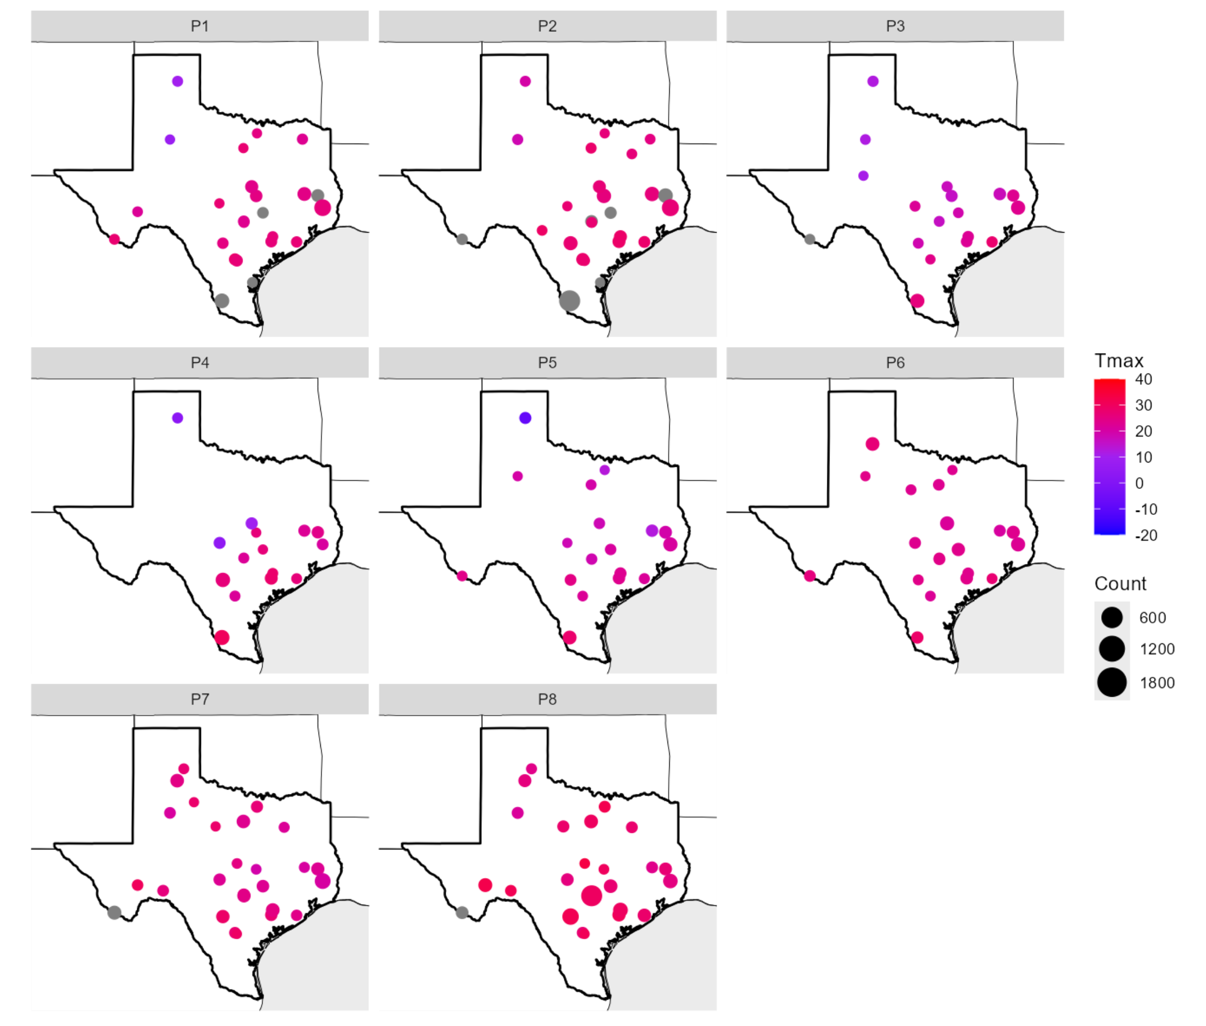
Winter 2022/2023
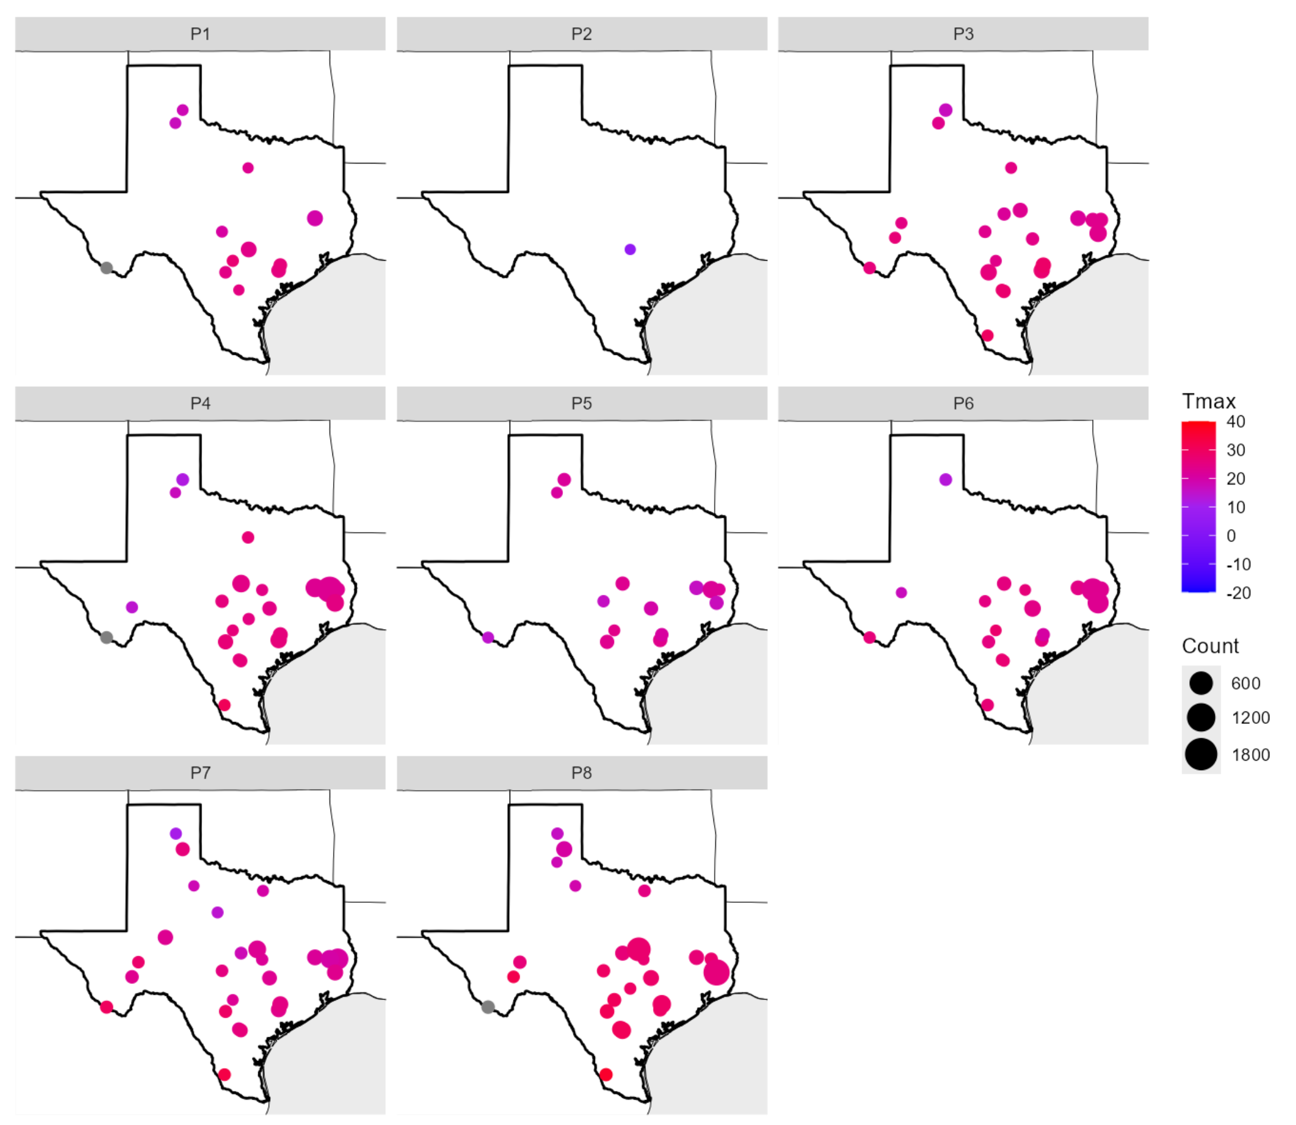

During winter 1, the lowest daily minimum temperatures (Tmin) of Reds acoustic passes occurred at –7° C (n = 1), followed by -6°C (n = 3), -5°C (n = 5), -4° C (n = 9), and -3° C (n = 37; Fig. 4.24). As Tmin increased, the number of Reds acoustic passes also increased. During winter 2, the lowest daily minimum temperatures (Tmin) of Reds acoustic passes occurred at –18° C (n = 14), followed by -13° C (n = 4), -12°C (n = 5), -9°C (n = 2), and -8° C (n = 4). As Tmin increased, the number of Reds acoustic passes also increased until ~16° C (n = 558), then decreased. During winter 3, the lowest daily minimum temperatures (Tmin) of Reds acoustic passes occurred at –11° C (n = 2), followed by -8° C (n = 5), -7° C (n = 2), -6° C (n = 7), and -5°C (n = 3). As Tmin increases, the number of Reds acoustic passes also increased until ~14° C (n = 1,477), then decreased (Fig. 4.24).

Fig. 4.24. Red bat activity based on daily minimum temperatures.

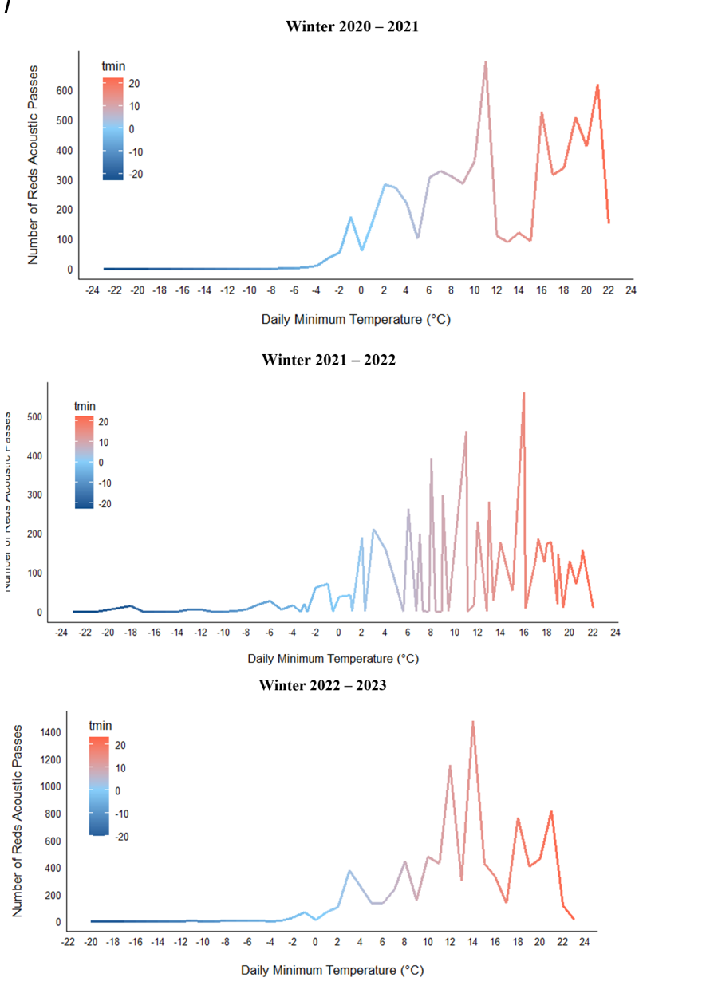

Lasiurus Summary of Results/Discussion
Lasiurus species were detected across the state during much of the fall and winter seasons, with non-detections occurring only in relatively cold periods. Unsurprisingly, temperature affected activity, as would be expected in any bat species. Interestingly, red bats activity was positively correlated with forest and water, possibly indicating the lack of western red bats detected thus results may be biased towards eastern red bats (and potentially Seminole bats). However, Guest et al. (2025) noted detections of western red bats in central Texas, leading us to ponder whether many former records of eastern red bats actually were western red bats.
There appears to be seasonal variations in occurrence, but it is difficult to disentangle potential migratory behavior from torpor/hibernation. Hoary bats are not as active around the periphery of the state during late fall and some of winter; however, there was not a discernable movement trajectory from one region to another based on these results. Red bats, similarly, did not appear to leave any portion of the state completely, but activity was greater in eastern and central locations, potentially agreeing that there may be a bias towards eastern red bats or locations of western red bats that have not yet been recorded.
Overall, results indicate that these species are highly active during all and winter across the state, which could increase fatality risk from wind turbines. Thus, for conservation purposes, it is imperative to continue to monitor bats both pre- and post-construction of wind farms to attempt to decrease fatalities. Few methods exist to decrease fatalities, but proper wind farm siting can help as can curtailment and the use of bat deterrents.

Task 1D: Community Ecology of Texas Bats

Community Analysis Introduction
As human-induced changes in climate and landcover alter all ecosystems on Earth, understanding the influence of these anthropogenic changes to ecosystems requires more than measuring atmospheric and landscape values (Jones et al. 2009). Ecosystems are complex, and their resilience and response to change vary across local, regional, and global scales. One way to measure ecosystem responses to change is by studying the biological communities within the system. Greater community complexity (e.g. species richness and diversity) is broadly thought to represent communities that are more resilient and recover better from disturbances. However, it is nearly impossible to identify every species within a community, thus it is often more efficient to narrow the focus to a subset of the community, such as indicator species or taxa (Goncalves et al. 2021; Jones et al. 2009; Kasso and Balakrishnan 2013; Moreno et al. 2007).
Bats are considered indicator species due to their large spatial distribution, body size, mobility, and sensitivity to human-induced environmental changes (de Conno et al. 2018; Jones et al. 2009; Kasso and Balakrishnan 2013; Li & Kalcounis-Rueppell 2018). Further, bats face many natural (e.g. natural disasters) and human-induced (e.g. deforestation) threats, and it is important to understand bat community responses to those threats (Boyles et al. 2011; Goncalves et al. 2021; Jones et al. 2009; Raposeira et al. 2023). As keystone species, bats are crucial to ecosystems and provide numerous ecosystem services such as insect suppression, pollination and seed dispersal, and serving as prey for other species (Ammerman et al. 2012; Jones et al. 2009; Kasso and Balakrishnan 2013; Kunz et al. 2011). For example, bats pollinate important food and cash crops such as durian (Durio species), blue agave (Agave tequilana), and cotton (Gossypium hirsutum; Kasso and Balakrishnan 2013; Kunz et al. 2011). In the United States (U.S.), it has been estimated that bats save the agricultural industry $3.7 billion per year by eating crop damaging pests (Boyles et al. 2011; Kasso and Balakrishnan 2013; Kunz et al. 2011). In addition to the agricultural industry, bats contribute millions of dollars to local communities through tourism to bridges and caves across the world (Kasso and Balakrishnan 2013; Kunz et al. 2011).
In the U.S., the state of Texas is a crucial location for bat conservation due to the economic importance, the diversity (both species and landcover), and the insurmountable threats to bats in the state including habitat loss, renewable energy production (e.g., wind energy facilities), disease (e.g., white-nose syndrome), and climate change (Boyles et al. 2011; Cryan et al. 2014; Gorman et al. 2021; Jones et al. 2009; Jung & Threlfall 2016; Loeb et al. 2015; Malaney & Cook 2018; Scheel et al. 1996; Smith et al. 2022). Texas is the largest state in the U.S, has the greatest bat species richness, and has the largest populations of bats in the world (Ammerman et al. 2012; Loeb et al. 2015). Bats in Texas decrease costs for Texas farmers by $741,000 yearly and attract hundreds of thousands of tourists to the state every year (Cleveland et al. 2006; Kasso and Balakrishnan 2013; Kunz et al. 2011). However, Texas also leads the U.S. in wind energy development which contributes to bat fatalities through wind turbine blade strikes and habitat destruction during construction. Texas also has been recently invaded with white-nose syndrome (WNS), a detrimental fungal disease affecting bats, which emerged in central Texas in 2020 (Arnett et al. 2013; Kunz et al. 2007; TPWD release 2024).
Additionally, due to the large size of Texas, the state encompasses numerous Ecoregions, each with unique landcover, climate characteristics, and bat communities (Chapman and Bolen 2018; Gorman et al. 2021; Rodhouse et al. 2012; Starbuck et al. 2015). Bat community composition and resilience also are affected by changes in weather and landcover occurring in Texas (Jones et al. 2009; Jung & Threlfall 2016; Kunz et al. 2011). Although Texas is in the southern region of the U.S. where many bat species are less likely to hibernate or migrate due to the mild winters that often occur in Texas compared to more northern latitudes of the U.S. (Stepanian & Wainwright 2018, Cryan et al. 2014; Gorman et al. 2021; Johnson et al. 2016), extreme hard freezes, that have been attributed to climate change (Busby et al. 2021), killed thousands of bats roosting under bridges in 2021 and 2022 (McSweeny & Brooks 2022). In contrast, increasing summer temperatures and decreasing rains have led to more frequent and severe drought. Interestingly, winter behavior can vary within the same bat species, with some individuals either migrating, hibernating, or staying active to some degree (Ammerman et al. 2012; Andersen et al. 2024; Geluso 2008; Gorman et al. 2021; Johnson et al. 2016; Smith et al. 2022; Stepanian & Wainwright 2018). This difference in behavior of bats in Texas could lead to species interactions not normally encountered in northern latitudes as well as seasonal changes in bat communities in a given area.
With very little known about bats to begin with, the impact of these threats on bat populations is severely lacking (Jung & Threlfall 2016; Rodhouse et al. 2012; Stevens et al. 2020). Unknown or outdated information about bats can lead to mixed ideas for the best conservation and management actions. Thus, more information is needed about bats, their behavior, and anthropogenic effects on populations to properly inform managers of helpful conservation actions with direct benefits for bats (Cryan et al. 2014; Jung & Threlfall 2016; Loeb et al. 2015; Rodhouse et al. 2012; Stevens et al. 2020). Specifically, research that assesses ecological variables at multiple scales to identify at which scales variables are most important to bats can improve conservation and management strategies. Habitat characteristics at various scales (100m - 50km) are important to bats, sometimes with differing results (Anderson et al. 2024; Bellows & Mitchell 2017; Burrell 2022; Raposeira et al. 2023; Rivero-Monteagudo & Mena 2023; Starbuck et al. 2015).
Our objectives were to assess temporal (seasonal) and spatial (across Ecoregions) changes in bat community composition from Fall 2020-Summer 2023 in Texas. Although this is a relatively short amount of time, this time frame corresponds to the first die-off of bats from WNS as well as the construction of 4,162 new wind turbines (12,928 MW) for a total of 19,127 wind turbines (42,548 MW) in the state (TPWD release 2024; Wind Turbine Database). Specifically, we examined differences in bat species richness, diversity, and community composition among years, eight Texas Ecoregions, and Periods for falls and winters separately. Additionally, we assessed the influence of landcover at multiple scales on community composition. Results provide baseline data for understanding how bat communities change through time, particularly with changes in land use and the introduction of WNS.

Community Analysis Results

Fall
Fall bat communities differed among Years (Fall 2020, Fall 2021, Fall 2022; F=5.904, p<0.001), Ecoregions (F=5.922, p-value<0.001SE), and Periods (P1-P6; F=3.218, p-value<0.001; Figs. 5.1-5.3). There were no two- or three-level interactive effects with these factors (Year x Ecoregions: F=0.669, p-value=0.993; Year x Periods: F=0.831, p-value=0.821; Ecoregions x Periods: F=0.563, p-value=1.000; Ecoregions x Year x Periods: F=0.036, p-value=1.000).
The Fall 2021 bat community was different than the other two Years (p-values=0.003; Fig. 5.1) and, since the dispersions were equal among Years (F=0.337, p-value=0.761), we can conclude that the Fall 2021 bat community differed from the Fall 2020 and Fall 2022 bat communities. Eight species or species groups (TABR, LANO, MYVE, REDS, PAHE, YELLOWS, NYHU, LACI) contributed to >90% of the dissimilarity in bat communities among Years over all Fall comparisons. All eight species contributed to the dissimilarity between Fall 2021 and Fall 2022 bat communities; LACI did not contribute to the dissimilarity between Fall 2020 and Fall 2021; NYHU did not contribute to the dissimilarity between Fall 2020 and Fall 2022. Five species (TABR, LANO, MYVE, REDS, YELLOWS) contributed to >75% of the dissimilarity in bat communities among Years and over all Fall comparisons. YELLOWS only contributed to the dissimilarity between Fall 2021 and Fall 2022 and REDS did not contribute to the dissimilarity between Fall 2020 and Fall 2022.

Fig. 5.1 nMDS plot during 3 fall seasons in Texas based on year.
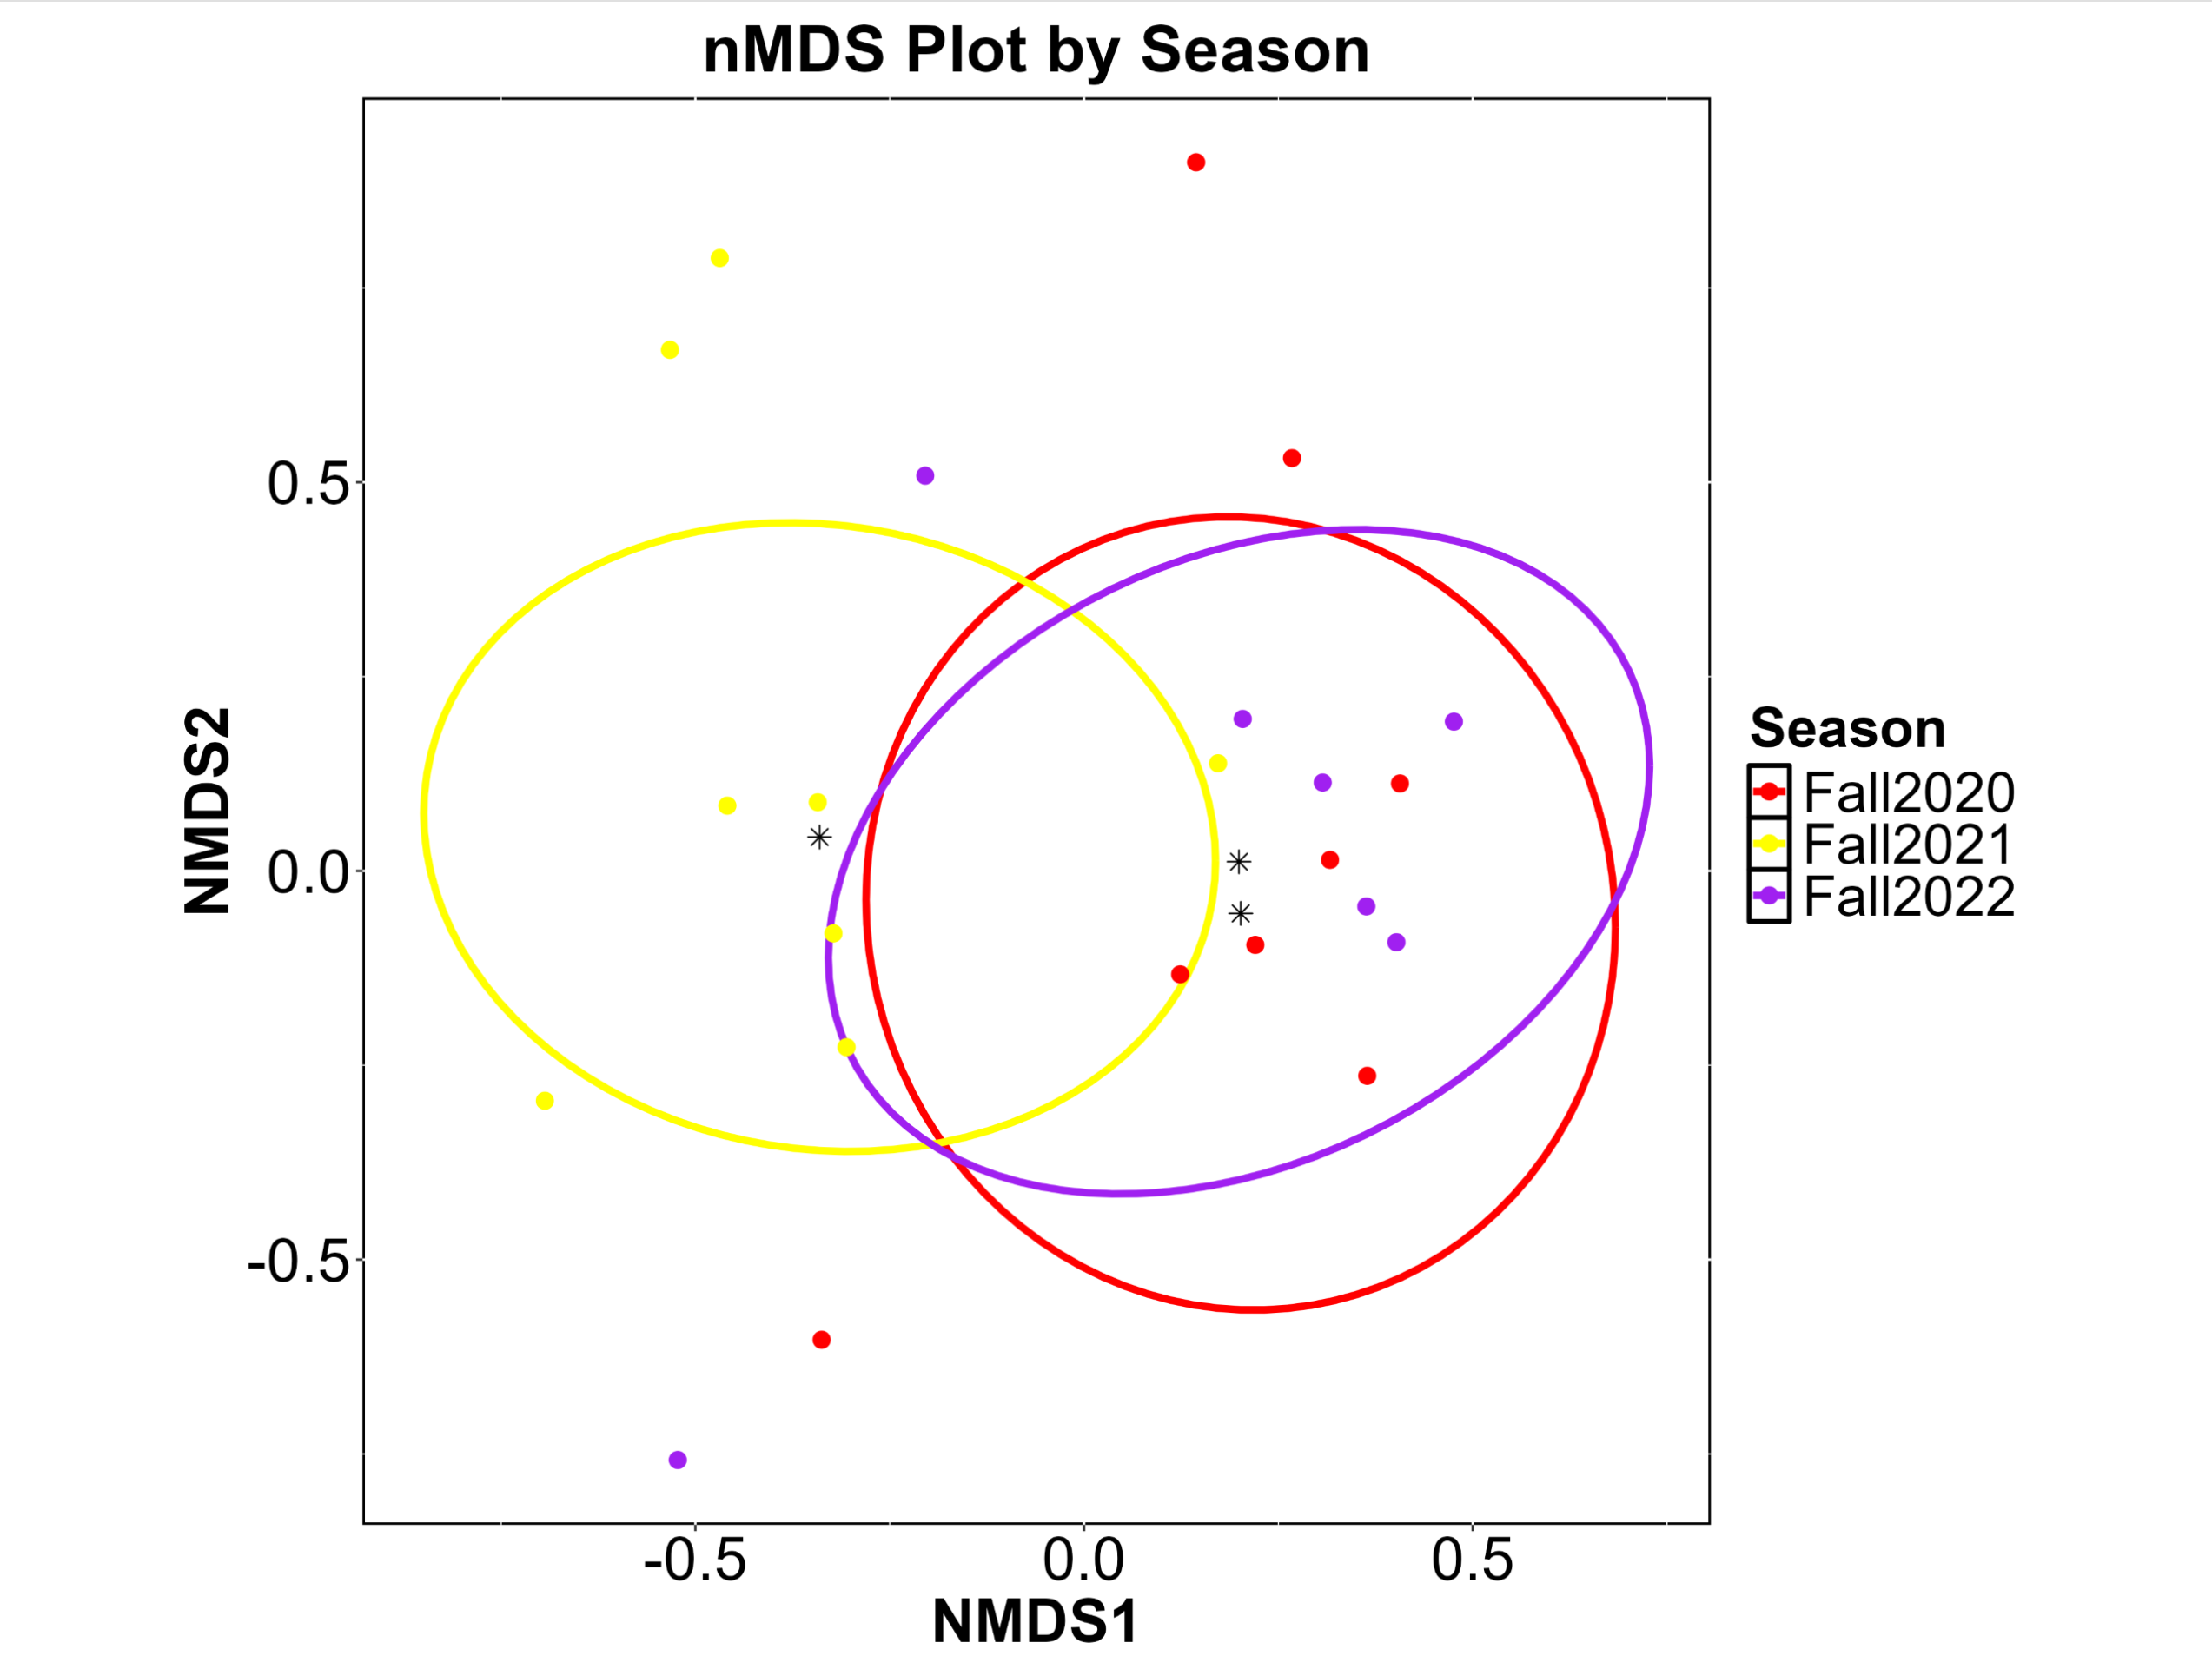

Fall bat communities were similar among several Ecoregions: TP vs HPP, HPP vs CT, HPP vs POS, HPP vs OP, HPP vs STP, CT vs POS, HC vs STP, POS vs PW, POS vs OP, and OP vs STP (p-values>0.05; Fig. 5.2). All other Ecoregion pairwise comparisons signified different bat communities. The dispersions differed among Ecoregions (F=4.887, p-value=0.002) but only for HPP vs HC, HPP vs OP, and HPP vs STP (p-values<0.05). Other than HPP vs HC, all other significant Ecoregion comparisons are likely due to true differences in the bat communities, not differences in dispersion. Eleven species or species groups (TABR, LANO, REDS, YELLOWS, PAHE, NYHU, PESU, MYVE, LACI, EPFU, MYCA) contributed over 90% of the dissimilarity in bat communities among Ecoregions over all Ecoregion comparisons. Four to eight species contributed to the dissimilarity in bat communities in each comparison. TABR contributed to the dissimilarity in all Ecoregion comparisons (n=28); LANO contributed to 25 Ecoregion comparisons; REDS contributed to 21 Ecoregion comparisons; YELLOWS contributed to 18 Ecoregion comparisons; MYVE contributed to 16 Ecoregion comparisons; PAHE only contributed to seven Ecoregion comparisons, but those comparisons all included TP. Ten species (TABR, LANO, REDS, YELLOWS, PAHE, NYHU, PESU, MYVE, LACI, MYCA) contributed to over 75% of the dissimilarity in bat communities among Ecoregions over all Ecoregion comparisons. Two to five species contributed to the dissimilarity in bat communities in each comparison.

Fig. 5.2 nMDS plot during 3 fall seasons in Texas based on Ecoregion.

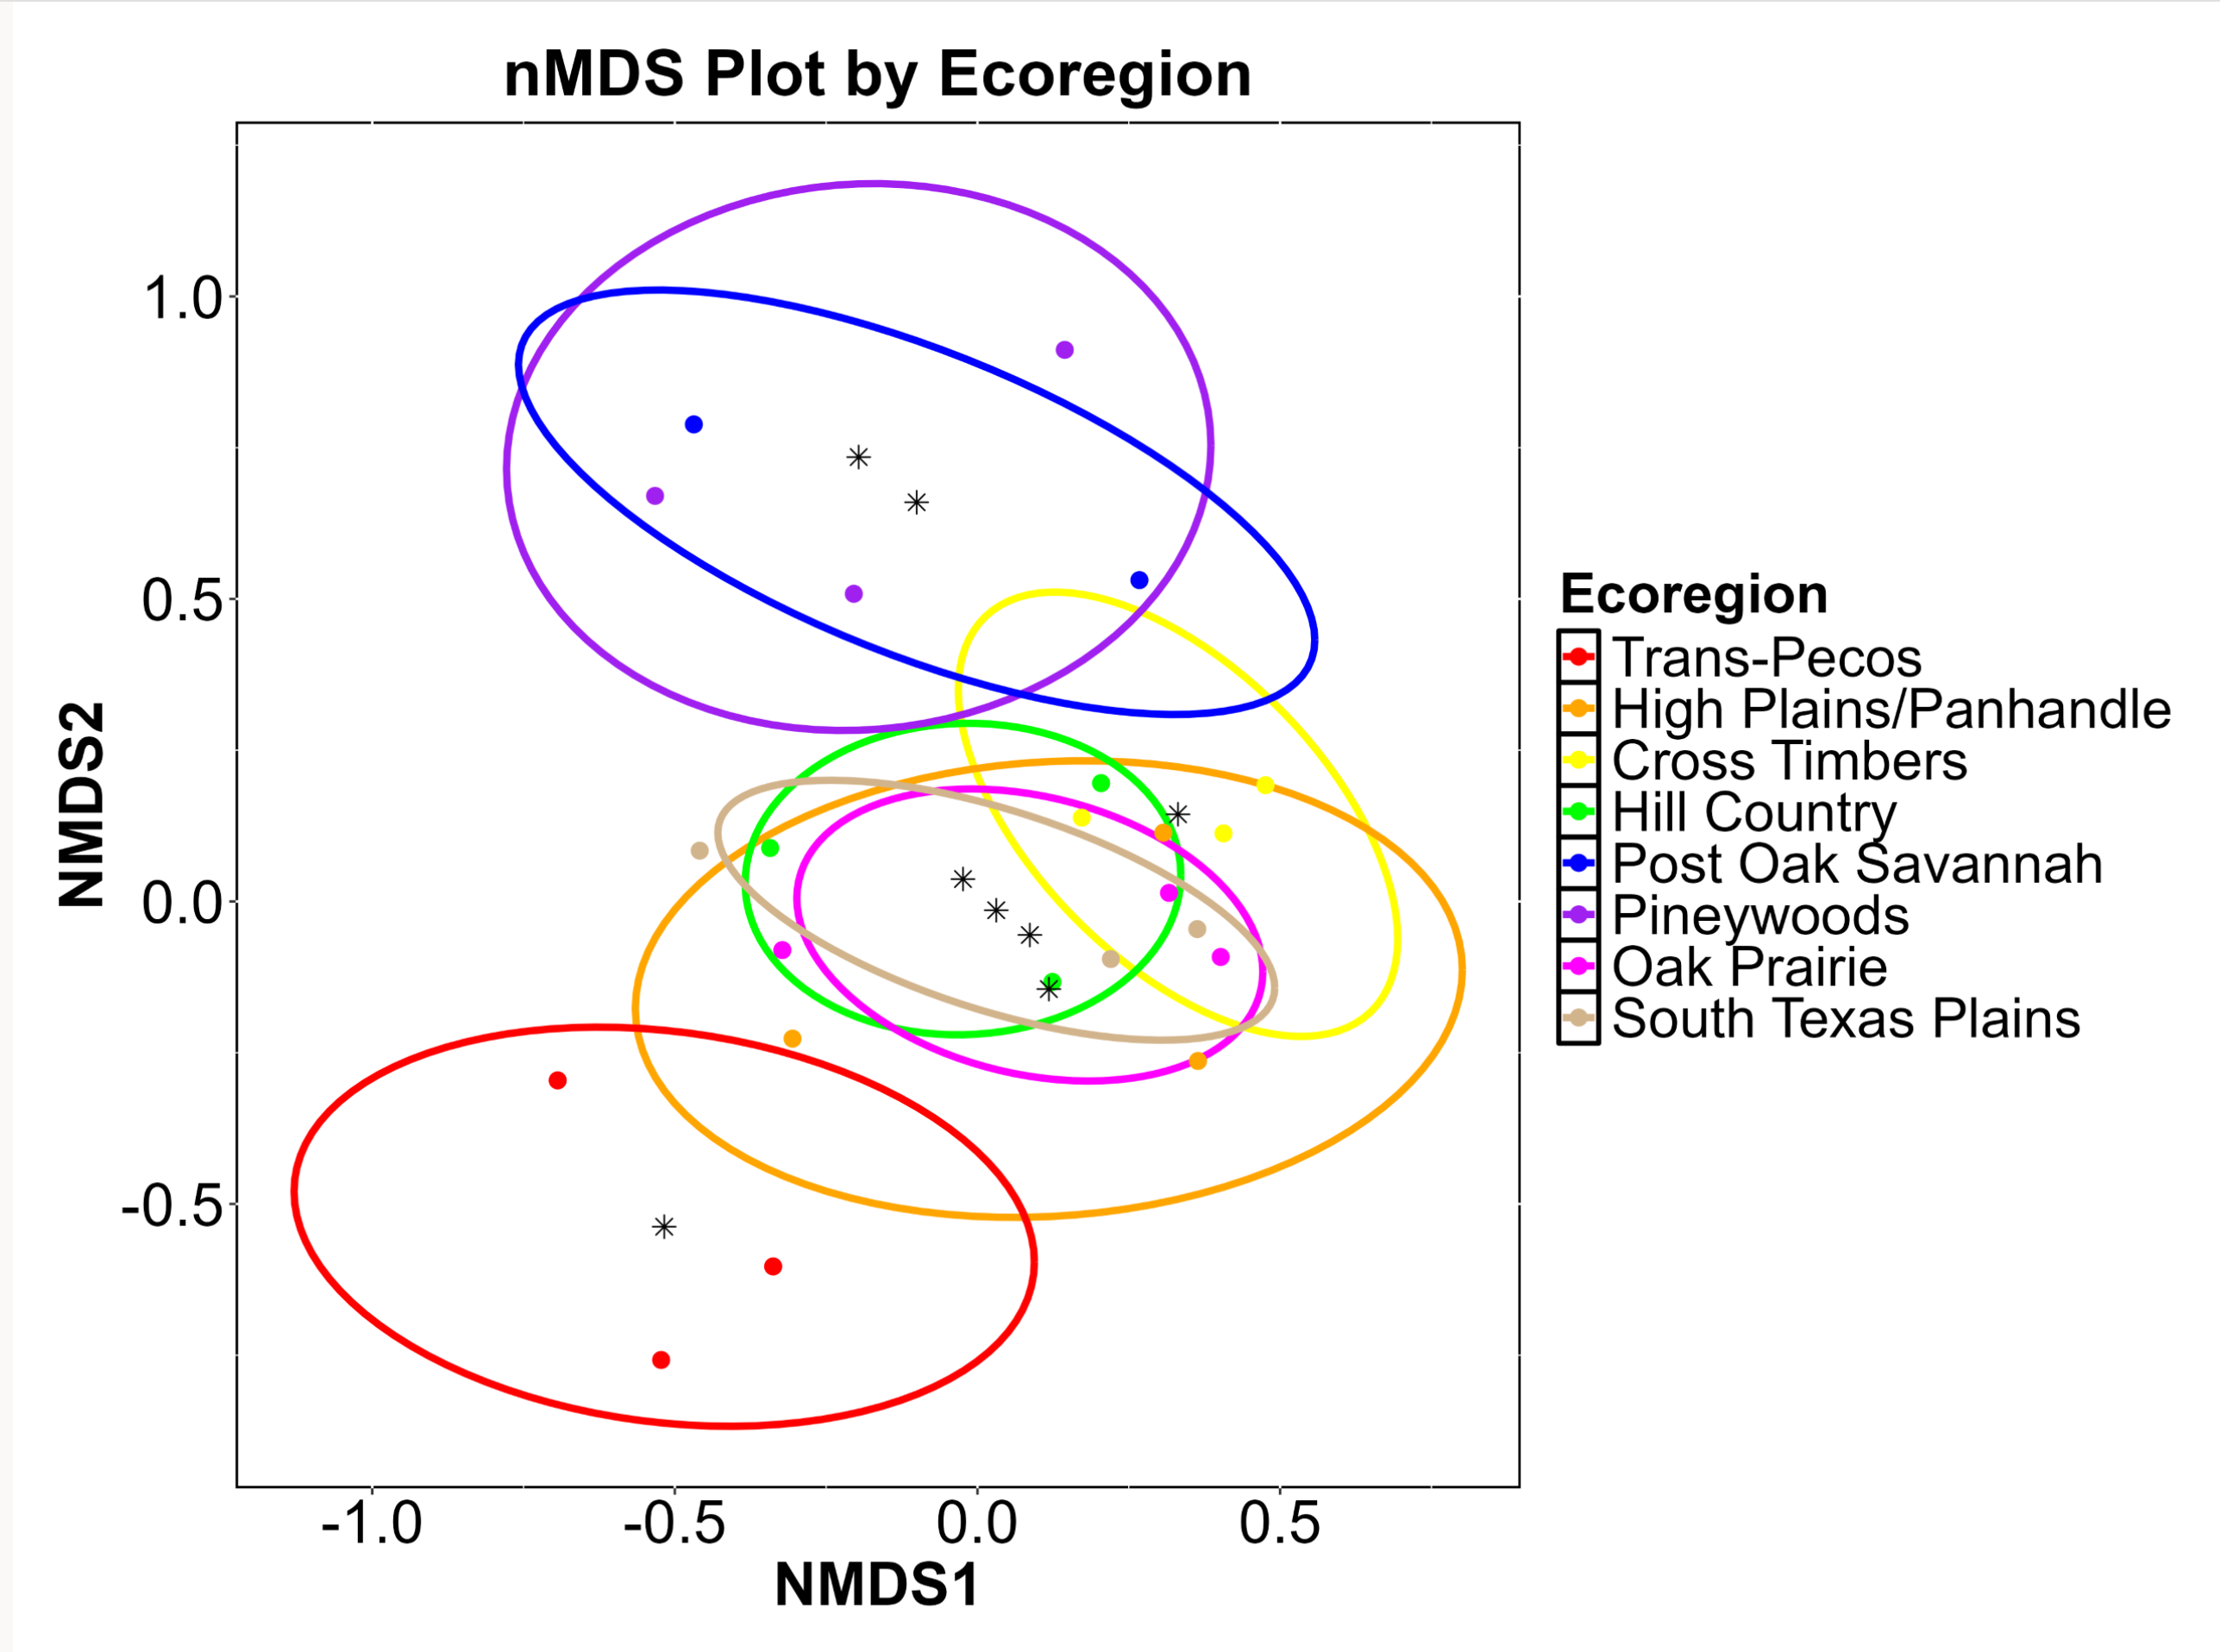
Fall bat communities were different among Periods (Fig. 5.3). P1 differed from all Periods (p-values=0.015) except P2 (p-value=0.33) and P3 differed from P6 (p-value=0.015). Dispersions were equal among Periods (F=1.058, p-value=0.385) and we can conclude that the observed differences are true differences in the bat communities among Periods. Nine species or species groups (TABR, LANO, MYVE, REDS, YELLOWS, NYHU, PAHE, LACI, PESU) contributed to over 90% of the dissimilarity in bat communities among Periods over all Period comparisons. Seven or eight species contributed to the dissimilarity in bat communities in each comparison. TABR and LANO were the top two contributors to the dissimilarity of bat communities in all Period comparisons; MYVE and REDS were primarily the third and fourth greatest contributors; LACI contributed to six Period comparisons, five of which included P1; PESU contributed to five Period comparisons, four of which included P2; NYHU contributed to all Period comparisons except for P3 vs P5 and P5 vs P6; all other species contributed to all Period comparisons. Six species (TABR, LANO, MYVE, REDS, YELLOWS, LACI) contributed to over 75% of the dissimilarity in bat communities among Periods over all Period comparisons. Three to five species contributed to the dissimilarity in bat communities in each comparison. YELLOWS only contributed to the dissimilarity of P1 vs P2 and P3; LACI only contributed to P1 vs P4, P5, and P6; MYVE did not contribute to the dissimilarity between P4 and P6; all other species contributed to all Period comparisons.

Fig. 5.3 nMDS plot during 3 fall seasons in Texas based on period.

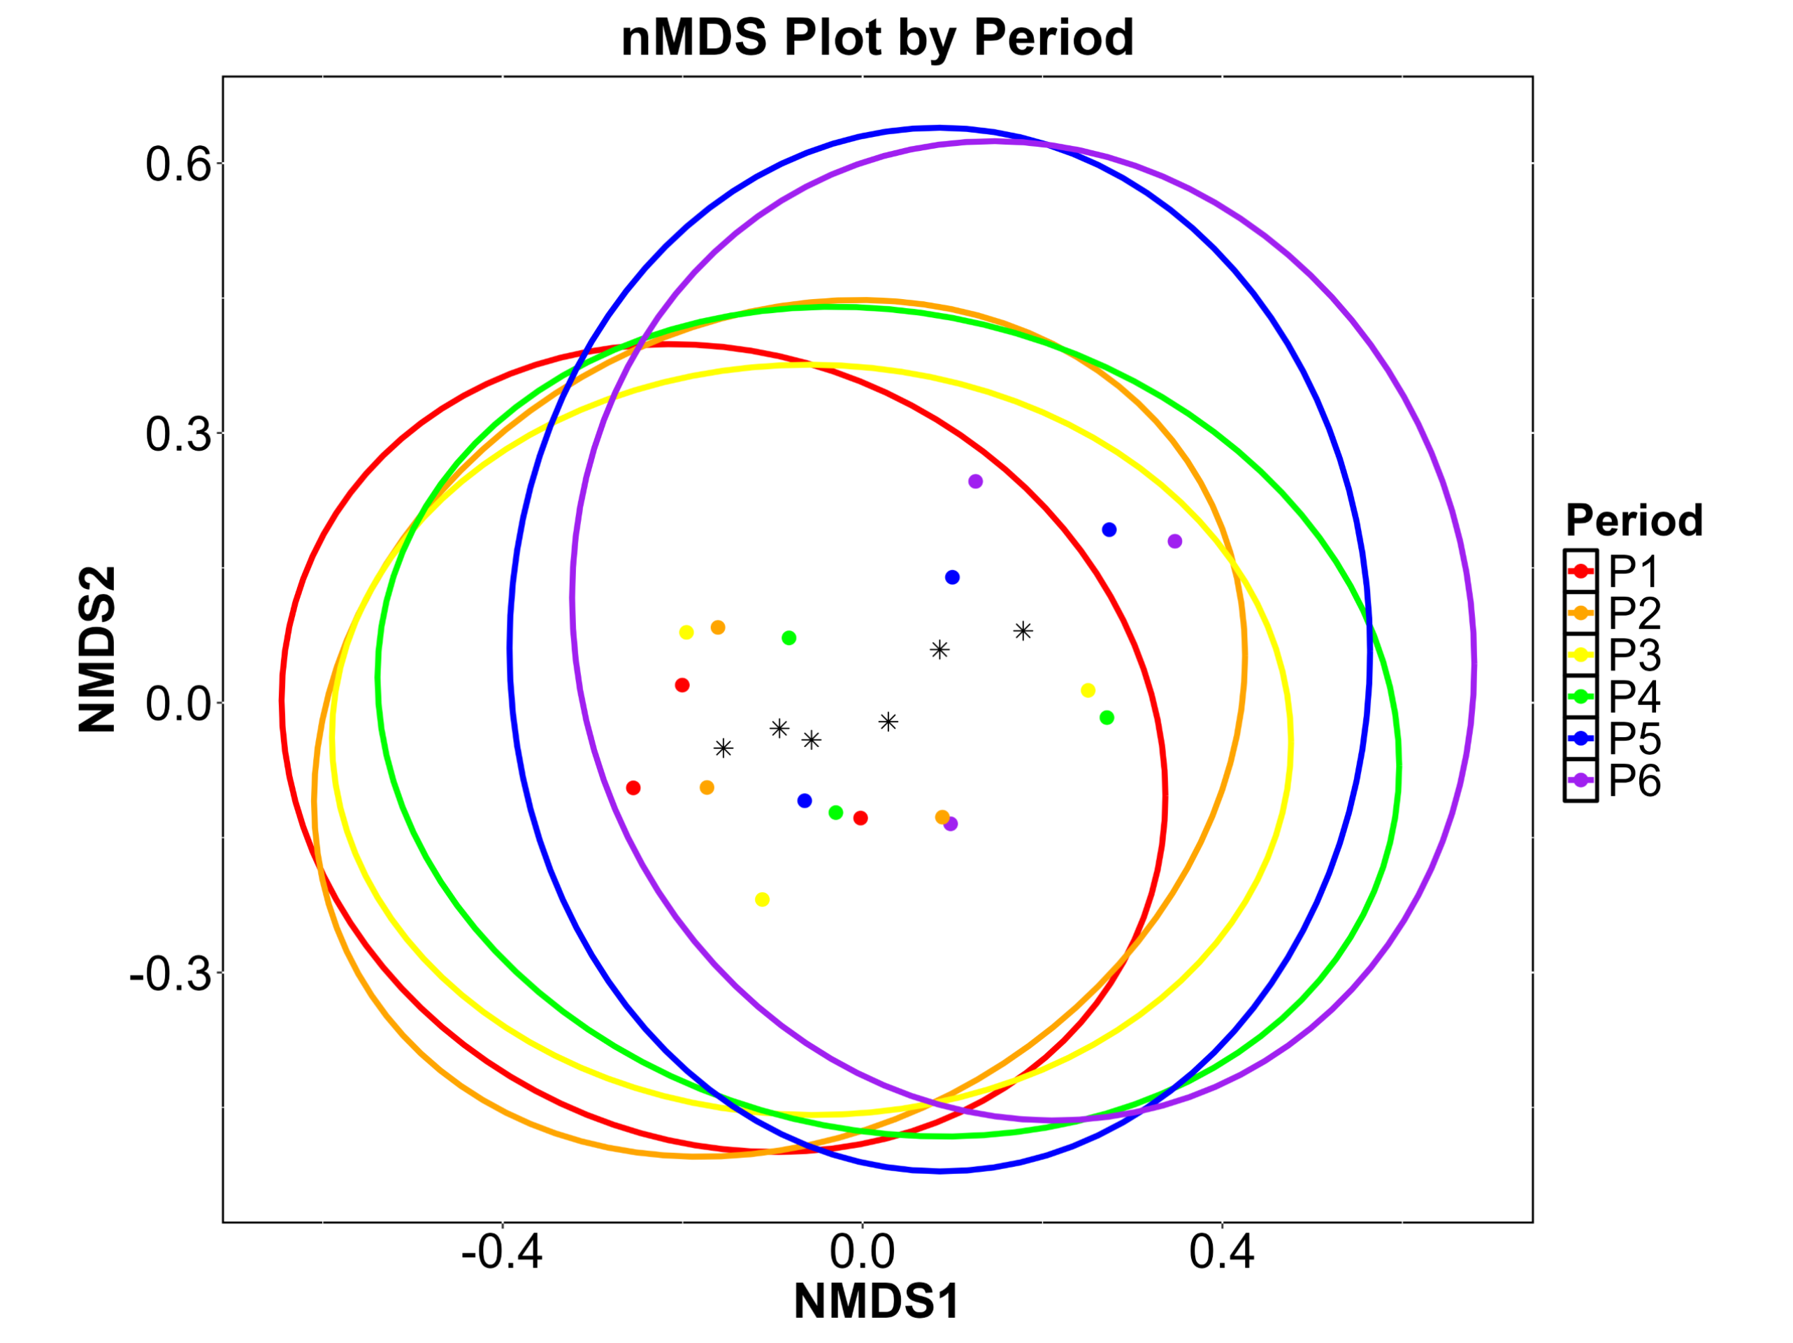
Fall species diversity was greatest in 2021 (H=1.947), followed by 2022 (H=1.182) and 2020 (H=1.154) with the lowest diversity. Fall species richness was similar in 2020 and 2022 (R=20-21) but greatest in 2021 (R=26). Fall species diversity was greatest in the PW Ecoregion (H=1.732), followed by TP (H=1.656), POS (H=1.562), OP (H=1.203), HPP (H=1.167), CT (H=1.135), STP (H=0.898), and lowest in the HC Ecoregion (H=0.853). Fall species richness was greatest in the TP Ecoregion (R=22), followed by STP and HPP (R=19), HC (R=18), OP (R=15), PW (R=14), POS (R=11), and lowest in the CT Ecoregion (R=9). Fall species diversity was greatest in P6 (H=1.411) followed by P1 (H=1.392), P2 (H=1.387), P3 (H=1.368), P5 (H=1.256), and P4 (H=1.120) with the lowest diversity. Fall species richness was greatest in P3 (R=26) followed by P5 and P2 (R=25), P4 and P1 (R=24), and lowest in P6 (R=21). The community composition results yielded no two- or three-level interactive effects with these factors (Year x Ecoregion, Year x Period, Ecoregion x Period) and no diversity and richness comparisons were made for them either.

Winter
Winter bat communities differed among Ecoregions (F=9.395, p-value<0.001and Periods (P1-P8; F=5.00, p-value<0.001) but not among Years (Winter 2021, Winter 2022, Winter 2023; F=1.171, p=0.269; Figs. 5.4-5.5). There were no two- or three-level interactive effects with these factors (Winters x Ecoregions: F=0.628, p-value=0.990; Winters x Periods: F=1.019, p-value=0.433; Ecoregions x Periods: F=0.958, p-value=0.698; Ecoregions x Winters x Periods: F=0.770, p-value=1.000).
Winter bat communities were similar among several Ecoregions: HPP vs CT, HPP vs POS, CT vs POS, HC vs STP, HC vs OP, HC vs STP, POS vs OP, POS vs STP, and OP vs STP (p-values > 0.05; Fig. 5.4). All other Ecoregion pairwise comparisons signified different bat communities. The dispersions differed among Ecoregions (F=20.955, p=0.001) for half of the pairwise comparisons (p-values<0.05). Therefore, differences in winter bat communities between Ecoregions should be accepted with caution. Significant Ecoregion comparisons with similar dispersions likely represent true differences in the bat communities regardless of overlapping ellipses in the nMDS plot; significant Ecoregion comparisons with different dispersions could be due to the dispersions, not true differences in the bat communities, even if the ellipses do not overlap. Eleven species or species groups (TABR, REDS, LANO, YELLOWS, PESU, NYHU, PAHE, LACI, EPFU, MYAU, MYCA) contributed over 90% of the dissimilarity in bat communities among Ecoregions over all Ecoregion comparisons.
Four to nine species contributed to the dissimilarity in bat communities in each comparison. TABR and REDS contributed to the dissimilarity in all Ecoregion comparisons (n=28); LANO contributed to 26 Ecoregion comparisons; YELLOWS contributed to 16 Ecoregion comparisons; PESU contributed to 14 Ecoregion comparisons; NYHU contributed to 13 Ecoregion comparisons; PAHE only contributed to nine Ecoregion comparisons, but those included all TP comparisons. Eight species (TABR, REDS, LANO, YELLOWS, PESU, NYHU, PAHE, EPFU) contributed to over 75% of the dissimilarity in bat communities among Ecoregions over all Ecoregion comparisons. One to six species contributed to the dissimilarity in bat communities in each comparison.

Fig. 5.4 nMDS plot during 3 winter seasons in Texas based on Ecoregion.

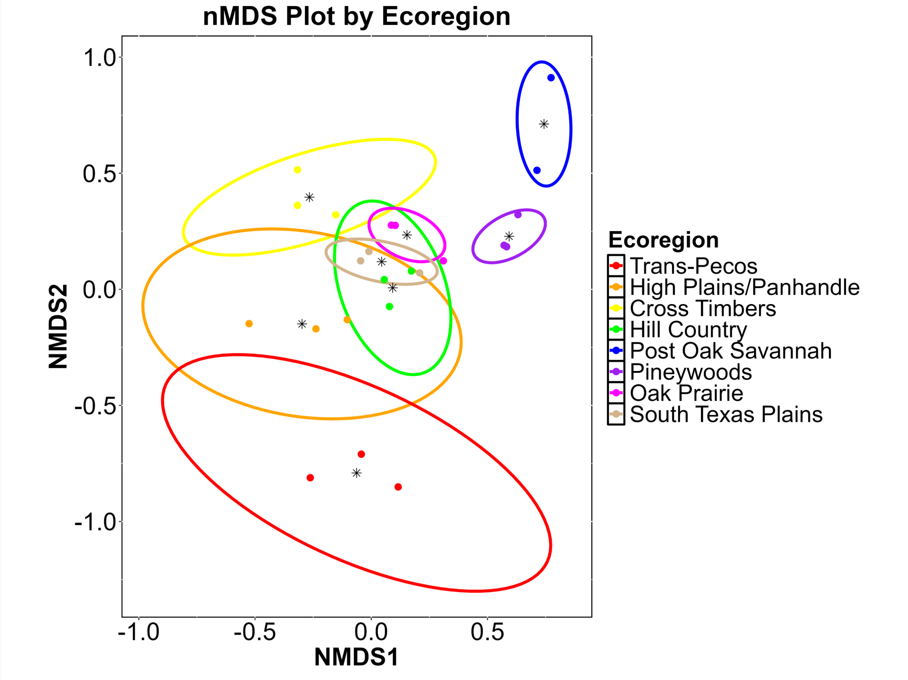
Winter bat communities differed among several Periods (Fig. 5.5). P8 differed from all Periods (p-values=0.028) except P7 (p-value=1.00); P7 differed from all Periods (p-values-0.028) except P6; and P6 differed from P1 (p-value=0.028); all other Period comparisons did not differ (p-values>0.05). Dispersions differed among some Periods (F=4.796, p-value=0.001). Significant comparisons with different dispersions (P8 vs P1, P3, P4, and P5; P7 vs P1, P3, P4, and P5) should be accepted with caution as the differences in bat communities could simply be due to differences in dispersion. Other significant comparisons can be concluded as true differences in the bat communities regardless of overlapping ellipses in the nMDS plot.
Nine species or species groups (TABR, REDS, LANO, YELLOWS, NYHU, PAHE, LACI, PESU, EPFU) contributed to over 90% of the dissimilarity in bat communities among Periods over all Period comparisons. Seven or eight species contributed to the dissimilarity in bat communities in each comparison. TABR, REDS, and LANO were the top three contributors to the dissimilarity of bat communities in all Period comparisons, except P4 vs P6 and P5 vs P6 where YELLOWS was third and LANO was fourth; YELLOWS and NYHU were primarily the fourth and fifth greatest contributors; PAHE contributed 24 Period comparisons; LACI contributed to 22 Period comparisons; PESU contributed to 17 Period comparisons; EPFU only contributed to P4 vs P6. Five species (TABR, REDS, LANO, YELLOWS, NYHU) contributed to over 75% of the dissimilarity in bat communities among Periods over all Period comparisons. Three to five species contributed to the dissimilarity in bat communities in each comparison.

Fig. 5.5. nMDS plot during 3 winter seasons in Texas based on period.

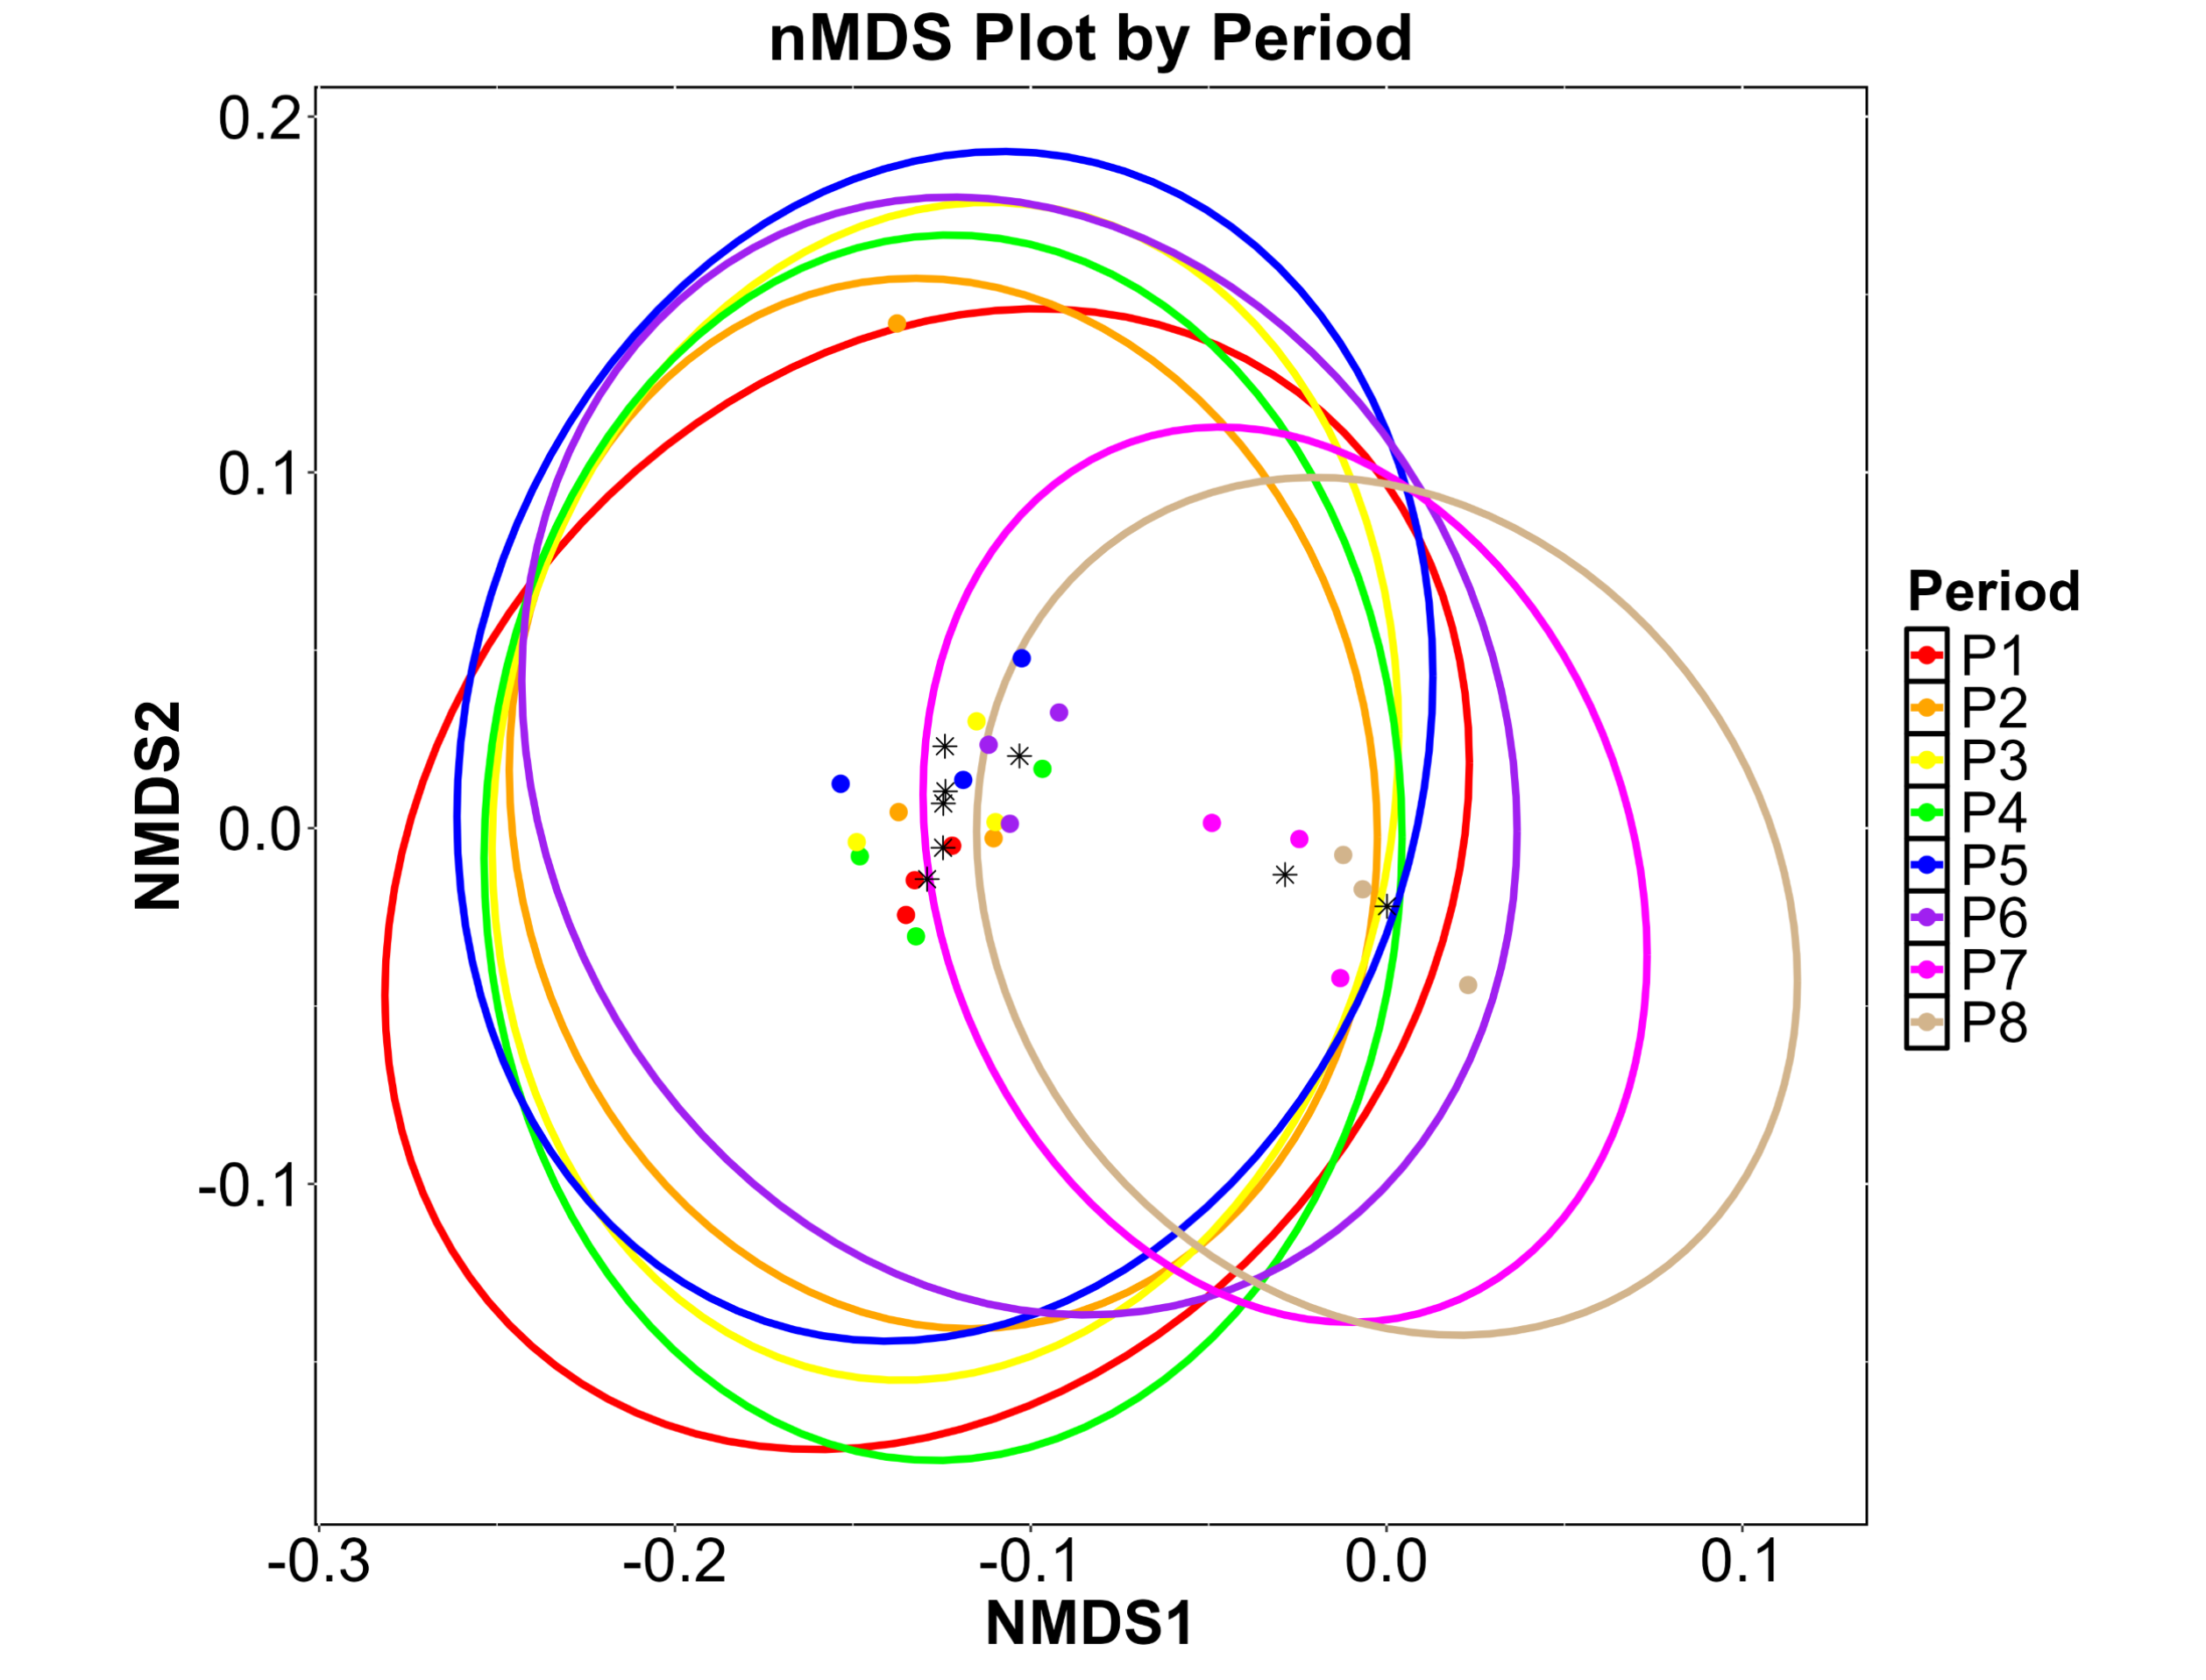
Winter species diversity was greatest in 2023 (H=1.493), followed by 2022 (H=1.479) and 2021 (H=1.179) with the lowest diversity. Winter species richness was similar in all three years (R=24-25). Winter species diversity was greatest in the PW Ecoregion (H=2.027), followed by TP (H=1.617), POS (H=1.341), HPP (H=1.264), HC (H=1162), OP (H=1.134), STP (H=0.822), and lowest in the CT Ecoregion (H=0.638). Winter species richness was greatest in the TP Ecoregion (R=21), followed by HPP (R=16), HC (R=14), PW (R=12), STP and OP (R=10), and lowest in the POS and CT Ecoregions (R=8). Winter species diversity was greatest in P1 (H=1.773) followed by P4 (H=1.710), P2 (H=1.536), P6 (H=1.487), P3 (H=1.470), P8 (H=1.358), P7 (H=1.278), and P5 (H=1.002) with the lowest diversity. Winter species richness was greatest in P8 and P7 (R=25) followed by P4 (R=23), P5 (R=22), P3 and P1 (R=21), P6 (R=20) and lowest in P2 (R=18). The community composition results yielded no two- or three-level interactive effects with these factors (Year x Ecoregion, Year x Period, Ecoregion x Period) and no diversity and richness comparisons were made for them either.

Task 2: Data uploads
All bat activity data was uploaded to the Bat Acoustic Monitoring Portal (BatAMP) in May 2025. BatAMP is publicly available and provides a centralized, web-based system that allows users to upload, visualize, share, and aggregate data derived from acoustic monitoring projects. BatAMP builds upon the core capabilities of the Data Basin platform, which allows you to:

- upload spatial datasets across a variety of formats, including spreadsheets with spatial coordinates
- participate in the BatAMP group and other groups, as well as create your own group workspace
- use feature-rich mapping and data visualization tools
- aggregate datasets from multiple contributors to create a growing database of bat monitoring data

Data is uploaded by season year and with separate files for east and west Texas due to the differences species that can potentially be identified as required by BatAMP.
https://batamp.databasin.org/search/#query=Texas&type=dataset&scope=gateway

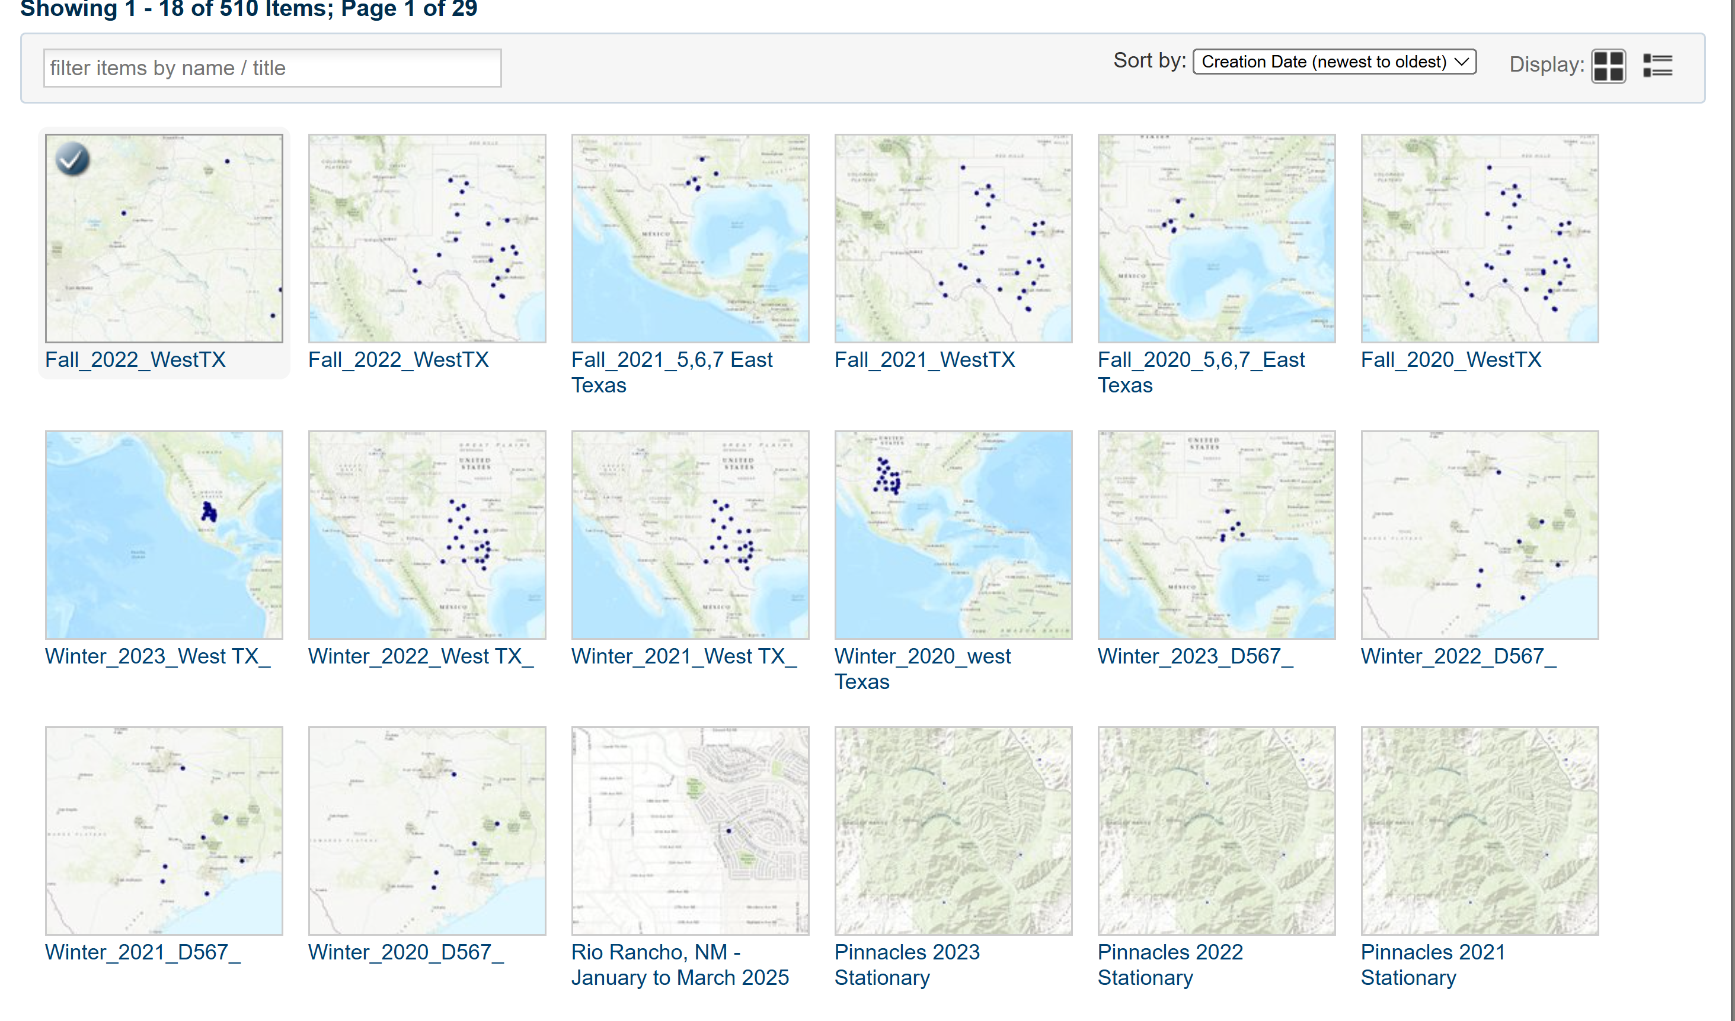

Deliverables

Publications and Theses
Henson, C. C. Mensah, C. Naundorff, S. Fritts. Moon illumination affects bat activity. In preparation.

Naundorff, C., C. Mensah, S. Fritts. Winter activity of vulnerable bat species in Texas: a landscape at the forefront of white-nose syndrome and wind energy expansion. In preparation.

Naundorff, C., C. Mensah, S. Fritts. Winter activity of vulnerable bat species in Texas: a landscape at the forefront of white-nose syndrome and wind energy expansion. Chapter in Thesis. Texas State University.

Mensah, C. Fall Activity of wind energy impacted bat species in Texas. M.S. Thesis. In Preparation.

Mensah, C., C. Naundorff, M. Nadler., S. Fritts. Fall Activity of wind energy impacted bat species in Texas. In Preparation.

Nadler, M., C. Mensah, C. Naundorff, S. Fritts. Changes in Texas fall and winter bat community composition. In preparation.

Nadler, M., C. Mensah, C. Naundorff, S. Fritts. Fall and winter Texas bat diel activity patterns. In preparation.

Presentations as of May 2025
Henson, C., S. Fritts. Moon illumination affects bat activity. IDEA Center Symposium. Texas State University.

Mensah, C., C. Naundorrf, M. Gover, M. Nadler, S. Fritts. 2025. When bats take wing: environmental influences of cave myotis and tricolored at activity patterns. Texas Chapter of The Wildlife Society Annual Conference. Denton, Texas, USA.

Naundorff, C., C. Mensah, M. Gover, M. Nadler, S. Fritts. 2025. Winter is coming! Understanding winter activity patterns and occupancy status of tricolored bats throughout Texas. Texas Chapter of The Wildlife Society Annual Conference. Denton, Texas, USA. Second place poster.

Mensah, C., C. Naundorff, M. Gover, M. Nadler, S. Fritts. 2025. When bats take wing: environmental influences of cave myotis and tricolored at activity patterns. Texas Conservation Symposium. Georgetown Texas, USA.

Naundorff, C., C. Mensah, M. Gover, M. Nadler, S. Fritts. 2025. Winter is coming! Understanding winter activity patterns and occupancy status of tricolored bats throughout Texas. Texas Conservation Symposium. Georgetown, Texas, USA.

Literature Cited
Ammerman, L. K., C. L. Hice, and D. J. Schmidly. 2012. Bats of Texas. Texas A&M University
Andersen BR, McGuire LP, Wigley TB, Miller DA, Stevens RD. 2022. Habitat associations of overwintering bats in managed pine forest landscapes. Forests. 13(5):803.
Arnett EB, Brown WK, Erickson WP, Fiedler JK, Hamilton BL, Henry TH, Jain A, Johnson GD, Kerns J, Koford RR, Nicholson CP. 2008. Patterns of bat fatalities at wind energy facilities in North America. The Journal of Wildlife Management. 72(1):61-78.
Arnett EB. 2010. OOS 55-7: Reducing bat fatalities at wind energy facilities by changing turbine cut-in speed. InThe 95th ESA Annual Meeting 2010 Aug 6.
Arnett, E. B. and E. F. Baerwald. 2013. Impacts of Wind Energy Development on Bats: Implications for Conservation. Bat Evolution, Ecology, and Conservation, Springer New York: 435-456.
Arnett, E.B., Huso, M.M., Schirmacher, M.R. and Hayes, J.P., 2011. Altering turbine speed reduces bat mortality at wind‐energy facilities. Frontiers in Ecology and the Environment, 9(4): 209-214.
Barbour, R. W., and W. H. Davis. 1969. Bats of america.
Bellows AS, Mitchell JC. 2017. Habitat use by bats on the upper coastal plain of Virginia. Virginia Journal of Science. 68(3):2.
Bennett, E.M., Florent, S.N., Venosta, M., Gibson, M., Jackson, A. and Stark, E., 2022. Curtailment as a successful method for reducing bat mortality at a southern Australian wind farm. Austral Ecology, 47(6), pp.1329-1339.
Bernard, R. F., and G. F. McCracken. 2017. Winter behavior of bats and the progression of white‐nose syndrome in the southeastern United States. Ecology and Evolution 7:1487-1496.
Boyles JG, Cryan PM, McCracken GF, Kunz TH. 2011. Economic importance of bats in agriculture. Science. 332(6025):41-42.
Boyles, J. G., M. B. Dunbar, and J. O. Whitaker Jr. 2006. Activity following arousal in winter in North American vespertilionid bats. Mammal Review 36:267-280.
Burrell G. 2022. Bat community structure and habitat selection across an urban-agricultural landscape. [ProQuest]: Purdue University.
Busby J. 2022. States and nature: The effects of climate change on security. Cambridge University Press.
Cheng, T. L., J. D. Reichard, J. T. Coleman, T. J. Weller, W. E. Thogmartin, B. E. Reichert, A. B. Bennett, H. G. Broders, J. Campbell and K. Etchison. 2021. The scope and severity of white‐nose syndrome on hibernating bats in North America." Conservation Biology 35(5):1586-1597.
Cleveland CJ, Betke M, Federico P, Frank JD, Hallam TG, Horn J, López Jr JD, McCracken GF, Medellín RA, Moreno-Valdez A. 2006. Economic value of the pest control service provided by Brazilian free‐tailed bats in south‐central Texas. Frontiers in Ecology and the Environment. 4(5):238-243.
Cornelison, C. T., K. T. Gabriel, C. Barlament, and S. A. Crow. 2014. Inhibition of Pseudogymnoascus destructans growth from conidia and mycelial extension by bacterially produced volatile organic compounds. Mycopathologia 177:1-10.
Cryan PM, Barclay RM. Causes of bat fatalities at wind turbines: hypotheses and predictions. Journal of mammalogy. 2009 Dec 15;90(6):1330-40.
Cryan PM, Stricker CA, Wunder MB. 2014. Continental‐scale, seasonal movements of a heterothermic migratory tree bat. Ecological Applications. 24(4):602-616.
Cryan, P.M., 2003. Seasonal distribution of migratory tree bats (Lasiurus and Lasionycteris) in North America. Journal of mammalogy, 84(2): 579-593.
Davis, W. H. 1964. Winter awakening patterns in the bats Myotis lucifugus and Pipistrellus subflavus. Journal of Mammalogy 45:645-647.
de Conno C, Nardone V, Ancillotto L, De Bonis S, Guida M, Jorge I, Scarpa U, Russo D. 2018. Testing the performance of bats as indicators of riverine ecosystem quality. Ecological Indicators. 95:741-750.
Erickson, J. L. and S. D. West. 2002. The influence of regional climate and nightly weather conditions on activity patterns of insectivorous bats. Acta Chiropterologica 4(1): 17-24.
Erkert, H. G. 1982. Ecological aspects of bat activity rhythms. Ecology of bats, Springer: 201-242.
Ford, W. M., E. R. Britzke, C. A. Dobony, J. L. Rodrigue, and J. B. Johnson. 2011. Patterns of acoustical activity of bats prior to and following white-nose syndrome occurrence. Journal of Fish and Wildlife Management 2:125-134.
Francl, K. E., W. M. Ford, D. W. Sparks and V. Brack Jr. 2012. Capture and reproductive trends in summer bat communities in West Virginia: assessing the impact of white-nose syndrome. Journal of Fish and Wildlife Management 3(1): 33-42.
Frick, W., E. F. Baerwald, J. Pollock, R. Barclay, J. Szymanski, T. Weller, A. Russell, S. Loeb, R. Medellin and L. McGuire 2017. Fatalities at wind turbines may threaten population viability of a migratory bat. Biological Conservation 209: 172-177.
Geluso K. 2008. Winter activity of Brazilian free-tailed bats (Tadarida brasiliensis) at Carlsbad cavern, New Mexico. The Southwestern Naturalist. 53(2):243-247.
Gonçalves F, Sales LP, Galetti M, Pires MM. 2021. Combined impacts of climate and land use change and the future restructuring of neotropical bat biodiversity. Perspectives in Ecology and Conservation. 19(4):454-463.
Gorman KM, Barr EL, Ries L, Nocera T, Ford WM. 2021. Bat activity patterns relative to temporal and weather effects in a temperate coastal environment. Global Ecology and Conservation. 30:e01769.
Haase CG, Fuller NW, Dzal YA, Hranac CR, Hayman DT, Lausen CL, Silas KA, Olson SH, Plowright RK. Body mass and hibernation microclimate may predict bat susceptibility to white‐nose syndrome. Ecology and Evolution. 2021 Jan;11(1):506-15.
Horn JW, Arnett EB, Kunz TH. Behavioral responses of bats to operating wind turbines. The Journal of Wildlife Management. 2008 Jan;72(1):123-32.
Hoyt, J. R., K. E. Langwig, J. P. White, H. M. Kaarakka, J. A. Redell, K. L. Parise, W. F. Frick, J. T. Foster and A. M. Kilpatrick (2019). "Field trial of a probiotic bacteria to protect bats from white-nose syndrome." Scientific Reports 9(1): 9158.
Hoyt, J. R., K. E. Langwig, J. P. White, H. M. Kaarakka, J. A. Redell, K. L. Parise, W. F. Frick, J. T. Foster, and A. M. Kilpatrick. 2019. Field trial of a probiotic bacteria to protect bats from white-nose syndrome. Scientific Reports 9:9158.
Huebschman, J. J. 2019. Bats in southwest Wisconsin during the era of white-nose syndrome. Northeastern Naturalist 26:168-182.
Johnson JS, Treanor JJ, Lacki MJ, Baker MD, Falxa GA, Dodd LE, Waag AG, Lee EH. 2016. Migratory and winter activity of bats in Yellowstone national park. Journal of Mammalogy.gyw175.
Johnson, J. S., M. J. Lacki, S. C. Thomas, and J. F. Grider. 2012. Frequent arousals from winter torpor in Rafinesque’s big-eared bat (Corynorhinus rafinesquii). PLoS One 7:e49754.
Jones G, Jacobs DS, Kunz TH, Willig MR, Racey PA. 2009. Carpe noctem: The importance of bats as bioindicators. Endangered species research. 8(1-2):93-115.
Jung K, Threlfall CG. 2016. Urbanisation and its effects on bats—a global meta-analysis. Bats in the Anthropocene: Conservation of bats in a changing world. Springer International Publishing. p. 13-33.
Kasso M, Balakrishnan M. 2013. Ecological and economic importance of bats (order Chiroptera). International Scholarly Research Notices. 2013(1):187415.
Kunz TH, Braun de Torrez E, Bauer D, Lobova T, Fleming TH. 2011. Ecosystem services provided by bats. Annals of the New York Academy of Sciences. 1223(1):1-38.
Kunz, T. H., E. B. Arnett, B. M. Cooper, W. P. Erickson, R. P. Larkin, T. Mabee, M. L. Morrison, M. D. Strickland and J. M. Szewczak (2007). "Assessing impacts of wind‐energy development on nocturnally active birds and bats: a guidance document." The Journal of Wildlife Management 71(8): 2449-2486.
Langwig, K. E., W. F. Frick, J. R. Hoyt, K. L. Parise, K. P. Drees, T. H. Kunz, J. T. Foster, and A. M. Kilpatrick. 2016. Drivers of variation in species impacts for a multi-host fungal disease of bats. Philosophical Transactions of the Royal Society B: Biological Sciences 371:20150456.
LaVal, R. K., and M. L. LaVal. 1980. Ecological studies and management of Missouri bats, with emphasis on cave-dwelling species.
Li H, Kalcounis‐Rueppell M. 2018. Separating the effects of water quality and urbanization on temperate insectivorous bats at the landscape scale. Ecology and Evolution. 8(1):667-678.
Loeb, S. C., and E. A. Winters. 2022. Changes in hibernating tricolored bat (Perimyotis subflavus) roosting behavior in response to white‐nose syndrome. Ecology and Evolution 12:e9045.
Loeb, S. C., T. J. Rodhouse, L. E. Ellison, C. L. Lausen, J. D. Reichard, K. M. Irvine, T. E. Ingersoll, J. T. Coleman, W. E. Thogmartin, and J. R. Sauer. 2015. A plan for the North American bat monitoring program (NABat). Gen. Tech. Rep. SRS-208. Asheville, NC: US Department of Agriculture Forest Service, Southern Research Station. 208:1-100.
Malaney JL, Cook JA. 2018. A perfect storm for mammalogy: Declining sample availability in a period of rapid environmental degradation. Journal of Mammalogy. 99(4):773-788.
Martinez Arbizu, P. (2020). pairwiseAdonis: Pairwise multilevel comparison using adonis. R package version 0.4
McSweeny T, Brooks DM. 2022. Some observations of severe weather events on a large urban population of free-tailed bats (Tadarida brasiliensis). The Southwestern Naturalist. 66(4).
Meierhofer, M. B., J. S. Johnson, S. J. Leivers, B. L. Pierce, J. E. Evans, and M. L. Morrison. 2019. Winter habitats of bats in Texas. PLoS One 14:e0220839.
Meierhofer, M. B., T. M. Lilley, L. Ruokolainen, J. S. Johnson, S. R. Parratt, M. L. Morrison, B. L. Pierce, J. W. Evans, and J. Anttila. 2021. Ten-year projection of white-nose syndrome disease dynamics at the southern leading-edge of infection in North America. Proceedings of the Royal Society B 288:20210719.
Moreno CE, Sánchez-Rojas G, Pineda E, Escobar F. 2007. Shortcuts for biodiversity evaluation: A review of terminology and recommendations for the use of target groups, bioindicators and surrogates. International Journal of Environment and Health. 1(1):71-86.
Newman, B. A., S. C. Loeb, and D. S. Jachowski. 2021. Winter roosting ecology of tricolored bats (Perimyotis subflavus) in trees and bridges. Journal of Mammalogy 102:1331-1341.
Oksanen J, Simpson G, Blanchet F, Kindt R, Legendre P, Minchin P, O'Hara R, Solymos P, Stevens M, Szoecs E,
O'Shea, T. J., M. A. Bogan and L. E. Ellison (2003). "Monitoring trends in bat populations of the United States and territories: status of the science and recommendations for the future." USGS Staff--Published Research: 35.
Palmer, J. M., K. P. Drees, J. T. Foster, and D. L. Lindner. 2018. Extreme sensitivity to ultraviolet light in the fungal pathogen causing white-nose syndrome of bats. Nature Communications 9:35.
Parker Jr, K. A., H. Li, and M. C. Kalcounis-Rueppell. 2020. Species-specific environmental conditions for winter bat acoustic activity in North Carolina, United States. Journal of Mammalogy 101:1502-1512.
Parlos, J.A., 2008. Population genetic structure of a cave-dwelling bat, Myotis velifer (Doctoral dissertation).
Pettit, J. L., and J. M. O'Keefe. 2017. Impacts of white-nose syndrome observed during long-term monitoring of a midwestern bat community. Journal of Fish and Wildlife Management 8:69-78.
Raposeira H, Horta P, Heleno R, Rebelo H. 2023. Changing with the times: Seasonal environmental gradients unveil dynamic bat assemblages and vulnerability. Ecology and Evolution. 13(7).
Reeder, D. M., C. L. Frank, G. G. Turner, C. U. Meteyer, A. Kurta, E. R. Britzke, M. E. Vodzak, S. R. Darling, C. W. Stihler, and A. C. Hicks. 2012. Frequent arousal from hibernation linked to severity of infection and mortality in bats with white-nose syndrome. PLoS One 7.
Rivero-Monteagudo J, Mena JL. 2023. Hourly activity patterns of the insectivorous bat assemblage in the urban–rural landscape of lima, Peru. Journal of Mammalogy. 104(4):770-782.
Rocke, T. E., B. Kingstad-Bakke, M. Wüthrich, B. Stading, R. C. Abbott, M. Isidoro-Ayza, H. E. Dobson, L. dos Santos Dias, K. Galles, and J. S. Lankton. 2019. Virally-vectored vaccine candidates against white-nose syndrome induce anti-fungal immune response in little brown bats (Myotis lucifugus). Scientific Reports 9:1-12.
Rodhouse TJ, Ormsbee PC, Irvine KM, Vierling LA, Szewczak JM, Vierling KT. 2012. Assessing the status and trend of bat populations across broad geographic regions with dynamic distribution models. Ecological Applications. 22(4):1098-1113.
Sandel, J. K., G. R. Benatar, K. M. Burke, C. W. Walker, T. E. Lacher, and R. L. Honeycutt. 2001. Use and selection of winter hibernacula by the eastern pipistrelle (Pipistrellus subflavus) in Texas. Journal of Mammalogy 82:173-178.
Scheel D, Vincent TLS, Cameron GN. 1996. Global warming and the species richness of bats in Texas. Conservation Biology. 10(2):452-464.
Schratz, S., V. Rolland, J. Phillips, R. Crossett, D. Richardson, and T. S. Risch. 2017. Bat occupancy estimates and species richness at Cache River National Wildlife Refuge. Journal of the Arkansas Academy of Science 71:97-104.
Smith LM, Gore JA, Doonan TJ, Campbell CJ. 2022. Tricolored bats at a southern range edge exhibit partial migration northward in autumn. Movement Ecology. 10(1):56.
Solick DI, Hopp BH, Chenger J, Newman CM. Automated echolocation classifiers vary in accuracy for northeastern US bat species. Plos one. 2024 Jun 3;19(6):e0300664.
Starbuck CA, Amelon SK, Thompson FR. 2015. Relationships between bat occupancy and habitat and landscape structure along a savanna, woodland, forest gradient in the Missouri Ozarks. Wildlife Society Bulletin. 39(1):20-30.
Stepanian PM, Wainwright CE. 2018. Ongoing changes in migration phenology and winter residency at bracken bat cave. Global Change Biology. 24(7):3266-3275.
Stevens RD, Garcia CJ, Madden MA, Gregory BB, Perry RW. 2020. Seasonal changes in the active bat community of the Kisatchie National Forest, Louisiana. Southeastern Naturalist. 19(3):524.
Stevens, R. D. 2024. Winter activity of Perimyotis subflavus outside culverts in east Texas. Western North American Naturalist 84.
Texas Parks and Wildlife Department. (2017). White-Nose Syndrome Action Plan February. Wildlife Diversity Program.
Texas Parks and Wildlife Department. (2024). Biologists See More Impacts to Texas Bats from Deadly Disease. News and Media Release.
Texas Parks and Wildlife. Biologists see more impacts to Texas bats from deadly disease. 2024. https://tpwd.texas.gov/newsmedia/releases/?req=20240611a
Thogmartin, W.E., R.A. King, P.C. MCkann, J.A. Szymanski, and L. Pruitt. 2012. Population-level impact of white-nose syndrome on the endangered Indiana bat. Journal of Mammalogy 93:1086–1098.
U.S. Fish and Wildlife Service (USFWS). (2022). Endangered species status for tricolored bat. Federal Register, 87(177), 56381–56393.
Vanderwolf, K. J., and D. F. McAlpine. 2021. Hibernacula microclimate and declines in overwintering bats during an outbreak of white‐nose syndrome near the northern range limit of infection in North America. Ecology and Evolution 11:2273-2288.
Vanderwolf, K. J., L. J. Campbell, T. L. Goldberg, D. S. Blehert, and J. M. Lorch. 2021. Skin fungal assemblages of bats vary based on susceptibility to white-nose syndrome. The ISME Journal 15:909-920.
Verant, M. L., C. U. Meteyer, J. R. Speakman, P. M. Cryan, J. M. Lorch, and D. S. Blehert. 2014. White-nose syndrome initiates a cascade of physiologic disturbances in the hibernating bat host. BMC physiology 14:10.
Viele, D. P., A. Kurta, and J. A. Kath. 2002. Timing of nightly emergence. Indiana Bat Biol Manag an endagered species:199-207.
Warnecke, L., J. M. Turner, T. K. Bollinger, J. M. Lorch, V. Misra, P. M. Cryan, G. Wibbelt, D. S. Blehert, and C. K. Willis. 2012. Inoculation of bats with European Geomyces destructans supports the novel pathogen hypothesis for the origin of white-nose syndrome. Proceedings of the National Academy of Sciences 109:6999-7003.
Whitaker Jr, J. O., and L. J. Rissler. 1993. Do bats feed in winter? American Midland Naturalist:200-203.
Whitby, M., B.J. Udell, A.M. Wiens, T. Cheng, W. Frick, B.E. Reichert, and J.D. Reichard. 2022. Summer Mobile Acoustic Transect Analysis for Little Brown, Northern Long eared, and Tricolored Bat Species Status Assessment. Chapter C in Straw, B.R., J.A. Martin, J.D Reichard, and B.E. Reichert, editors. Analytical Assessments in Support of the U.S. Fish and Wildlife Service 3-Bat Species Status Assessment. Cooperator Report prepared in cooperation with the U.S. Geological Survey, United States Fish and Wildlife Service and Bat Conservation International
Wiens, A.M., J. Szymanski, B.J. Udell, and W.E. Thogmartin. 2022. Winter Colony Count Data Assessment and Future Scenarios for the Little Brown, Northern Long-eared, and Tricolored Bat Species Status Assessment. Chapter E in Straw, B.R., J.A. Martin, J.D. Reichard, and B.E. Reichert, editors. Analytical Assessments in Support of the U.S. Fish and Wildlife Service 3-Bat Species Status Assessment. Cooperator Report prepared in cooperation with the U.S. Geological Survey, United States Fish and Wildlife Service and Bat Conservation International.

